CURRICULUM VITAE
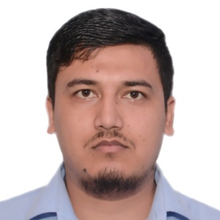

Rizwan

Email: Rizwan.373613@2freemail.com

PERSONAL SUMMARY

A highly motivated and dynamic Electrical Engineer with polished technical and communication skills. Aspiring to carve a niche in the industry using my strong communication, technical and analytical skills.

EDUCATION

2009-2013: B. Tech in Electrical Engineering, Graphic Era University, Dehradun. (Grade: 74.51%)

2008-2009: AISSCE (XII), Kendriya Vidayala, Rampur. (Grade: 60.00%)
2006-2007: AISSE (X), Kendriya Vidayala,Rampur. (Grade: 63.43%)

EXPERIENCE/TRAINING

- Site Engineer in M/s. Mateen Ahmed Contractor Pvt. Ltd. (January2016- August 2017)
- Machine shop maintenance Engineer in Aurangabad Electricals Ltd. (July 2014-November 2015)
- Trainee Site Engineer in VEEKAY General Industries (July 2013-July2014)
- Trainee Engineer Uttarakhand Power Cooperation Limited, Ranikhet (June 2011)

KEY/TECHNICAL SKILLS

- Proficient with office software like MS Word, Excel, Power Point.
- Excellent written, communication, inter personal and problem solving skills.
- Ability to work independently and in a team environment.

PROJECTS

- Project On Digital Code Lock and Key Hole Lighting Device
- Project On Power Flow Control in A Transmission Line Through Unified Power Flow Controller (UPFC)

ACHIEVEMENTS/AWARDS

- Won third price in LAN gaming (AOE3)
- Participated in Social Science and Science fair at regional level.
- Participated in Science exhibition at regional level.
- Participated in Industrial Project of Chilla Hydro Power Plant, Haridwar.
- Active member of the Organising Committee of the GEU techno-cultural fest.

LANGUAGES

English (Fluent), Hindi (Native), Arabic(Elementary).

PERSONAL INFORMATION

DOB: May 27, 1991.
Citizenship: Indian

