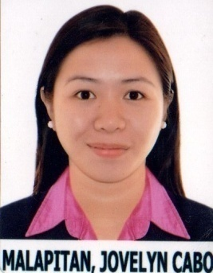Jovelyn RMT, MLS(ASCPi)
Jovelyn.373623@2freemail.com

Date of Birth: November 11th, 1994
Nationality: Filipino
Marital status: Single

Objective
Seeking a full-time, challenging position as a medical laboratory scientist in a clinical or industrial laboratory.
Education:
Central Philippine University: Bachelor of Medical Laboratory Science
2011 – 2015 Jaro, Iloilo - Philippines.

Sta. Barbara National Comprehensive High School:High School diploma
2011 Santa Barbara, Iloilo - Philippines.

Certificates:

Certificate In American Society of Clinical Pathology MLS (ASCPi)
August 16th, 2017. Manila - Philippines.

Professional Regulations Commission:Registered Medical Technologist, RMT
September 2015. Manila - Philippines.

Work experience:

GLOBAL HEALTH DIAGNOSTICS CENTER: Medical Technologist
September 2015 - September 2017, Manila - Philippines.
Job Description:
- Collect samples to perform analysis, culture and sensitivity tests, smears, blood tests such as; CBC, CRP, HIV, ANA TEST
- Undertake jobs in all lab departments such as; Hematology, Microbiology, immunology, etc…

Achievements:
- Collect specimen and analyze tests in a precise & accurate manner
- Assisted pathologists during cutting of biopsy and autopsy specimen.
- Successfully using laboratory equipment and chemicals used for tests.

Training:

Medical Technology Internship Trainingat: CPU Kabalaka Laboratory, Iloilo Mission Hospital and Western Visayas Medical Center.
October 6th, 2014- March 15th, 2015 Iloilo – Philippines

Job description:
- Able to follow regular procedures and help prepare samples for testing.
- Demonstrated ability to establish and maintain supportive relationships with patients, physicians, pathologist and co-workers
- Performs Pre-analytical, analytical and post analytical procedures.

Languages:

Tagalog - Native
English – fluent spoken and written

Skills:
- Excellent computer skills, Microsoft Excel, Words, PowerPoint,
- Excellent communication skills with patients
- Excellent time management skill
- Excellent teamwork

Hobbies:
- Reading
- Singing
- Playing organ, guitar
- Dancing

Reference
Submitted upon request

I certify that the above information are true and correct to the best of my ability

