CARRICULAM VITEA
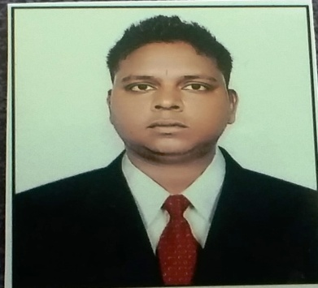 Dheeraj
E-mail- Dheeraj.373629@2freemail.com

CAREER OBJECTIVE

To be a part of an Organization with challenging and dynamic work environment. Contribute to the growth of the Organization and to upgrade personal skill set and perception.

PROFESSIONAL QUALIFICATION

- B.Tech in Mechanical Engineering with Ist division from Affiliated to Kurukshetra University Kurukshetra 2013 in Haryana India.

EDUCATIONAL QUALIFICATION

- 10+2 in Non-Medical for Ist division from Haryana Board of School Education in 2009.
- 10th in Ist division from Haryana Board of School Education in 2007.

WORKING EXPERIENCE
- December 2015 to till date working in ISGEC HEAVY ENGINEERING LTD. (BOILER) (TUBE MANUFACTURING DIVISION, RATTANGARH) Yamunanagar.
Duties & Responsibilities: 1.Executes the specific inspections on materials, equipment’s and construction/installation activities on site.
2. Issues the relevant Quality Records and when necessary, writes and sends to QC Supervisor non-conformances reports.
3. Controls equipment installation, alignment and leveling.
4. Verify special processes and the relevant workers’ qualifications.
5.Witness the tests, controls and inspections, guarantee inspection status control for parts of the plant within his area of responsibility, authorizing their acceptance at quality control completion, obtain the relevant documentation and ensure the correct implementation of the approved Inspection Test Plan according to Client’s requirements.
6. Intermediate knowledge of mechanical electrical plumbing , fitting of Fire fighting system, ducting for ventilation system, work as a team leader at construction site.

- 2 years 3 month experience in India auto Industry Pvt. Ltd ISO Certified Company 9001:2008. (RAILWAY SHOCK ABSORBERS) from August 2013 to November 2015.

Duties & Responsibilities: I) Work as Quality assurance & Inspection, production engineer .
- Also Work as quality department representative for RAILWAY AUDITS & ISO AUDITS.
- Visit in other companies whom they supply us materials regarding Quality assurance.

COMPUTER PROFICIENCY
- Certified training in the AUTO CAD.
- Making Railway inspection reports, ISO documents and Material inspection reports, Production planning.
- Microsoft Office Word, PowerPoint Presentation, Microsoft Excel.
- Use Internet and gaming.

EXTRA CURRICULAR ACTIVITIES

- 1st prize in cricket championship at district level.
- 1st prize in kabaddi compitation at collage level.
- Participate as coordinator in collage cultural as well as athletic events.

SUMMER TRAINING

- Sonalika International Tractor in assembly and quality section Six Weeks, Hoshiyarpur , Punjab, India
- Six Weeks training at Bhagat fabrication unit:-2 at Yamunanagar Haryana, India.

TECHNICAL EXPOSURE
- Attended 1 day visit Railway Workshop, Jagadhri
- Attended 1 day visit at HMT, Panchkula.

PROJECT UNDERTAKEN

- A project based on Automobile Recreations.
- A project on hydraulic crane.

STRENGTH

Ability to handle the pressure and a big team of manpower.
Work in any desire condition and any desire state.
Ability to resolving the Technical problem.

PERSONAL DETAILS

Father’s
Date of Birth : 12 Aug 1992
Sex : Male
Marital status : Married
Languages Known : Hindi, English & Punjabi
Nationality : Indian
Skills : Solving technical problems.
Hobbies : Listening music, Playing Cricket.

DECLARATION

I hereby declare that the above given information are true and to the best of my knowledge.

