Waqas
Waqas.373634@2freemail.com 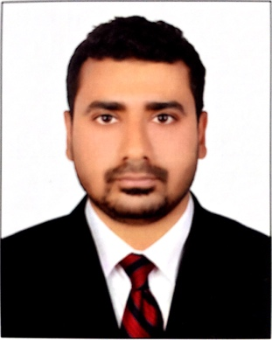

IT ENGINEER
Technical Support Executive having 5 plus years of experience. IT System engineer skills include:
- Backups  - Troubleshooting  - Virtualization | - Windows server  - Network monitoring  - macOS
Experience
emaratech FZ LLC, Dubai, U.A.E  IT System Engineer | 2011 - 2017
Being an IT Engineer my responsibilities are:
- Providing technical support to employees.
- Hyper-V virtualization
- DNS server management
- Coordinating with vendors regarding hardware and software issues.
- Windows server 2012 active directory management and administration.
- Setting up and configuring new laptops, desktops and IP phones.
- Setting up new user and email accounts.
- Solar winds network monitor.
- Managing backups using Veeam backup
- Wireless network administration
- Microsoft ofice365
- Troubleshooting Macintosh users
- CCTV camera management.

Systems Engineer
Systems Engineer having 3.5 years of expertise with extensive experience Installing, configuring, troubleshooting servers and desktop machines. Systems Engineer skills include:
- Installation of Windows Server on IBM & Dell servers.  - Installation and configuration of windows Client OS.  - Troubleshooting Windows server errors.  - Tape Backup & Restoration.  - Provide support client connectivity issue. | - Worked on Ubuntu, Fedora, Open Suse, Red hat Enterprise server.  - Installation & configuration of hardware of x-series servers & dell power edge servers.  - Structured cabling of Data Center.
Experience
Data Check(PVT) LTD, Karachi, Pakistan  Systems Engineer | 2008 – 2011
Being a system engineer in DataCheck (PVT) LTD my responsibilities are:
- Installation and administration of active directory & implementation of polices.
- Deployed Symantec Antivirus Endpoint protection in our organization securing servers and desktop machines using its endpoint capabilities.
- Deployed Windows server update services server for updating machines with the latest service packs and patches to overcome OS vulnerabilities.
- Deployment of rack mounted servers Dell 2950 & IBM 3650.
- Maintained Software and hardware inventory records.
- Working on ISA server in DPL environment to manage internet traffic.
- Managing Mail Daemon e-mail server, managing email accounts, implementing restrictions.
- Troubleshooting of client connectivity problems.
- Working with various vendors and consultants for purchasing equipment and other hardware.
- Structured cabling of Data center.
- Configuring Visual source safe.

Education & Training
University of Karachi, Karachi, Pakistan  Bachelor of Commerce | 2009
Aligarh Institute of Technology, Karachi, Pakistan  3 Years Diploma in Computer Information Technology | 2007
Higher Secondary Education(Private), Karachi, Pakistan  Intermediate Commerce | 2004
Karachi Cambridge School, Karachi, Pakistan  Secondary School Certificate | 2001
Professional certification
Microsoft Certified IT Professional  Microsoft Windows Server 2008 Enterprise Administrator | 2010

