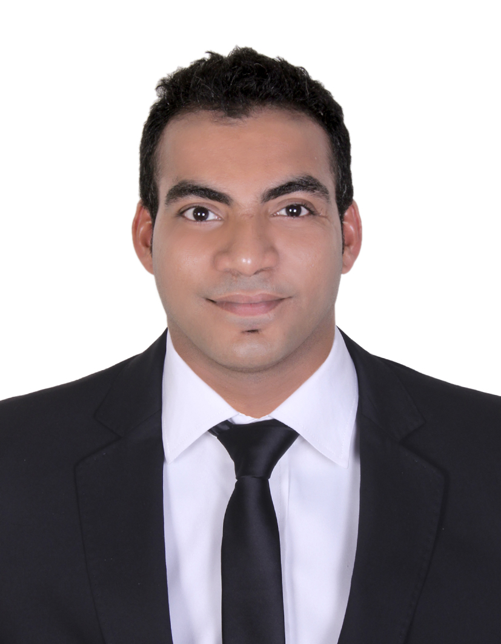
Constance
Constance.373654@2freemail.com

PROFILE

A diligent, hardworking and goal oriented barista professional committed to providing the best possible guest
experience by creating a warm and welcoming atmosphere for all of our customers, with the key aim of retaining and
attracting new clients.

EXPERIENCE
Head Barista, Limetree Cafe & Kitchen
DUBAI, UAE • APR 2013 – JAN 2017

• Responsible for preparing standardized recipe procedure across all café outlets
• Conducted training for both new and existing barista across all cafe branches
• Preparing barista related operational reports
• Taking initiative for routine timely maintenance of barista machine across all cafes
• Periodically checked perishable stock on bi-monthly basis and non-perishable stock on a monthly basis for every cafe
• Supervised cafe barista operations and ensure that baristas carry out their job duties in a responsible and efficient manner.
• Deliver excellent customer service, at all times
• Serve and present hot non-alcoholic beverages quickly and efficiently, meeting our standards
• Assist in keeping front-of-house and related public areas clean and tidy, at all times
• Keep up to date with current promotions and new products
• Make customers aware of offers on our great food and drink range
• Speak to customers to ensure that they are satisfied with their meals
• Maintain personal knowledge by completing in-house training and workbooks
• Always adhere to all company policies and procedures and licensing laws
• Be involved and contribute at team meetings
• Carry out instructions given by the management team and head office

Restaurant Supervisor, Sea Coin Hotel
GOA, INDIA • NOV 2011 - FEB 2013

• Assisted food preparers in order completion by informing chefs of client preferences and immediate response upon food call
• Responsibly overlooked the operation two sections of restaurant with punctual, friendly service for new and current customers
• Assisted managers in writing menu options and price adjustments.
• Produced direct mail pieces for current client base to increase sales
• Increased sales over 3% by consistently offering friendly service prompt response and creatively upselling high revenue menu items

Head Bartender, Hippopotamus (Abu Dhabi International Airport)
ABU DHABI, UAE • DEC 2008 - SEP 2011

• Managed nightclub operations and administration including scheduling, reports, inventory and Customer service
• Supervised staff of 10 employees
• Responsible for team development, communications, sales, profit and cost control management, conceiving
and implementing promotional campaign for Metropolitan Music Cafe & Ultimate Sports Bar
• Coordinate and oversee functions for over 700 guests and train dining and bar staff
• Responsible for good operation of a bar, receipt and inventory accountability
• Escort customers to their tables

Bartender, Sai International
KARWAR, INDIA • OCT 2007 - SEP 2008

• Mixed ingredients to prepare cocktails and other drinks.
• Displayed excellent customer service and cash handling skills
• Attended to customers’ needs on the bar and on the floor
• Served food to customers seated at the bar
• Checked customers' IDs to make sure they meet age requirements for alcohol and tobacco purchase and consumption
• Ordered Stock from various vendors and maintained an inventory of supplies.
• Coordinated banquets and functions for special occasion

Waiter, Sizzling China
GOA, INDIA • FEB 2005 - OCT 2007

• Assisted bartenders by stocking and restocking them with glasses, ice, liquor, garnishes and other supplies
• In charge of putting away inventory and maintaining the cleanliness of the bar
• As a bartender, duties included pouring cocktails for guests at the servers' tables, cash handling and waiting on guests at the bar

EDUCATION

Diploma in Food and Beverage service from ODPS
Basic Computer’s course completed at LABS Institute
Completed SSC from Karnataka University

PERSONAL DETAILS
D.O.B.: 15th December 1986
Nationality: Indian
Marital Status: Married
Visa Status : Visit Visa (Expiry : 20 Nov 2017);lko]p\ogto kmmlnm.j,nhhgz

DECLARATION
(I hereby declare, that the above information provided is true and correct to the best of my knowledge)
Date: ___________
Place: ___________

