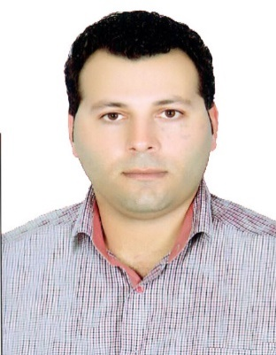

Mohsen
Mohsen.373668@2freemail.com

Professional Summary
Electrical Engineer with exceptional problem solving and troubleshooting skills seeking a position in which these skills can be utilized and enhanced for the betterment of the company.

Core Qualifications
- Excellent knowledge of the installation and maintenance of electrical systems and equipment
- Understanding of all the applications of electrical engineering
- Great teamwork abilities on group projects
- Excellent communication skills when working with others
- Proficient in mathematics and computer technology
- Capable of reading or writing diagrams and instructions for electrical panels or equipment
- Efficient in time management and able to fulfill deadline requirements

Experience
Electrical Inspector 11/2014 - Present
Persian Gulf Star Oil Company Hormozgan-Iran

- Inspected all electrical and control systems throughout the building to ensure efficiency and proper functioning
- Inspected all electrical and instrument equipment installation throughout the plant
- Led project teams delegating specific tasks to each engineer
- Ordered supplies for the installation and/or maintenance of electrical and instrument equipment
- Research the latest technology regarding electrical engineering as well as competitor systems and products

Electrical Engineer 10/2010- 11/2014
Sakoo consultant engineering co Tehran, Iran

- Inspection on Installation main and auxiliary electrical equipment and ensure it is running efficiently in all power plant unit’s
- Inspection on Installation instrument devices according to P&ID and Hook Up in all power plant unit’s
- Meet with other engineers to discuss new possibilities and projects for the company
- Work with computer software to draft plans and diagrams for electrical and control systems
- Check the power plant unit’s documents for any contradiction and expose to discussion with Central Office

Electrical Technician 01/2008- 02/2010
Tavan Gostar Daghigh Marib, Bani hareth, sana’a – Yemen

- Installation new electrical equipment both main and auxiliary
- Installation instrument devices and their Process test’s
- Maintenance and operation the main and auxiliary equipment’s
- Pre-commissioning and commissioning all control and protection cabinet’s

Electrical Technician 08/2007- 09/2008
Tavan Gostar Daghigh asaluye – Hormozgan – Iran

- Installation new electrical equipment both main and auxiliary
- Installation instrument devices and their Process test’s
- Maintenance and operation the main and auxiliary equipment’s
- Pre-commissioning and commissioning all control and protection cabinet’s

Building Electrician 08/2003- 03/2005
Freelance
- Performed building electrician for installation of power/lighting panels, RSC/PVC pipe & wiring layout, lighting fixture, small power, fire alarm system and motor control circuit.
- Identifying and wiring panels, gears, junction boxes, switches, receptacles, occupancy sensors, etc.

Education
Bachelor’s Degree XXXX - XXXX
Electrical Engineering Sapkoo University Tehran, IR

Associated Degree XXXX - XXXX
Electrical Engineering Azad kamalvand University Khorramabad, Lorestan, IR

Diploma XXXX - XXXX
Vocational School Khorramabad, Lorestan, IR

Languages
Persian: Native
English: Intermediate
Germany: beginner

Skills
Building Electrician
Industrial Electrician
Computer operator

Certificated and rewards
Receive a citation from IWPC executive manager of SIAH BISHE pumped storage power plant
Driving License: B
Ielts: Grade 5
Industrial Electricity
Building Electricity
Computer
PLC S7 200 – 300
PLC LOGO SIEMENS
WINCC

