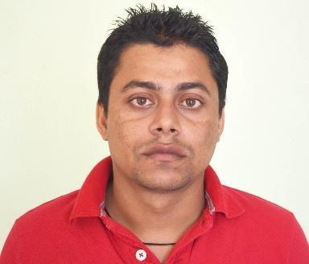
Rabindra

Email: rabindra.373673@2freemail.com

Profile

- result oriented Supervisor with excellent Customer service, able to work within a team, be confident when dealing with difficult situations and able to stick to health and safety rules at all times and Currently working as sales and store Supervisor in Qatar Fuel (WOQOD, Retail Operation Department). More than two and half years of experience , Cashiering and Merchandising in a convenience store and three years’ experience in Sales and Store supervisor in a fashion and footwear showroom.

CAREER HISTORY

Customer Service and store Supervisor

Qatar Fuel (WOQOD) 20/12/2012-20/12/2016

Duties and responsibilities

- Lea a team ensuring with excellent customer service.

- Resolve customer complaints, in a timely and professional manner.

- Maintaining all necessary product movement reports (transfers, credits) as required.

- Manages all merchandise is stocked and displays are attractive, priced correctly, and displayed in a safe manner and each merchandise category of the site so as to ensure that sufficient stock of all products is available at all times to satisfy all customer demands and set guidelines and promotional programs are implemented in a timely and orderly fashion as directed by the Category Manager and Area Manager

- Monitoring all shift reports and investigating any anomalies, daily site financial report and preparing cash for collection.

- Follow and enforce all Company Policies and Established Procedures in the store Operations.

- Implement Monthly promotions, insure all POS advertising/signage is properly posted at the proper time and report to site in charge.

- Ensure that all site staff is fully conversant with safety and hygienic matters, fully conversant with the operation of equipment within their area responsibility and

1 | P a g e

procedures arising from the site's operation. Ensure any shortfalls in the safety of the working environment are documented and reported to the Area Manager.

- Analyses variation in shift performance to maximize capacity utilization of all site staff within budgeted wage allowances.

- Report and process all employee and/ or customer incidents or accidents following company procedure.

Customer Service Assistant, Cashier, Merchandiser

Emirates General petroleum Corporation (EMARAT), UAE 16/09/2009-07/01/2012

Duties and responsibilities

- Provide five star customer services following with company’s SOP.

- Receive products from supplier and make sure that their products are in stores and present in an appealing, saleable way.

- Product placement, promotions and pricing.
- Make LPO and Goods Return lists and send to the Supplier and enter all data.

- Welcoming, friendly and polite to customers, able to work quickly and calmly at busy times and accurate with taking payments and giving change.

- Reconcile the direct debit mandates.

Sales and Store Supervisor

The Smiles (A Fashion Warehouse), Kathmandu Nepal 12/04/2006 - 15/07/2009

Duties and responsibilities

- Dealing with any queries or complaints.

- Advising customers on their purchases.

- Ordering, managing and taking out stock.

- Helping with promotions.

- Overseeing deliveries.

- Managing and motivating staffs.

- Making sure sales targets are met.

- Compiling the daily store financial report and cash accounting. Preparing cash for collection.

- Preparing and placing stock orders and supervising their receipt.

- Manages each merchandise category of the site so as to ensure that sufficient stock of all products is available at all times to satisfy all customer demands.

2 | P a g e

Academic Degrees

Higher Secondary in Management 2001 Crimson Higher Secondary School, Kathmandu, Nepal

Trainings and Skills

- Microsoft Office Package, e-mail and internet (Diploma in office Management).

- Basic Fire Fighting Course. (EMARAT, UAE) and (Civil Defense of Qatar).

- Cash Register Training on Ruby VeriFone (EMARAT, UAE).

- Merchandising Training. (EMARAT, UAE).

- Food and safety course (level 2) and examination. (BOECKER, Qatar).

3 | P a g e

