Curriculum Vitae  JAYAKRISHNAN  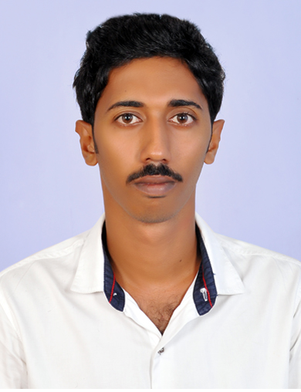  Address for Communication:-  Email:  Jaykrishnan.373683@2freemail.com  Personal Data:  Gender : Male  Nationality : Indian Marital Status : Single  Date of Birth : 08-07-1991  Languages Known : English, Hindi  Malayalam  Hobbies &Interests  Reading, Travelling  Notice Period  On Visit Visa, Immediate joining possible | CAREER OBJECTIVE  Seeking opportunity to enhance my career from a growth oriented organization that believes in team effort.  STRENGTHS  Organization abilities and communication skills.  Sincere, Committed, Straight forward and Honest.  Ability to work under pressure and face cope with pleasure.  Able to adapt at any kind of situation and willing to learn.  Self-Starter and adapted easily to new concepts.  Ability to Take Initiatives and ‘Can Do’ attitude.  Ability to work with team and individually with minimum supervision.  ACCADEMIC QUALIFICATION  - BSc Computer Science  - Master of Computer Application( Course Completed)  - MCSE ( Microsoft Certified Solution Expert)  KEY SKILLS  PC Engineering (A+)  Installing & configuring the Windows 8 (70-687)  Installing & configuring Microsoft Windows Server 2012 (70-410)  Administrating Microsoft Windows Server 2012 (70-411)  Configuring advanced Windows Server 2012 (70-412)  Basic Knowledge in Linux Operating System  Knowledge in web Designing languages such as PHP, ASP.net and RDBMS such as MY-SQL and SQL Server 2010
Working Experience

- ACS Technologies - Cochin , Kerala

Position : Desktop and Network Engineer (Since September 2016 - September 2017)

- Synergy Global Web Solutions , Kannur ,Kerala

Position : ASSOCIATE TECHNICAL ENGINEER (Since September 2015 –July 2016)

- Job Responsibilities:-

Provide technical support for both hardware and software issues our users encounter

Manage the configuration and operation of client-based computer operating systems (Win 7, Win8, Win10)

Monitor the system daily and respond immediately to security or usability concerns

Create and verify backups of data

Respond to and resolve help desk requests

Responsible for installing and troubleshooting Network and Local printers

Upgrade System to new releases and models

Upgrade systems and processes as required for enhanced functionality and security issue resolution

Administrate infrastructure, including firewalls, databases, malware protection software and other processes

- Services such as Domain, DNS, DHCP, File Server, Web, Backup & Restore

Server Monitoring

- Responsible for managing Active Directory

Install and test computer-related equipment

- Setup computers and install software for various applications and programs.

Data Networks (LAN) Designing, implementation, troubleshooting and Monitoring

Handling remote support (VNC, Team Viewer, Remote Desktop Service)

Asset Maintaining

Documentation of Asset/Change Requests/new request etc

Managing Hardware issues vendor coordination

ACADEMIC PROJECTS AND COURSES

- VILLAGE AGRICULTURAL SYSTEM (This is a project implemented using ASP .net with VB as the front end and SQL Server 2010 as the back end. The project mainly aimed to create a E-
commerce website for agricultural products )

- ONLINE CRIME REPORING SYSTEM ( This is a project implemented using ASP.net with C# as the front end and SQL Server 2010 as the backend. This project makes all activities of a Police station online.)

WORKING CLIENTS

Sothern Naval Command, Kochi, Kerala

( Worked with the System Administration Group in Navy Head Quarters)

Joint Controller of Defense Accounts Department (JCDA), Kochi

DECLARATION

I hereby declare that the above furnished details are true to the best of my knowledge

•

•
•

