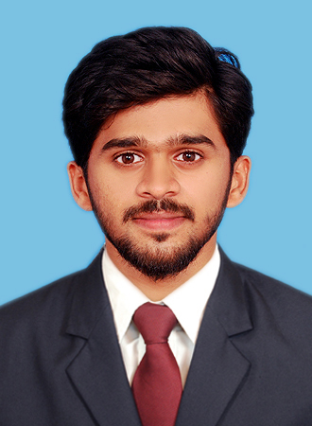

AJMAL
Ajmal.373695@2freemail.com

CAREER OBJECTIVE
To work with an adulated organization and be a part of the group that stands out in the work towards the goal and growth of the organization and to employ my skills and capabilities thereby ensuring my own success, growth and satisfaction.

SUMMARY
- Proactive and result oriented fresh postgraduate with basic experience on assisting and implementing marketing strategies and business development of a successful organization.

- Experienced in devising and implementing marketing strategies, assisting on redesigning of branded packaging of products, promotion of products and services and achievement of organizational goals.

- Good exposure of working close with diverse cultured personnel and hence developed strong interpersonal skills.

- Team Player with excellent communication, planning, analytical, organizational, networking and time management skills with an attitude to adapt to evolving business challenges.

- Good knowledge on basics of computer and experience in working with MS Office with front page

WORK EXPERIENCE
SALES ASSISTANT for SLABSTONE ENGINEERING & CONTRACTORS, KERALA - May 2013 – July 2015
- Reporting to Manager
- Completing the targets
- Creating Good relationship with the dealers
- Persuasive with marketing and sales
- Assisting the seniors
- Re-check the accounting statements

ACADEMIC CREDENTIALS

YEAR | COURSE | UNIVERSITY
2017 | Master of Business Administration (Logistics & H.R) | Bharathiar University , Tamil Nadu
2013 | Bachelor Of Commerce | Mahatma Gandhi University, Kerala
2010 | T.T.V.H.S.S | Higher Secondary Education Kerala State Board
2008 | T.T.H.S.S | Kerala State Board Examination

CORE COMPETENCIES
- Excellent leadership.  - Multi tasking ability.  - Excellent Communication Skills.  - Ready to adopt new challenges  - Organization Skills.  - Coping with pressured situations | - Strong Presentation Skills.  - Resource Management.  - Excellent computer skills.  - High Ethical Standards.  - Team Management  - Problem solving.

PERSONAL DETAILS

- Date of Birth 23rd October, 1992
- Marital Status Single
- Nationality Indian
- Language proficiency English, Hindi, Tamil, Malayalam
- Visa status Visit Visa valid till January 2018

ACHIEVEMENT
• Received First prize for Best manager in COLLEGE FESTIVAL
• Received First prize for Dance competition (Group) in COLLEGE FESTIVAL
• Active participation in college cultural events
• Member in College Soccer Team

