RESUME
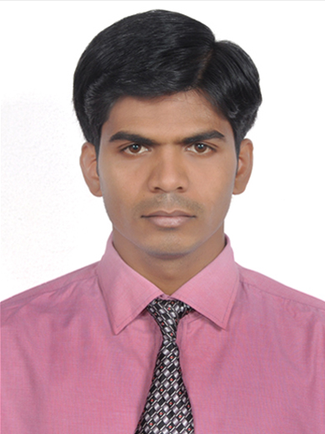
Dr. Shahid, Pharm-D
Email id: Shahid.373701@2freemail.com
Male : 27years
Visa type : visit visa
Visa validity : 17/12/2017
DHA exam : under process

CAREER OBJECTIVE
To join an organization where I can utilize my skills and goal oriented personality to improve the reputation of the company on the global stage with the use of the knowledge acquired during my professional experience, as well as during my academic studies
.
EXPERIENCE:
- One year of internship (Pharm-D) in Indian hospital(Owaisi group of hospitals) as clinical pharmacist in hospital setting.
- Two year experience in retail pharmacy
EMPLOYMENT DETAILS :
MOHAMMEDIA MEDICAL HALL [ FROM MARCH 2015 to APRIL 2017]

Responsibilities :
- Dispensing medicines for healthcare
- Guide the patient regarding dosage,duration and effect of medicines
- Dispensing a follow up of routine medical prescription,storage and handling of medicines
- Monitor storage,distribution and use of pharmaceuticals

EDUCATION:
Year | Qualification | Board/University | Institution | %
2008-2014 | Pharm-D | Pharmacy Council of India (PCI) / Jawaharlal Nehru Technological University (JNTU) | Deccan school of pharmacy | 70.5%
2006-2008 | Intermediate (science) | Board of Intermediate | Vasu Junior College, Bodhan Dist:Nizamabad,A.P. India. | 80.3%
2006 | SSC | Secondary School Certificate | Vijaya Mary High School Bodhan  Dist Nizamabad | 76.8%

PROJECT UNDERTAKEN
A STUDY ON IMPACT OF HEALTH EDUCATION REGARDING THE USE OF INHALER DEVICES IN BRONCHIAL ASTHMA AND COPD PATIENTS AND SUBSEQUENT CHANGES IN THEIR PSYCHOLOGICAL STATES IN A TEACHING HOSPITAL.
AREA OF INTEREST:
- Retail pharmacy
- Hospital- Clinical Pharmacy services.
- Pharmacovigilance&Drug safety.
- Clinical research coordinator.
- Pharmaco-epidemiology studies.
- Pharmacoeconomic studies
- Teaching.
- Medical writing.
- Patient counseling.

HIGHLIGHTS

- Hardworking & punctual.
- Good verbal & written communication skills
- High-energy, dependable individual focused on continued professional development
- Good analytical and reasoning skills
- Good basic understanding of computers
- Capable to work independently and manage stress, time effectively
- Indian driving license
LANGUAGES KNOWN:
English, Urdu,Telugu and Hindi

PROFESSIONAL AND CLINICAL PRESENTATIONS

Year | Event | Institution | Level | Activity
April 2011 | National workshop on Professionalism In Pratice- Through Pharm.D Education | Raghavendra Institute Of Pharmaceutical Education And Research, Anantapur, Andhra Pradesh | National | Participated in workshop
February 2011 | Pulse polio immunization programme | District medical and health office, Hyderabad, India. | National | Immunized children with oral polio vaccines.

PHARMACO-CLINICAL SKILLS
- Knowledge of contemporary Hospital & clinical pharmacy practice and services including integration of clinical services , distributive services, education & research activities.
- Knowledge of Pharmacotherapeutics, Pharmacovigilence, Pharmacoepidemmiology , Pharmacoeconomics, Clinical Toxicology , Clinical Research , Clinical Pharmacokinetics , Clinical pharmacy & Hospital pharmacy,
SOFTWARE SKILLS :
- Working knowledge with Data base like MICROMEDEX,MEDSCAPE .

- Sound Knowledge in Microsoft office (Excel, Word, PowerPoint)

- Has a sound knowledge to work in different Microsoft & Apple operating systems (windows xp, vista, mac, win 7, Win 8 DP& CP) and Linux operating systems.

- Data retrieval from various internet portals like Science direct, PubMed, Highwire press Google scholar, etc.

DECLARATION :
I, hereby declare that all the above mentioned information about me is correct to the best of my knowledge.
Shahid

