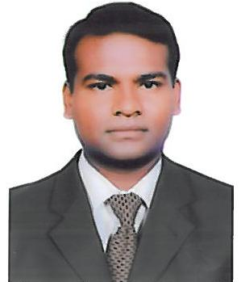
CURRICULUM VITAE

PETER

Currently working in ABU DUBAI
E Mail – peter.373704@2freemail.com

Career Objective : Working on interesting and challenging projects ,
: Holding a steady long term job, that truly helps me to build a
career and add value to me and the organization i belong to.

Achievements : Total 17 years experience with top Organizations.
: 2 year worked as Team leader (In- situ)
: 5.5 year as Senior Detailer (In-situ, precast & Modular villa)
: 3 year worked as Rebar Detailer (In-situ)
: 6.5 years worked as site Engineer / billing engineer / supervisor

Abilities : To lead a Detailing team efficiently with satisfactory output.

: Make and check Detail Drawing. Calculate steel quantity,

: To lead & monitor Site work efficiently.

: To make Billing for work done at site.

Responsibilities
* Maximum accurate Shop / production Drawing, BBS & As-Built drawings etc,
* Drawing is done as per standard code & consultant requirement.
* Coordination properly with structural Engineer, Architectures & MEP engineer to avoid any delay in work at site or office.
* Train and educate to standard code & AutoCAD.
* Co-ordinate with project manager for Planning
* Co-ordinate with consultant for approvals.
* Preparing Date to Date Work progress at site
* To ensure Work are carried as per planned.
* Assigning work for Supervisors.
* Assigning work for Labor contractors
* Preparing and maintain labor contractors Payments.

Salary Expected : 10000 aed negotiable

Professional Experience:

Kulak Construction Company (Abu Dhabi) :- (2017 Feb – To date)

Position : Senior Detailer Building.

Mammut Technocrete FZE / Mammut Contracting Company FZE Dubai, UAE (2007 September to 1 November 2016 )

Position : Senior Detailer / (Team Leader from MAY 2010 to 2013)

N Ram lingam & company Bangalore, INDIA (2006 August to 2007August)

Position : SR. Site Engineer

Gannon Dunkerly & Co Ltd Hyderabad, INDIA (2001 June 2006 March)

Position : Building Supervisor, (2001 to 2005)
: Billing Engineer (2005 to 2006)

Metha Associates Gulbarga INDIA, (2000 June to 2001April)

Position : CAD Operator

Education Records:

- Technical Trade : DIPLOMAN IN CIVIL ENGINEERING in June 2000 from

HKE’ society INDIA.

- Computer Skills : AutoCAD 2017. ALLPLAN, RIVET (BASIC)

: MS Office,

- SSLC : Mount Carmel Convent School

Personal Details:

- Date of Birth : 27-06-1978

- Nationality : Indian.

- Maternal Status : Married.

- Language Known : Hindi, English, Tamil & Kannada

- Permanent Address : INDIA

This is a true copy of my C.V. should you require any further information regarding my Testimonials or references, please contact me.

