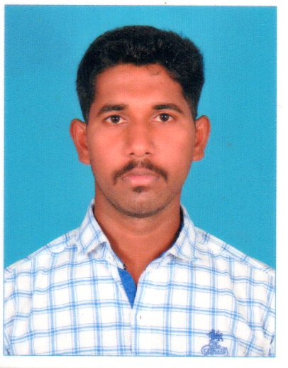

EMAIL ID
Dinakaran.373713@2freemail.com

PERSONALDETAIL
Visa :vist visa
Upto :December 30
Nationality :Indian

MEP ENGINEER

PERSONAL SUMMARY

To consistently meet or exceed company expectations by responding promptly to guests needs, solve maintenance problems in a timely, cost efficient manner. Demonstrates company values while maintaining and refining preventive maintenance programs for the entire property, interior and exterior that will minimize downtime.

Duties:

Be responsible for undertaking the design of mechanical, electrical and plumbing installations in accordance with electrical and plumbing standards.

    - Equipment selection as per the specifications.
    - Prepare the heat load calculations.
    - Prepare the quotations.
    - Technical Support to the sales.
    - Check and Full fill the customer requirements.
    - Working in heat load calculation software.
    - Review, verify the HVAC designs and drawings...
    - Quality Control according to ASHARE.
    - Work coordination.
    - Electrical cable and wiring.
    - Fire suppression systems.
    - Electrical distribution system

ON JOB TRAINING

                - Specialized in MEP engineer from TWG Group,tamil nadu,india
                - Undergone training on Team Management Techniques.
                - Undergone training on implementation of 5S

AREA EXPERTISE

- HVAC
- Energy management
- Energy Controls
- Plumbing
- Fire Protection
- Power Distribution
- Emergency Power
- Lighting

EDUCATION
- BE(electrical and electronic engineer)
- Passed out with 70% from MAM College of engineer. Affiliated to Anna University Chennai, India.
- Higher secondary with 75%
- SSLC with 70%

AREA OF INTEREST

- Music
- Playing cricket

SOFTWARE

- Ms office
- AutoCAD
- Computer Hardware and networking.
- Duct sizer

WORK EXPERIENCE
a.Kims Hospital(India)
(Sole Distributor of HAIER Air conditioners )

Designation: Project Engineer (HVAC).

b.Jayasuriya Aqua Tech And Marriage Hall,
(Sole Distributor of BLUE STAR Air conditioners )

Designation: Project Engineer (HVAC).
From April 2017 to October 2017

c.RBS Residency and Hotel.
(sole distributer of DAKIN air conditioner)
Designation: project engineer and site supervisor
From augest 2017 to September 2017

d. OVERALL PRODUCTS EXPERIENCE:
- VRF/VRV System (Variable Refrigerant Flow Or Volume),
- AHU (Air Handling Units),FAHU (Fresh Air Handling Units), Packaged Units, DX Split units,
- Basics Chilled Water System(Chiller, FCU’s), ERV Units (Energy Recovery Ventilator),
- Exhaust Fans, Staircase and Lift pressurization fans.

PROJECT RESPONIBITIES:
    - Carryout of full HVAC (A/C & Ventilation systems) designs.
    - Visit the site during an installations & problems.
    - Work coordination
    - Installation and eriction

DECLARATION

I do hereby declare that the particulars of information and facts stated above are true, correct and complete to the best of my knowledge and belief.

Signature

(DINAKARAN)

