JOSEPH

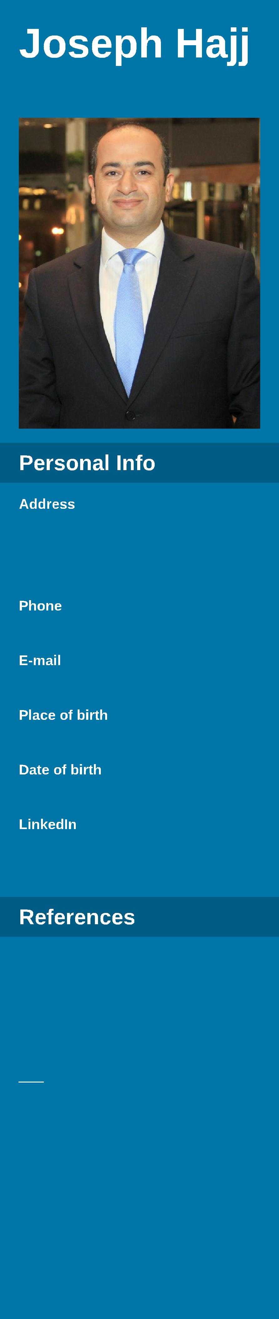
Hotelier

Joseph.373714@2freemail.com

Beirut- Lebanon

13 August 1976

Available upon request

Holding a UAE driving license

Proactive forward-thinking leader with more than 16 years of experience in the hospitality industry. A unique international background, a disarming array of interpersonal skills and an in-depth understanding of hospitality, public relations and customer services – as expressed through real life experiences. Highly qualified expert with the ability to quickly raise an institution’s profile, services level and profitability.

01-2017 -

present

- In charge of the re- launching of the Walk at the Resort, managing daily operation.

- Creating new menus, planning promotions and menu engineering.

- Providing marketing plans and activities .

- Reporting to owner, insuring return on investment.

- Maintaining profitability levels, increasing revenues by 35% within the first 3 months.

- Reducing expenses by 10% compared to previous year

05-2013 -

09-2016

- Obtain profit contribution by managing staff; establishing and accomplishing business objectives.

- Accomplish subsidiary objectives by establishing plans, budgets, and results measurements; allocating resources; reviewing progress; making mid-course corrections.

- Build company image by collaborating with customers, government, community organizations, and employees; enforcing ethical business practices.

- Manage the hotel team, towards a healthy business environment.

- Budget reviewing and contracted suppliers.

- Review & Implementation of property procedures & policies implementation.

- Evaluating outlets menu & restructuring kitchen & Service manning.

- Managing all aspects related to customer satisfaction and external review processes.

- Enforcing training and mentoring to different training topics.

- Opening 3 food & beverage outlets, including 2 night clubs and one Arabic club, and launching the Garden beer place.

- 58.4% revenue growth Year to date 2013 vs 2014.

- Implementation of the Staff Satisfactory Surveys

- Leading the newly opened hotel & resort of Ain al Faida to establish it’s positioning among the 4 star properties in Al Ain, through required levels of services, events organizations, outlets openings & hotel reputation, formulating strategies and action plans, evaluating the success of core functions and ensuring that targets and deadlines are met.

- Reduced hotel staff turn over to 15% compared to previous years.

05-2012 -

04-2013

- Property handover from the previous operator.

- Coaching management team and staff to enhance customer satisfaction and increase repeated guest data base.

- Explore new potential markets and enhance tourism in the island.

- Ensure profit and return on investment for owners and Management Company.

- Implement management company standards.

- Planning and launching F&B themes to enhance outlets foot fall.

- Establish close business relationships with the governmental different sectors as Presidential palace, Minister of Tourism, Department of Transport, local TV & newspapers.

- Increased property positioning to be 1st ranked hotel on the Island.

- Diverted 80% of the Governmental business to the property.

- Secured an airline crew threw a 4 years contract.

10-2008 -

05-2012

- In charge of the 2 hotels including rooms and services of Cristal Salam & Cristal Abu Dhabi.

- Pre-opening of the second Cristal property, 112 Units. Handover from contractors the hotel rooms & reception areas. Executing snag list along with Housekeeping department.

- Analyze P&L, drill down to root cause and come out with strait forward action plan to make sure business plan is achieved.

- Investigate expenses, making sure not exceeding budget, creating business channels to enhance revenues.

- Creating Front office standards of operation (SOPs)

- Ranked #9 within 126 properties in AUH on trip advisor

- Fist page listing on booking.com

- Maintained 89% occupancy % YTD

- Implemented the Up-selling scheme, an increase of 1/2 million on rooms revenue

09-2000 -

10-2008

“Front Office Manager” Oct.2006 - Oct. 2008 - Al Ain Rotana Hotel (5 star, 198 units) - Al AIn

“Front Office Manager” Oct. 2003- Oct. 2006 - Hazmieh Rotana Hotel (4 star, 151 units) - Lebanon

"Assistant Front Office Manager” Dec. 2002- Oct 2003 - Gefinor Rotana Hotel. (5 star, 140 units) - Lebanon

“In charge of the Housekeeping Department” Sep.2002- Dec. 2002 - Gefinor Rotana Hotel (5 star, 140 units) - Lebanon

“Front Desk Supervisor” Aug. 2001- Sep. 2002 - Gefinor Rotana Hotel

“Night Auditor/Night Supervisor” Sep. 2000 - Aug. 2001- Gefinor Rotana Hotel

- Managing Front Office operations.

- Budgeting departmental revenues, staff manning, Controlling expenses.

- Pre-opening planning of the new hotel extension (90 additional units).

- Overlooking rooms revenue department and reservation department

- Active sales calls as part of sales team in order to insure efficient market penetration.

- Leading sales blitz, introducing the corporate accounts to hotel facilities and services.

- Preferred Hotels Group Ambassador, Project Manager Partnership program launcher.

01-2010 -
05-2011 | • Master of Business Administration (MBA) - Management and Marketing - 2011
 | • University of Atlanta, Abu Dhabi
09-1995 -
05-1988

advanced

Written, Spoken, Read

Native language

Written, Spoken, Read (intermediate)

