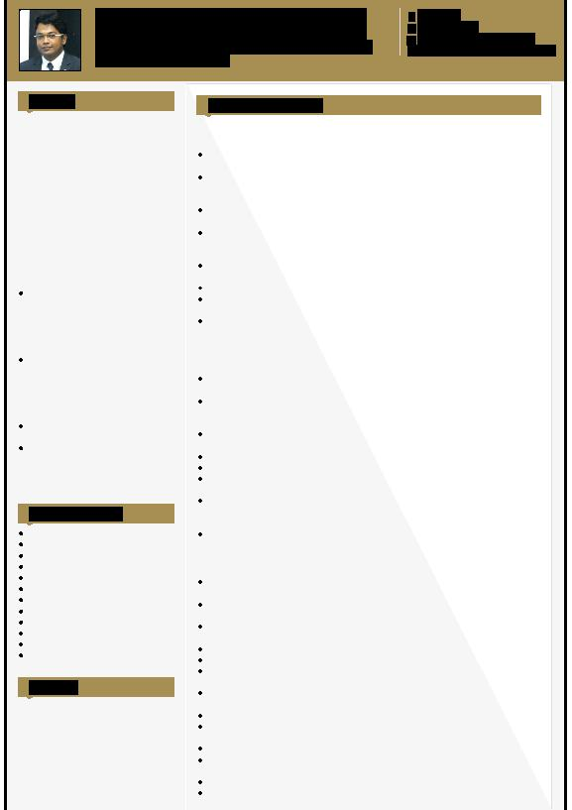
Sattar

HR MANAGER - ADMINISTRATION / EMPLOYEE WELFARE /

SOURCING & RECRUITMENT

Sattar.373716@2freemail.com

Summary

Visionary leader bringing over 12.8 years of experience, who translates business vision into HR initiatives that improve performance, profitability, growth, and employee engagement. Empowering leader who supports companies and top executives with a unique perspective and appreciation that human capital is every organization’s greatest asset. Genuine influencer who thrives on tough challenges and translates visions and strategies into actionable, value-added goals.

Diversified background in Operations & HR management; distinguished for an entrepreneurial mindset, creative problem solving, cross-functional teams and a bottom-line orientation.

Offers innovative solutions to operational challenges and leverages decisiveness to implement solutions while minimizing risk and maximizing performance.

Expert in transforming strategic plans into tactical initiatives. Motivator and coach combining business acumen with analytical depth to align operational efficiencies with corporate goals.

Core Competencies

Staff Recruitment & Training

Payroll Management

New Hire Orientations

Employee Relations

HR Policies & Program Development

Time Management

Grievance Resolution

SharePoint 2007/2010

Leave, Compensation & Benefits

HR Planning

Reporting & Analytics

Performance Management

Education

2008 - 2009

PG Diploma from Acharya Nagarjuna University, Hyderabad

2005 - 2008

B. Com (Commerce) from Osmania University, Hyderabad

Professional Experience

Operations Manager Jan 2017 - Aug 2017

Sama Building Services

Determine staffing requirements and interview, hire and train new employees or oversee those personnel processes.

Establish and implement departmental policies, goals. Objectives and procedures, conferring with managing director, organization officials and staff members as necessary.

Develop and implement product marketing strategies, including advertising campaigns or sales promotions.

Review financial statements, sales and activity reports and other performance data to measure productivity and goal achievement and to determine areas needing cost reduction and program improvement.

Took ownership of any obstacles to make sure the smooth running of company activities and follow through to resolution.

Manage the movement of goods in and out of central store and site facilities.

Assist with the implementation of cost control measures in all commercial spend areas, to make sure the maximization of profits at all times.

Report on any discrepancies, carrying out audits on timely basis.

HR Manager Oct 2014 - Dec 2016

Priyadarshini Advertising Pvt Ltd, Hyderabad

Interfacing with management and heads of department for implementing HR policies & procedures in line with core organizational objectives.

Managing the recruitment life cycle for sourcing the best talent from diverse sources after identification of manpower requirements for new / existing departments.

Executing the entire gamut of task in recruitment encompassing sourcing, screening, selection and appointment etc.

Carrying out induction / orientation program to the new recruits.

Updating all new staff details in Database.

Develop & maintain all the MIS and other operation reports which involves processing daily attendance, updating leave records, permission slips etc.

Worked with Compensation and Benefits Policy, under the Employee Life Cycle Events, in updating the compensations like Promotion amount of the employees. Support the annual compensation planning and revision exercise.

Analyze statistical data and reports to identify and determine causes of personnel problems and develop recommendations for improvement of organization's personnel policies and practices.

Accomplishments:

Reduced employee attrition rate through implementation of new incentive program and bonus structure.

Streamlined the interview process and reduced the time spent on completing the interview cycle.

Automated the payroll system with in a 1 month of joining and gave tax benefits to employees. Highly acknowledged by employees.

Acknowledged by management for error free execution of payroll consistently.

Introduced employee leave tracking mechanism.

Designed & structured levels & roll out the hierarchy charts and organization structure to all the employees.

Introduced digitization of all employee verification documents to remove paper storage files and for an easy access to the leadership at any time.

Created a toolkit that defined the roles, responsibilities and duties of employees.

Designed a leader’s development tracker to assess the skills, performance and behaviors of leaders for succession planning

Launched an Innovative Walking for Wellness Program

Initiated exuberant creative ways to motivate employees by introducing client relations service awards, Employee Appreciation, Acts of Kindness, etc.

Created Monthly Newsletters and arranged monthly employee events. Supervised HR interns and provided assistance in resume building, training and career path development

Senior Analyst/Team Lead April 2009 - Sep 2014

Deloitte Touche Tohmatsu, Hyderabad

Performed job analyses, including interview, evaluation, internal comparison and external survey.

Participated in salary surveys and analyzed the survey results to determine the competitiveness of the company's compensation package.

Assisted in the preparation of the salary grade structure.

Assisted in the communication of employee compensation and benefit programs, including counseling employees, drafting and distributing employee communication materials.

Assisted in the administration of the defined benefit and defined contribution retirement plans, including plan design,

Researched and analyzed salary rates and benefits offered by other employers in the same sector.

Undertook job evaluations to ensure that the differences in pay between those doing different jobs within the organization are fair and are perceived to be so.

Focusing on quality in the recruitment process, ensuring that SLAs and TATs are met by the entire team

Drafting offer letters and initiating background investigation process

Sending out Orientation and other emails to the candidates who have accepted the offers

Hiring into the New Hire Registry System, moving candidates in the System to activate their records in SAP

Directed activities of 10 training professionals in design, implementation & evaluations of the training programs

Monitored the performance of the team by giving feedback, setting goals and conducting meetings

Successfully boarded new hire employees to the operations and forwarded their feedback to respective managers

Coached learning professionals on various training programs to create a culture of strong team with recognition.

Accomplishments:

Got highest client appreciations within a very less time frame in the organization.

Highly recognized by the management for giving numerous ideas at work, majorly the idea for having monthly stack ranking on every process. The firm had successfully adopted the monthly ranking idea.

Got Applause Award (nominated anonymously by the leadership) for consecutively 3 years.

Promoted twice within 4 years of joining in HR (Deloitte), presently as Senior Analyst HR Operations.

Part of every fun events in Deloitte and have been recognized by management for hosting great shows.

Process Developer Oct 2004 - Mar 2009

GE Money Service, Hyderabad

Trained new hires on sales techniques and management

Reviewed sales made by each member & took corrective actions to ensure smooth management of the team on a daily basis

Monitored non exempts meeting the VOC, AHT, Sales, Quality & amp; scheduled adherence target, liaised with other departments to resolve escalated customer issues

Demonstrated abilities in optimizing the Average Handle Time (AHT)

Mentored teams to achieve target of achieving 100 % VOC Scores

Made conference calls with clients & amp; management team in the US to make sure 100 percent customer satisfaction was achieved.

Accomplishments:

Received highest client appreciations

Successfully resolved more than 98% of escalated complaints within the TAT of two days

Successfully trained 200 employees on the sales techniques and management

Mentored the team which achieved 100% VOC scores for the month of Jan’07 (End customer Voice feedback

Received “Best Associate” award in Jan’07 & May’07 and in May, June & Jul’08

