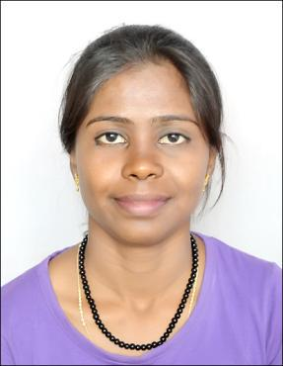
Email: jancy.373735@2freemail.com

J A N C Y

VISA STATUS : VISIT

Career Profile:

A highly dynamic, organized and skilled Customer Support Executive with diverse knowledge of operating customer care department. Seeking a position as Customer Care Executive to utilize my skills and experience in a renowned organization.

Professional strengths:

Possess 2 years of professional experience in the mentioned field

Highly proficient in handling customer care services

Possess excellent communication and interpersonal skills

Ability to deal professionally with a number of external and internal customers

Quick learner and possess creative problem solving skills

Ability to adapt to new processes within limited time frame

Familiar with basic operating systems like Microsoft Outlook, Office and the Internet Self-motivator and ability to work in a fast paced work environment

Ability to convince and satisfy customers Excellent team player with good listening skills

Professional Experience:
Company Name | Hinduja Global Solutions, India
Duration | Jun-2016 to Aug -2017
Designation | Customer Care Representative

Customer Support Executive

- Assigned the tasks of handling customer queries, feedback, complaints and request

- Responsible for maintaining and developing relationships with external and internal clients
- Assigned the tasks of preparing day-to-day activities of customer care department

- Handled the tasks of recording and scrutinizing the complaints received from customers

- Responsible for providing administrative support to customer service team

- Researched and complied answers to provide information to customers

- Assigned the tasks of providing timely responses to the queries and complaints of customers
- Handled the tasks of making outbound sales for new and existing customers

Company Name | Y- Cook India Pvt Ltd, India
Duration | Jun-2015 to Jun -2016
Designation | Customer Care Representative

Customer Support Executives

- Responsible for handling and solving customer support issues via calls and mails

- Assigned the tasks of supporting sales team in recognizing and developing new sales ideas
- Handled the tasks of contributing ideas for developing ongoing process and workflow

- Responsible for operating the department managing system requirements and timelines

- Assigned the tasks of supporting, analyzing and investigating the development of new features in supporting sales
- Responsible for preparing, maintaining and analyzing data

- Handled the tasks of contributing to other functional responsibilities of the organization

- Provided technical assistance and gave suggestions to meet customer’s expectations

- Performed other administrative tasks as assigned

Fitkids Education and Training Pvt Ltd Feb 2013 to Jun 2015

- Physical Education Specialist

Nightingaels Medical Trust (NGO) Apr 2012 to Feb 2013

- Worked as a Project Coordinator (Regional Resource and Training Centre)

AREAS OF INTEREST:

To exceed the expectations of the organization and achieve customer satisfaction To contribute my customer service skills in solving complex customer problems

EDUCATION

Namakkal, India Sri Ragavendra Polytechnic College

DIPLOMA IN COMPUTER SCIENCE AND ENGINEERING, and secured 94.4% (Overall)

Hosur, India Madhagondapalli Model school
X (CBSE) with 62%

ADDITIONAL QUALIFICATION

Web designing from 360i Design Solutions
LANGUAGES KNOWN:

English, Tamil, Malayalam, Kannada, Hindi and Telugu

