Nidheesh

E-Mail:

Nidheesh.373741@2freemail.com

Personal Profile:

Date of Birth: 28-12-1991 Gender :Male Nationality : Indian Marital Status: Single

RESUME
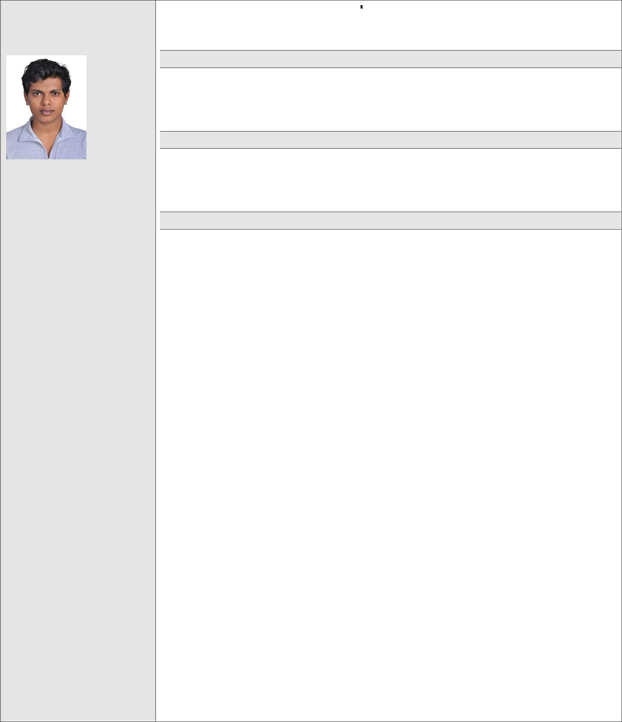

MY OBJECTIVE

Seeking a challenging position where that knowledge I have gained can be utilized for the development of the organization. Aim is to maximize and enhance my skills to serve better for the progress of the organization.

PERSONAL SKILLS

Appetite to learn new things, ability to deal diplomatically, A person waiting to take up the challenging assignments and meet the requirements in total and on time.

EXPERIENCE

1.MANAGEMENT TRAINEE 22.12.2014 TO 24.04.2015 AND PROMOTED AS PLANT ENGINEER ,TRAVANCORE AMMONIA PVT LTD EDAYAR FROM 25-04-2015 TO 05-12-2015

Job profile

- Interact with the clients and understand their requirements effectively

- Plan works according to the client requirements and manage the time

- Supervise the plant operators

- Guide and suggest changes requirements and necessities in the plant

- Conducts gas cylinder safety test

- Maintain stock details and document them properly

- Involvement in weekly meetings to solve plant related issues

2.ASSISTANT ENGINEER MECHANCAL THE SATE FARMING CORPORATION OF KERALA LTD PUNALUR FROM 07-12-2015 TO 05.12.2016

Job profile

- Ensure the accuracy of measuring instruments like weighing balance and tapes by frequent checks and calibration

- Preparation of estimates for repair and maintenance work and keep the record of all essential certificates for vehicles

- Test fuel consumption rate of vehicles

- Recommend for condemnation of vehicles/machineries and valuation

- Supervision of works for repair and maintenance and scrutiny of bills for the same

3.PROJECT ENGINEER, HVAC,ARCTIC COOLING SOLUTIONS INDIA PRIVATE LIMITED (Authorized Dealers of BLUE STAR) FROM 09.01.2017 to 14.10.2017 Job profile

- Get approved HVAC Shop Drawings, MEP- Coordination Drawings, Work method statement and Project Specification from the authorities

- Ensure the HVAC Ducts & Fitting accessories and chilled water pipes, are available as approved by Inspection department prior to installation

- Inspection of machines which has been delivered to the site and liaise with other individuals & team to ensure site clearance is available to start the HVAC Activities

- Arrange the sufficient manpower such as Supervisor, Foreman, Duct

Strengths:

Complete dedication towards my work and like to take new challenges so as to meet my career objectives.

The burning desire for Self Improvement.

A good team player and positive attitude

Ability to strike a friendly chord with any kind of personality and versatility.

KEY SKILLS

Expertise in planning

,designing budget estimation

and resource allocation

Well versed in design tool

AUTO CAD

Expertise in financial forecast

accuracy

Expertise in managing team resources

Expertise in managing multiple projects in specific deadline

fitter, pipe fitter, Assistant duct and pipe fitter etc.., ensuring all of them are attended safety orientation and having proper PPE’s prior starting installation activities at site
- Coordination of shifting of required ducting and piping approved material from warehouse to site and arrange required material to avoid progress delay

- Closely monitor site activities to ensure quality of work is in compliance with approved shop drawing and specification to get daily progress report from site supervisor (or) foreman and update to the Manager with

RFI’s

- Preparing relevant documents to conduct inspection for completed installation activities and raise RFI to QC-Inspector

- Carry out all planned site inspections as per the intervention points marked in the relevant drawing and standard

- Preparing the relevant documents to conduct testing inspection such as duct light testing for Ducts and Hydro test for above ground and underground chilled water piping systems

- Assist the Commissioning Team in pre-commissioning & commissioning stages of all HVAC Equipment’s and help testing, adjusting & balancing

(TAB) stages of the Air

- Preparation of final Test Reports, as built drawings &operation by maintenance of manual and handing over the project to client.

ACADEMIC RECORD
 | Course | of | Name of the |  | Year | Of | University/B |  |  | Aggregate
 | study |  | Institute |  | Passing |  | oard
 | (MBA) |  | BHARATHIAR |  | 2017 |  | BHARATHIAR |  | 65%
 | LOGISTIC | AND | UNIVERSITY |  |  |  | UNIVERSITY
 | SUPPLY | CHAIN
 | MANAGEMENT
 | (B.E ) |  | SARDAR | RAJA | 2013 |  | ANNA |  | 73.5 %
 | MECHANICAL |  | COLLEGE | OF |  |  | UNIVERSITY
 | ENGINEERING |  | ENGINEERING |  |  |  | CHENNAI
 |  |  | CATHOLICATE |  | 2009 |  | KERALA | STATE | 79%
 | XII |  | HIGHER |  |  |  | HIGHER
 |  |  | SECONDARY
 |  |  | SCHOOL |  |  |  | SECONDARY
 |  |  | PATHANAMTH |  |  |  | BOARD
 |  |  | ITTA
 | X |  | NETAJI |  | 2007 |  | KERALA | STATE | 85%
 |  |  | HIGHER |  |  |  | BOARD
 |  |  | SECONDARY
 |  |  | SCHOOL

CO CURRICULAR ACTIVITIES

Member in school cricket team

Drama artist

Served as the student head in Invitation Committee events

- Techno- Cultural fests in college

PROJECT/SEMINAR IN SCHOOL/COLLEGE LEVEL

- Project on the topic “Evaluation Of Steam Turbine & Performance dggfgfgImprovement”.

- Undergone industrial training at FACT Udyogamandal division

COURSES COMPLETED
- Diploma in MEP

- Process Piping and Design Engineering as per ASME B – 31.3

- NDT (Level 2)

LINGUISTIC ABILITIES
 | LANGUAGE | READ | WRITE | SPEAK | UNDERSTAND
 | English | Y | Y | Y | Y
 | Malayalam | Y | Y | Y | Y
 | Hindi | Y | Y | Y | Y
 | Tamil | N | N | Y | Y

I hereby declare that the above particulars given are true to the best of my knowledge and belief.

Place :,DUBAI
Yours Sincerely,

NIDHEESH

