IRFAN CURRICULUM VITAE

Abu Dhabi - United Arab Emirates |  | Irfan.373743@2freemail.com

CURRICULUM VITAE
Irfan | Born 10 Oct 1992 | Abu Dhabi - UAE

Seeking a challenging job and responsible position, where my education and Potential can be fully and effectively utilized and which offers opportunities for growth and acquiring more knowledge.

Personal
Information:
 |  | Marital Status | Single
 |  | E-mail: | Irfan.373743@2freemail.com

SKILLS

illustrator photoshop indesign coreldraw

^{ACADEMIC} INTER MEDIATE (ICS)
^{QUALIFICATION} 2008 Board of Intermediate and Secondary Education Sargodha-Pakistan.

EXPERIENCE

Extra

MATRICULATION

2006 Board of Intermediate and Secondary Education Gujranwala-Pakistan.

AL SAHEL Printing Press - Abu Dhabi - UAE
From December 2015 to till now

Major Duties
Customer Dealing - Designing - Finalizing Job - Machine Operating

THE CREATORS Printing System - Rawalpindi - Pakistan
From October 2011 to December 2015

Major Duties
Customer Dealing - Designing - Finalizing Job - Production

SN GRAPHICS - Rawalpindi - Pakistan
From August 2008 to September 2011.

Major Duties
Customer Dealing - Designing - Finalizing Job - Machine Operating

EXCELLENT Printing System - Rawalpindi - Pakistan
From August 2007 to July 2008.

Machine Operating

(Mimaki SWJ-320 S4 + Roland Versa Works VS-540 Print & Cut)

Roll Up Stand Fixing | Popup Stand Fixing | Lamination

LANGUAGES |  | English: Good written and oral skills
 |  | Urdu: Excellent written and oral skills

References can be provided on request.

IRFAN PORTFOLIO

Irfan.373743@2freemail.com
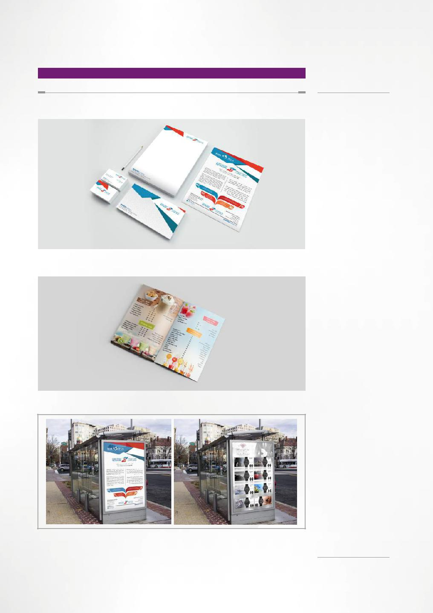

PORTFOLIO

Stationery

Logo Desing Flyer Design Poster Design Envelop Design Business Card Design

Menu Design

Posters

Irfan.373743@2freemail.com

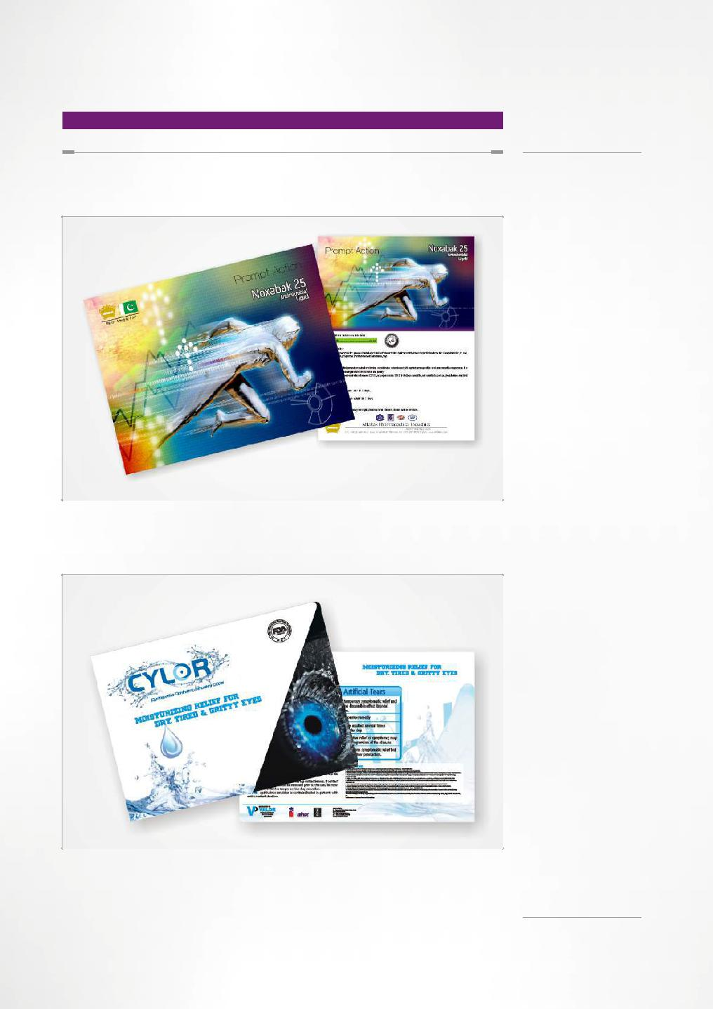

PORTFOLIO

Product Brochure

Product Booklet

Irfan.373743@2freemail.com

PORTFOLIO
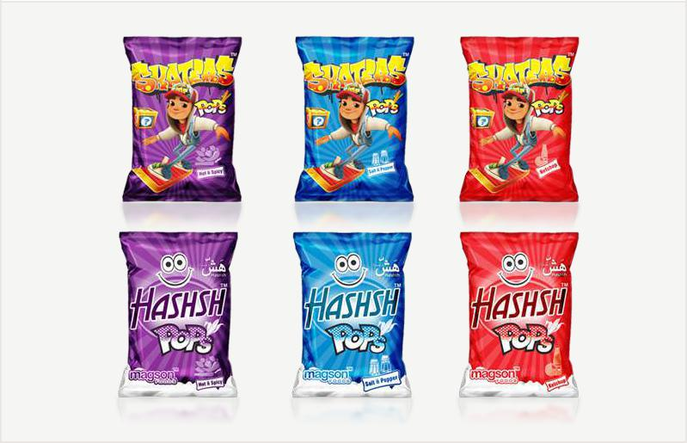

Wrappers
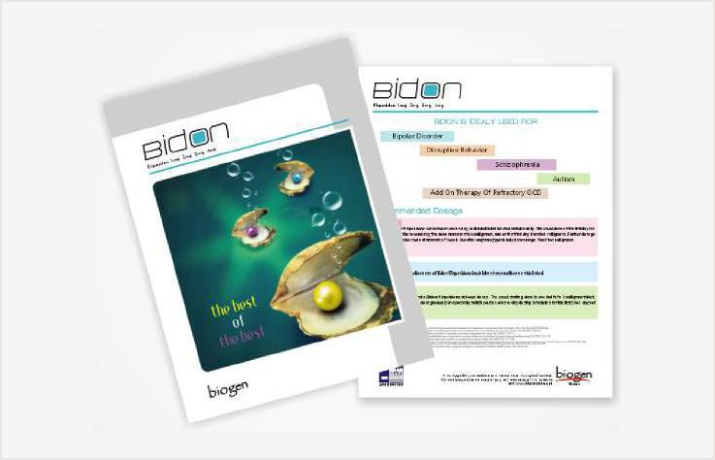

Product Brochure

Irfan.373743@2freemail.com

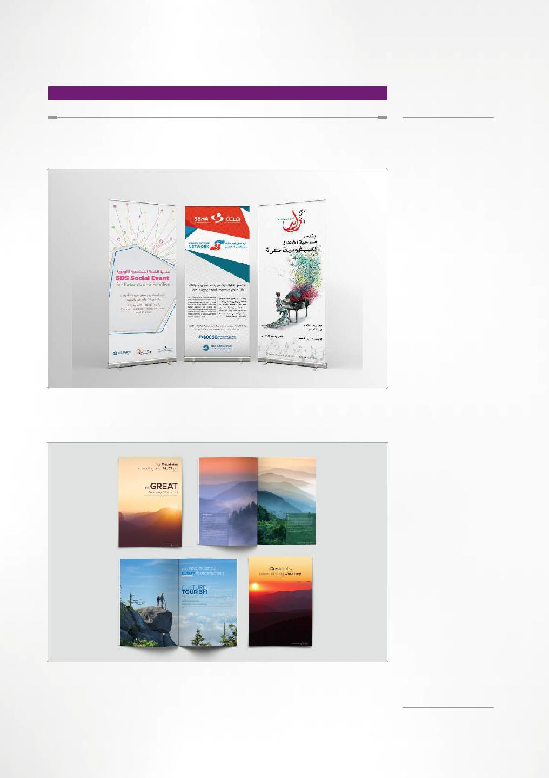

PORTFOLIO

Roll Up Design

Information

Manual

The Great Smokey Mountain

United State

Irfan.373743@2freemail.com

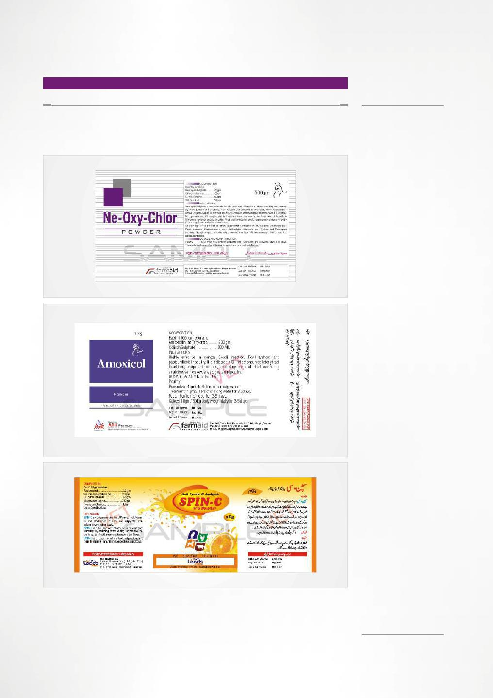

PORTFOLIO

Label

Label

Label

Irfan.373743@2freemail.com

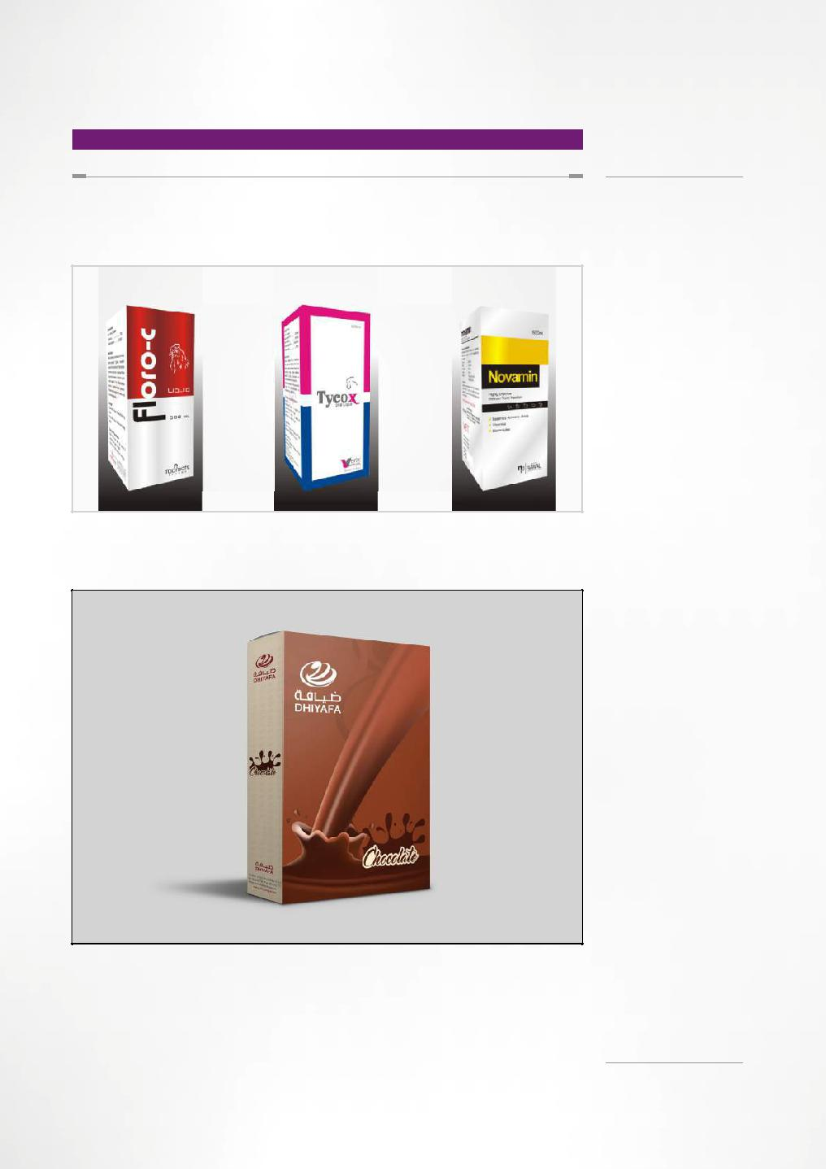

PORTFOLIO

Medicine U/C

Unit Carton

Irfan.373743@2freemail.com

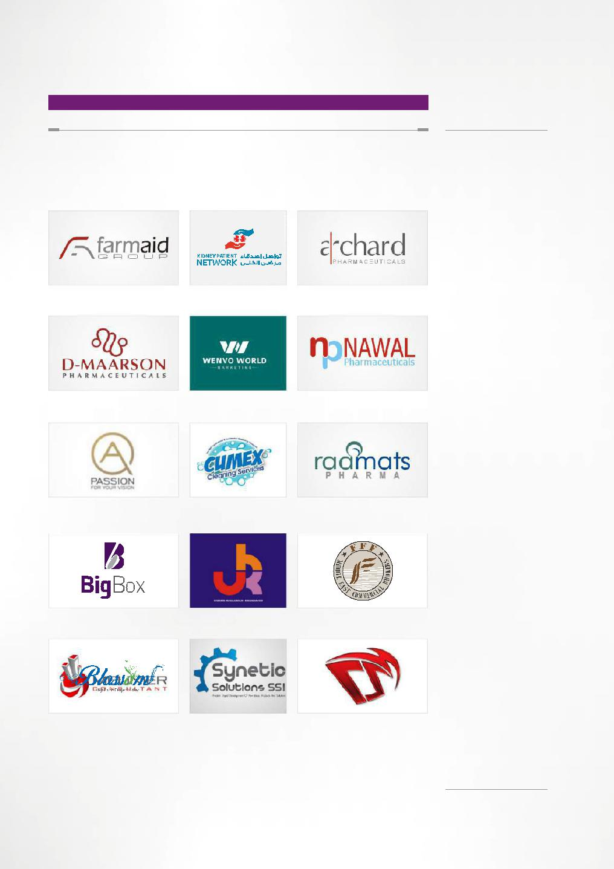
PORTFOLIO

Logo Making

Event Organizing

Irfan.373743@2freemail.com

Irfan.373743@2freemail.com

