CURRICULUM VITAE
SAJITH  E-mail: sajith.373745@2freemail.com | . 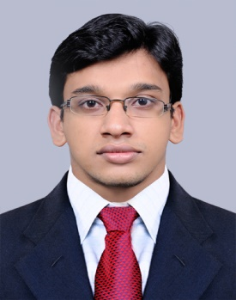

Strengths:  - Highly energetic, self driven and willing to work under pressure  - Hard working and highly responsible to the job entrusted  - Strict follower of Honesty and Sincere philosophy  Areas of interest:  Administration related,  - Coordination  - Assistance  - Analysis  Extra Curriculum Activities:  - Sports and Arts  - NSS  Hobbies:  - Travelling  - Listening to music  - Playing football | OBJECTIVE  Seeking a position to utilize my skills and abilities in an organization that offers security and Professional growth while being resourceful, innovative and flexible.  PERSONAL SKILLS  - Listening skills  - Adaptability - capable of adapting to new environment and grasp work quickly.  - Capable of working under pressure situation.  - Good interactive skills.  - Time management.  QUALIFICATION  - B.Tech (2009-2013) in Mechanical Engineering from CALICUT UNIVERSITY with FIRST CLASS  - 12th (2009) in Mathematics, Physics, Chemistry and Biology under HSE Kerala with 81%  - 10th (2007) under State Board Of Kerala with 96%  TECHNICAL QUALIFICATION  - obtained professional certificate in NDT(ASNT LEVEL II) from GAQC Kochi.India  - obtained professional certificate in  QC& WELDING INSPECTION, PIPING ENGINEERING, PIPELINE ENGINEERING from GAQC Kochi,India  WORK EXPERIENCE  Company Name : Engineering Quality Inspection Services,  Chennai,India  Job Title : Trainee quality control  Specializations : Radiographic testing,Welding inspection  Years of Experience : 2 ( 14-10-2013 to 31-10-2015)  PROFESSIONAL SKILLS  - Ensuring that all testing is performed at highest standards  - Distributing written quality assurance results to appropriate parties  - Monitoring all inspection and testing equipment to ensure correct and valid calibration  - Writing up evaluations and assessments  - Reading blueprints and specifications  - Conducting quality audits and surveys  - Carrying out final inspections  - Looking out for defects in a products  - Making sure that labels are accurate  - Review of RT films  - Dimensional checkup for after complete fabrication  - Preparing the welding report  CONCLUSION  I am looking forward to work for a company, which has got a good corporate image which offers me the following four criteria in my profile,  - Greater scope for learning opportunity  - Good corporate culture and freedom of cooperation  - Good job enrichment  - Faster carrier growth  DECLARATION  I do hereby declare that the above information is true to the best of my knowledge.  SAJITH VARGHESE
Personal details

Sex : Male
Nationality : Indian
DOB : 15-11-1991
Marital Status : Single

Software skills

Computer proficiency

- MS Office

Softwares

- Autocad
- Solid edge ST3

