Skills

Configuration of CISCO routers and switches, installation configuration in Microsoft Windows server 2012 based Networks.

Current Status

Website designing using html, CSS. Doing MBA through distance educa-tion in Logistics & chain Management and MCSE.

Certification

Abhishek ME, BE, CCNA
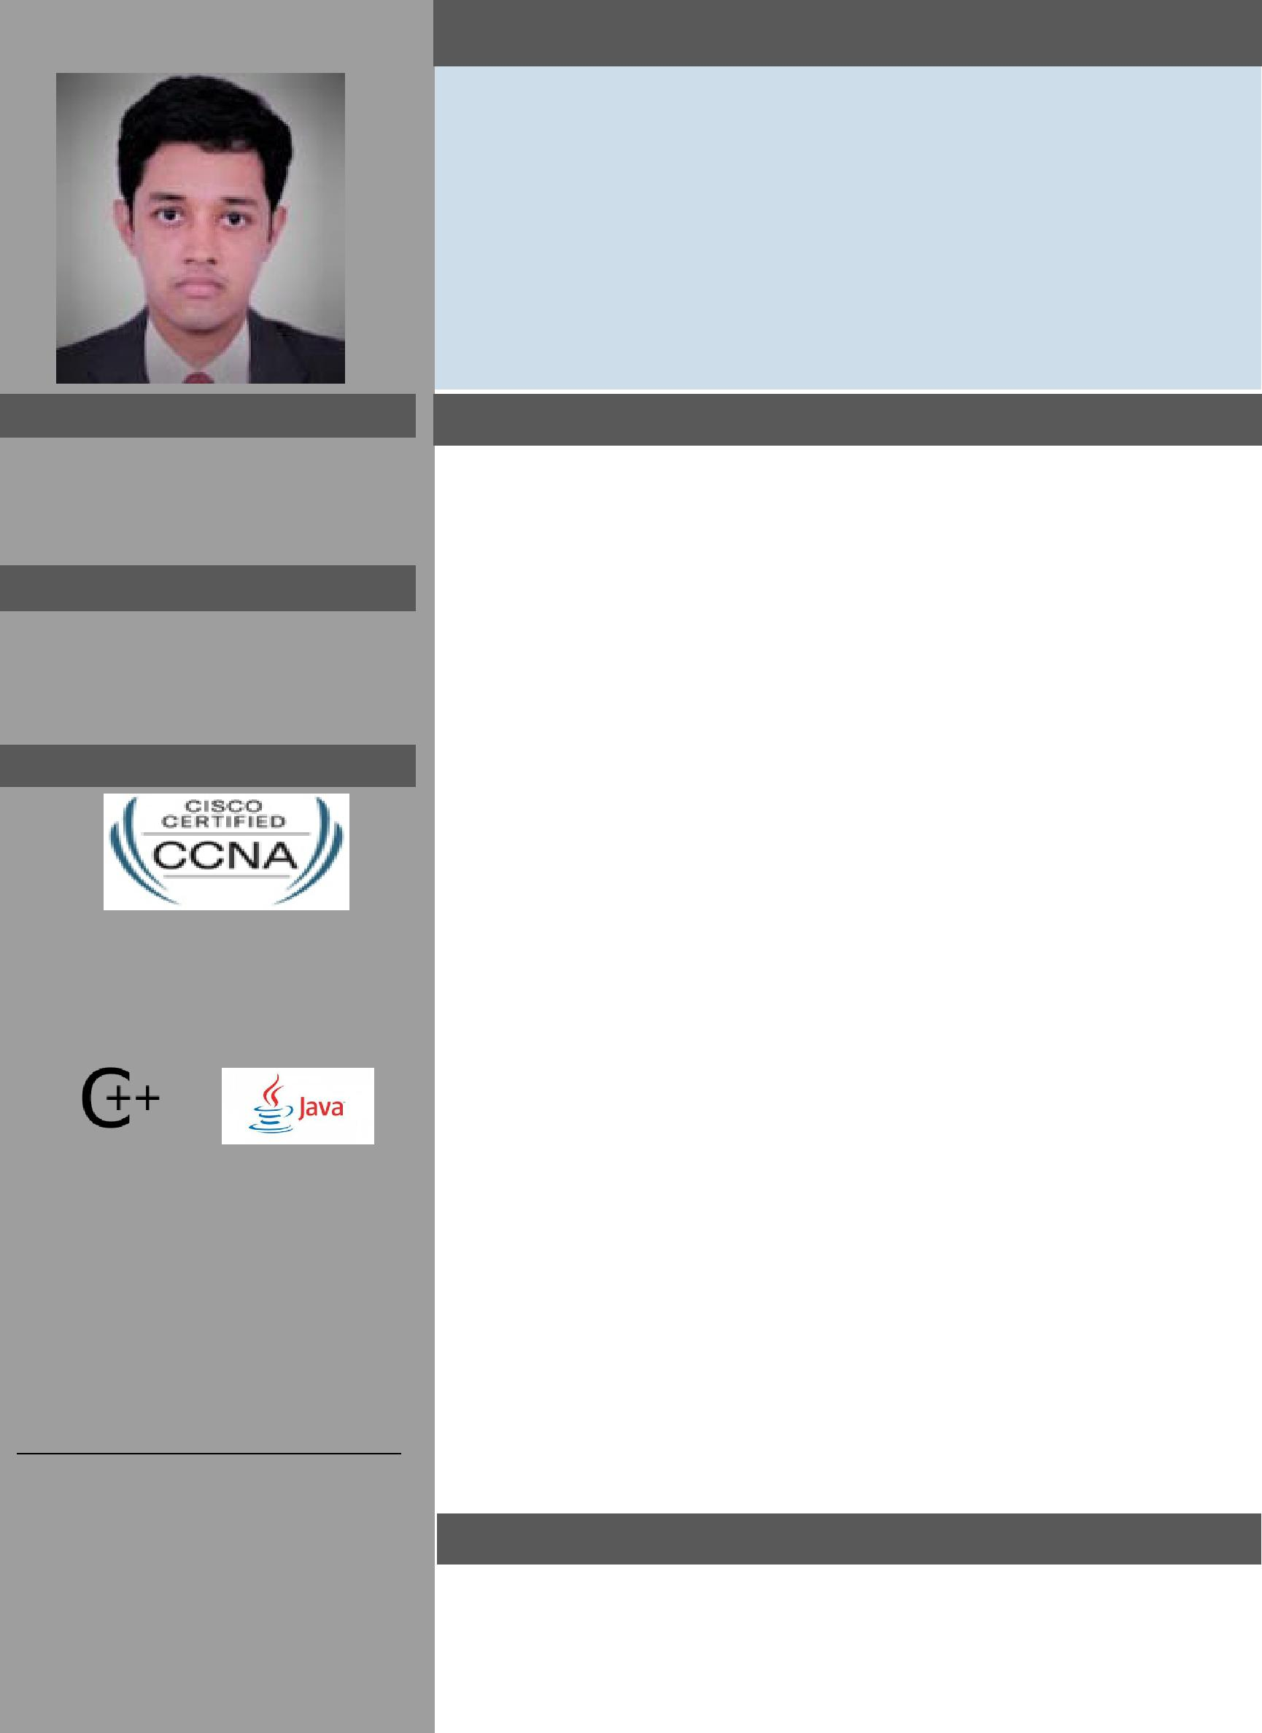

Master of Engineering—Computer Science Bachelor of Engineering – Computer Science Email: abishek.373759@2freemail.com

Professional Objective

The progression of technology and the effects it has had on civiliza-tion has always fascinated me, and generated within me a profound interest in computing and business management. A recent Master of Engineer with high scores from the Anna University Chennai, looking to secure a Networking and Communication Asst. Execu-tive position (Admin Assistant) or similar to utilize my skills, knowledge and experience through continued association with dy-namic organizations for a mutual growth. Consistently improve performance at work and service the organization with utmost loy-alty. Continuously keep updated on areas related to my profession and be keenly aware of technological changes and direction and en-hance my horizons of knowledge, skills, and capability . EXPERENCE : 1-2 year as technical Support in MULTIDATA India.

Languages |  |  | Education
 |  |  |  | Master of Engineer- | Sivaji College | Anna Universi- | 2015-2017 | 79.5%
 |  |  |  | ing (Computer Sci- | Of Engineering | ty Chennai
 |  |  |  | ence
 |  |  |  | B E(Computer Sci- | Sivaji College | Anna Universi- | 2011-2015 | 70.3%
 |  |  |  | ence) | Of Engineering | ty Chennai
Projects |  |  | Additional Training

- Web Designing for: Sivaji Motors

Vedaz Business Consultants Pvt Ltd

2 . Secure Private Data sharing to

prevent external attacks: Used the

basic IEEE model for ‘Privacy preserv-ing Data sharing with Anonymous ID Assignment’ adding encryption keys to prevent attacks from hackers using AES for Hospital Information Systems.

CCNA—Routing and Switching from CISCO 16-6-2017 valid till 16-6-2020

CISCO ID # CSCO13192585

CCNP– Routing and Switching—from Network Systems

MCP— Microsoft Windows NT operating system, related desktop systems, net-

working, and Microsoft's BackOffice server products.

Published papers

Presented a paper on Anonymous Authentication for privacy preserving data in remote access at the International Conference on Computer Electri-cal & Electronics Engineering (ICCEE – 3rd March, 2017)

