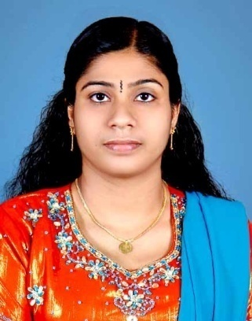

DEVIKA
DEVIKA.373788@2freemail.com

DENTAL ASSISTANT ( MOH LICENSE:T41442)

PERSONAL DETAILS

Nationality | : INDIAN
Date of Birth | : 24/11/1987
Marital Status | : Married
Current Visa status | : Husband’s Visa
TRAINING ATTENED

BLS & ACLS
PROFESSIONAL HIGHLIGHTS
• Highly-systematic professional with 3 years’ track record of assisting dentists in selecting instruments, mixing dental filling materials and cleaning work area.
• Special talent for preparing patients for dental surgery and educating them regarding the same.
• First-hand experience in setting up instruments, supplies and materials for necessary dental procedures.
• Substantial knowledge of dental procedures and terminology.
• Friendly and outgoing personality with a customer oriented demeanor.
CORE COMPETENCIES
• Filling Preparation | • Equipment Handling
• Sterilization | • Preparing Patients
• Infection Control | • Room Setup
• Dental Impressions | • Appointment Scheduling
PROFESSIONAL EXPERIENCE
Hospital: | Sagarlal Memorial Hospital ,Mushrebad, Hydrebad, India | 01.02.2010 to 01.02.2011
No. of beds: | 120
Department(s): | NICU.

Hospital: | Welfare Hospital ,Keralapuram, Kollam Kerala, India |  | 01.03.2011 to 30.09.2011
Department(s):  Clinic :  Hospital :  Hospital : | NICU  Al Amal Clinic, Al Bustan, Ajman, U.A.E.  Kailas Super Specialty Dental Clinic & Implant Centre  Specialist Medical center Ajman, United Arab Emirates |  | 12.03.2012to15.01.2013  04.03.2013to19.09.2015  Still working…..
EDUCATION
Course | Name of the Institution | Year of passing | Pass with
Degree in Nursing (B.Sc. Nursing) | Dr. NTR University of Health Sciences, Andhra Pradesh, India | 2010 | 70%
HSC | Govt.Vocational Higher Secondary School,Chathanoor. | 2005 | 71.67%
SSC | Girls High School, Punalur, Kollam | 1999 | 58%

PROFESSIONAL REGISTRATION:

Certificate of Registration for Nurses | Under Andhra Pradesh Nurses & Midwives Council
Certificate of Registration for Midwives | Under Andhra Pradesh Nurses & Midwives Council
Certificate of Registration for Public Health Nurse | Under Andhra Pradesh Nurses & Midwives Council
ADDITIONAL STRENGTHS
• Excellent dexterity and eye hand coordination
• Bilingual: English and Hindi, Tamil, Telugu & Malayalam

