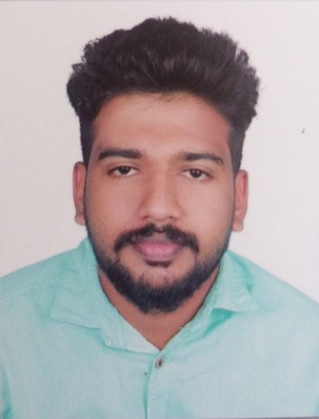  Personal Information  Age : 24  Date of Birth : 10-05-1992  Sex : male  Marital Status : single  Nationality : Indian  Languages known  English,Hindi,Malayalam  Tamil | ANISH  Anish.373797@2freemail.com  CAREER OBJECTIVE  To obtain challenging position with growing company that will provide an opportunity to utilize my knowledge of computer aided drafting /designing continuing my personal and professional growth, where my positive attitude, integrity and strong desire to succeed will contribute to the company’s success.  PROFESSIONAL MERITS:  - EDUCATIONAL Qualifications:  - Achieved Diploma in Architectural Engineering from Government Polytechnic College Adoor (2013-2016) Board Of Technical Education, Kerala  - Achieved National Trade Certificate, Draughtsman (Civil) from SINDHU ITI in 2012 ,NCVT,Government Of India  - Achieved Plus two from TMGHSS PERINGANAD in 2010, Board of Higher Secondary Education, Kerala  - Achieved S.S.L.C from NSS HSS CHOORAKODE in 2008 in , Board of Secondary Education, Kerala  - SOFTWARE SKILLS:  - Auto CAD 2D & 3D  - Revit Architecture  - Photoshop  - windows XP & windows7 & Windows 8,OS,MS word, Excel and power point, internet& email..  PROFESSIONAL experience:  - AFSAL CONSTRUCTION,Kayamkulam,Aleppy  Role: Architectural Design,drafting,Site Supervision  Duration: August 2012 to June 2013  - RKV GROUP,Architectural Consultancy,Kochi  Role: Auto Cad Designer,Architectural drafting,  Duration: September 2016 to September 2017
Skills in design field
- Good Knowledge about Civil, Electrical Drawings.
- Experience with Auto CAD 2013 to 2017
- Willing and able to learn new product, concepts and techniques.
- Able to create a variety of drawings of various size on different drawing media.

other Skills
- Good communication and writing skills.
- A team player with good interpersonal, communication &Influencing skills.
- Open minded and able to work in complex projects and environment.
- Learning attitude towards new ideas & challenges.
- Strong analytical and problem solving skills.

DECLARATION:
I Mr.Anish hereby declare that above furnished information is true and correct to the best of my knowledge and belief.

Place :India

