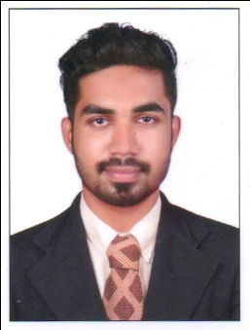
MOHAMMED.373816@2freemail.com
I’m looking forward to enhance and develop my human resource skills in an organisation and tackle problems professionally.

MOHAMMED

About me
I always contribute fully, and enjoy maintaining high standards of accuracy and perfection to my work. I have the recognition of being polite, friendly, hardworking, honest and disciplined. I enjoy being part of a team but can also work alone if required.

COURSE | NAME OF COLLEGE/ |  | UNIVERSITY | YEAR
MBA  (marketing and human resources) | P.A College of Engineering, Mangalore. |  | Visvesvaraya Technological university | 2017
BCOM  ^{(co-operation)} | Excel College Thalassery |  | Calicut University | 2015
12thStd  ^{(science)} | G.H.S.S Palayad |  | Kerala State Higher Secondary Board | 2012
SSLC | Madrasathul Mubarak Higher Secondary School |  | Kerala State Board | 2010

SKILLS

Interpersonal Skill

Communication Skill

Creativity

Problem Solving skill

INTERESTS/HOBBIES  - Stage plays  - Travelling and exploring cultures of different place.  - Shopping  - Writing short poem and stories. |  | SKILLS (TECHNICAL)  - MS Excel  - Microsoft PowerPoint  - Word processing

Working Experience

2 year experience as a sales consultant in Hyundai Automobiles in Kannur.
6 months experience as a Customer consultants in Rubco sales international Pvt.Ltd, Kannur, Kerala

Project/ Internship

Company : Rubco Sales International Pvt.Ltd, Kannur, Kerala.
Project Title : “Study on impact of promotional strategies on consumer purchase behaviour of Rubco mattress”
Expertise acquired : Knowledge about how the respondents are influenced by sales promotion of Rubco Mattress.
Help to analyse the customers of Rubco and know how they influenced by promotional strategies of the company.

Extra-curricular activities /Achievements

Receivedspecialawardsin school level for Stage plays and skits.
Won A grade in Kolkkali and short story writing (English) in School Fest.
Participated in Management festin college level.
Participated in college football team.

Personal Information

Date of Birth : 27December 1993
Nationality : Indian
Languages Known : English, Hindi, Malayalam, Tamil.
Gender :Male
Religion & caste : Islam
Date of Expiry : 29-10-2023
Visa status : visiting
Date of Expiry : Dec 25/ 2017

I, Mohammed do declare that the above information is true and correct to the best of my knowledge and belief, and nothing has been concealed or distorted.

