MIRZA
MIRZA.373825@2freemail.com 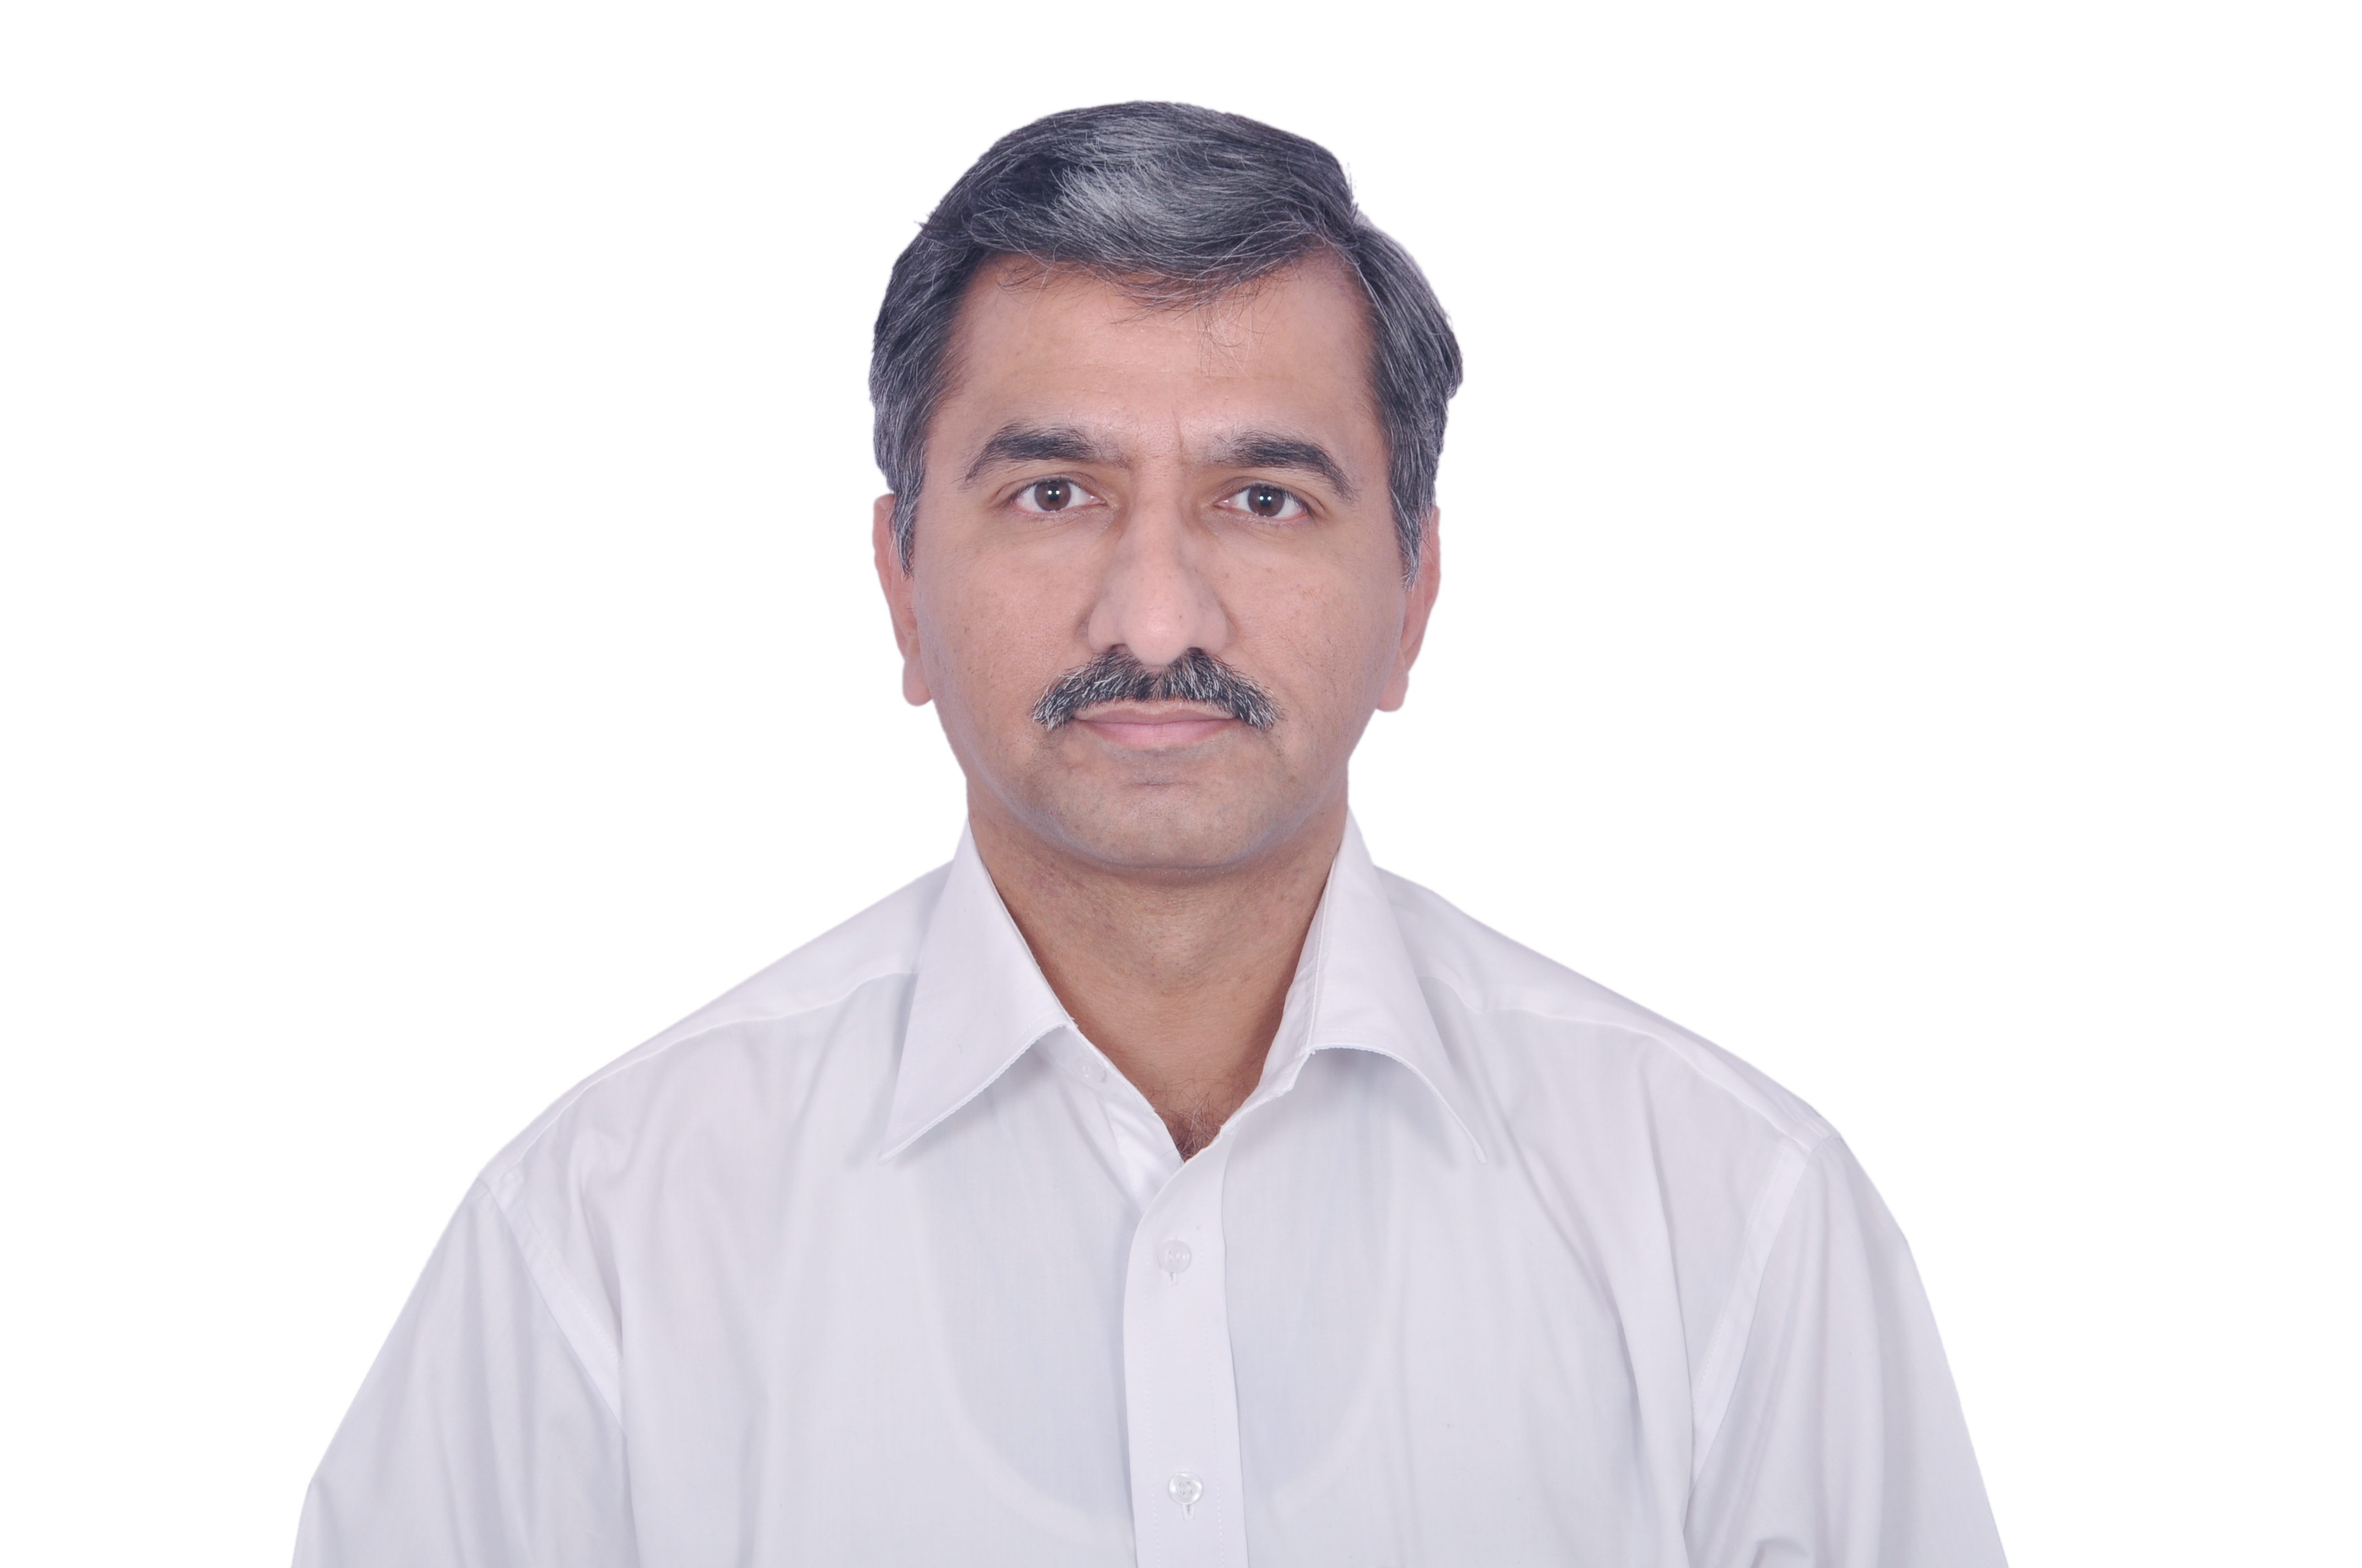

Seeking assignments in the domain of Administration / Human Resource Management with an effective organization

SYNOPSIS

- An acclimatized professional with 18 years of experience in handling the entire scope:
General Administration Human Resource Management Facilities Management
Policy Implementation Vendor Management Statutory Compliance
Quality Control Welfare Management MIS Preparation
- Last associated with Obopay Mobile Technology India Pvt. Ltd., Bangalore as Manager – Admin.
- Expertise in developing and implementing Standard Operating Procedures for operational areas inclusive of Administration and Operations & Maintenance.
- Successfully led General administrative activities, corporate policy implementation and Facilities Management across assignments.
- Sound exposure of general administrative activities, personnel & Team Management, policy implementation and facility management across assignments.
- Strong ability to master a situation quickly; highly knowledgeable in a wide variety of professional disciplines and an expert at organizing & directing turnaround situations.
- Skilled in handling large workforce, maintaining peaceful & amicable work environment in the organization, and in initiating measures for the benefit of people in the organization.
- Proficient in developing & streamlining systems with proven ability to enhance operational/ administrative effectiveness and meet operational goals within cost, timelines & quality parameters.

CORE COMPETENCIES

- Conceptualizing and implementing procedures/ systems across designated area of operations for facilities management, administration to ensure safe and smooth work environment.
- Conceptualizing and effectuating Standard Operating Procedures from quality control perspective.
- Handling Vendor Management including calling quotes, preparing comparison charts, negotiation & evaluation of vendors, placing order and ensuring timely execution.
- Ensuring optimum and effective utilization of funds in providing congenial work environment and basic amenities in the work premises.

- Overseeing operation of fleet of company owned vehicles including instituting control over maintenance regimes, manpower training, scheduling, discipline and statutory compliances.
- Ensuring quality food served to staff as per standard, preparing of the daily MIS for food order, ensuring proper hygiene level, finalization of weekly menu, quality check of the ready to serve food.
- Implementing HR policies, personnel, welfare strategies for handling employee unrest.
- Assisting the management in formulating man management policies to meet statutory compliance and formulating effective employee relation strategies at grass root level.

WORK EXPERIENCE

Jun’15 – May’17 with Obopay Mobile Technology India Pvt. Ltd., Bangalore as Manager – Admin

Accountabilities:
- Responsible of Admin department Information Risk Management.
- Managing, Maintaining and controlling the office facility and overviewing of Housekeeping & Security.
- Monitoring the Admin activities, the assigned job to the team members.
- Overviewing of travel, accommodation, etc.
- Assets Management.
- Procurements.
- Renewals of Agreements of vendors and reviewing of vendor management.
- Vendor payments & petty cash control.
- Overviewing of EPABX, CCTV & Biometric functioning.

Apr’07 – Feb’10 with Schenker India Pvt. Ltd., Bangalore as Assistant Manager – Administration

Accountabilities:
- Handled various activities related to Human Resource Management viz. interviewing and recruiting, organizing training & personality development program, attendance – attire – discipline in the office.
- Interacted with corporate office on all HR queries for the regional staff.
- Handled the facilities management systems in and around office.
- Looked after the procurement and disbursement of office stationary and other periodicals.
- Arranged tours, air tickets, accommodations, etc.; arranged visa for staff, vehicles for pick and drop, etc.
- Coordinated with all Admin heads in different regions on various levels.
- Conducted game shows for office staff.

Highlights:
- Organized tours for the teams
- Organized staff cricket tournament.
- Received a memento for proving quick work in the request of corporate office.

Sep’06 – Mar’07 with Spark Security Services, Abu Dhabi, UAE as Administration Officer

Accountabilities:
- Assisted the Finance Manager in over all administrative and accounts matter.
- Prepared of Local Purchase Order, Bills and Statement of Accounts.
- Provided IT support to the company staff & handled the procurement of IT products
- Monitored the fuel consumption, new vehicle registration & renewals, negotiated with various workshops for repairs & maintenance; monitored the consumable procurement like stationary, guard’s uniforms & their requirements, purchase of office and camp furniture including other accessories.
- Handled the day to day reporting of staff by Admin clerk, Camp Boss (in-charge), Receptionist, Office Boys and Drivers.
- Ordered Radio Mobiles as per the clients request for the security guards and applied for frequency Licence from TRA (Telecommunication Regulatory Authority).
- Visited the company branches within the U.A.E. for issues related to capital assets requirement and support to the operations department.

Oct’02 – Jun’06 with Gulf Target Debt Receiving (Hadaf al Khaleej Debt Collection), Abu Dhabi as Administrator cum Executive Secretary

Accountabilities:
- Assisted the Branch Manager and handled all the administrative duties.
- Prepared & arranged the interview for the candidates.
- Arranged for all the renewals i-e Visas, Employment Card, Health Card/Insurance Card, etc.
- Negotiated & purchased of stationary, booked air tickets with the help of various travel agents and airlines, booked hotel rooms, etc.
- Looked after the daily bank transactions & updated the accounts; handled petty cash.
- Clearance of loans of customers
- Entering the date of new cases received from clients for the defaulters.
- Helped the staff (collectors) in collection in regards to make calls, to collect money, to prepare receipts, etc.
- Tracked and updated the entire office records; prepared monthly stock requirements.

Highlights:
- Received ‘Best Employee Award’ in the year 2005.
- Implemented in cutting irregular office expenses.
- Initiated in one shift basis to improve staff productivity.

PREVIOUS ASSIGNMENTS

Nov’00 – Oct’02 Lucky Recycling Ltd., Jebel Ali, UAE Admin Coordinator

Feb’95 – Nov’98 Lucky Recycling Ltd., Jebel Ali, UAE Secretary

SCHOLASTICS

M.B.A. (Specialization in HR) Madras University, Chennai (Distance Learning) 2013
B.Com. Vijaya Evening College, Bangalore 1997

Certification:
- Microsoft Certified Professional

TRAININGS ATTENDED

- Business English through British Council in Dubai in 1997.
- I.I.A.T.A in Airline Passenger Course & Airline Cargo Course in 1991.
- International Fare Construction & Air Ticketing in 1998.
- Computer Based Training & Travel Management in 1999.

IT SKILLS

Operating Systems : Windows 2007/2010 and Windows XP
Packages : MS Word, MS Excel, and Power Point.
Computer Basic : Fundamentals & DOS, BASIC, LOTUS123

PERSONAL DOSSIER

Date of Birth: 23rd Nov’71
Sector, Bangalore - 560102, Karnataka, India.
Linguistic Ability: English, Hindi, Urdu, Kannada and Tamil

