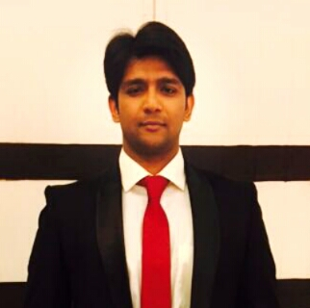
Farrukh
MBA (MKT), BBA (MKT)
E-Mail: Farrukh.373841@2freemail.com

Personal Summary
I am a confident, honest and hardworking individual with extensive knowledge of marketing strategies. Having almost of 2 years of professional experience in the field of planning and executing marketing campaigns and know how to develop and maintain good relationships with existing and new clients. A quick learner who can absorb new ideas and can communicate clearly and effectively with work colleagues, clients and senior managers.
Now looking for a suitable marketing position to significantly contribute to the marketing department of an ambitious company that offers genuine opportunities for progression.
Professional Experiences
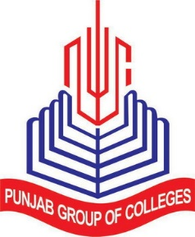
- Punjab College Of Commerce Daska, District Sialkot, Pakistan
February 2014 – August 2015
Position: Assistant Marketing and Admission Officer

Responsibilities:

  - Support college in the implementation of its marketing campaigns.
  - Organizing all annual college events and informative exhibitions campaigns in all over district schools.
  - Guest handling in all college functions and major events.
- Proof reading for all marketing material, both print and online.
- Ensuring effective execution of advertisements.
  - Responsible for maintaining and updating the college’s website and social media.
  - Coordinating telemarketing activity.
  - Managing and maintaining applicant data information within college system.
  - Assisting in organizing promotional events in and out of college territory.
  - Liaising on weekly basis with clients and suppliers.
  - Booking advertisement space with local newspapers.
  - 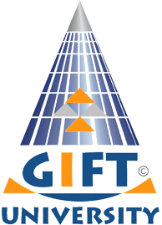Involved in producing and publishing online marketing material.

- GIFT University, Gujranwala, Pakistan
July 2012 – October 2012
Position: Marketing Internee

Responsibilities:

  - Responsible for providing excellent customer service while dealing admission inquiries.
  - Outdoor marketing and promotional activities (Bill boards, digital media advertisement, print media and distribution of promotional material)
  - Ensuring effective execution of advertisements.
  - Assist Executive Manager in scholarship and financial assistance department
  - Manage new applicant’s record on system and in files.

Educational Profile
National University Of Computer & Emerging Sciences (Fast-Nu), Lahore
Post-Graduation (M.B.A. (Marketing))
- Aug 2015- Dec 2016

Gift University, Gujranwala
Under-Graduation (B.B.A. (Hons) (Marketing))
- Oct 2009 – Dec 2013

Major Academic Projects Undertaken
During Post-Graduation
Project Title: 3G Service Quality of Mobilink
Description: Customer Perception, Network Coverage, Service Blue Print, Service Marketing Triangle and Mobilink H.R. Strategies for Delivering Service Quality through People.

Project Title: Kentucky Fried Chicken (KFC) Social Media Campaigns Content Analysis
Description: Theme, Display, Social Media Location, Promotions, Execution, Public Response and Content Analysis.

Project Title: Eco-Friendly Paper Products
Description: The business idea is to introduce the eco paper products which include paper cups, boxes and plates. Idea includes Design, Production, Promote and selling into the market.

During Under-Graduation
Project Title: Analysis of Retailing Strategies of Hyper-Star (Carrefour), Lahore
Description: Merchandising, Display, Location, Promotion and Location Strategies

Project Title: Pepsi Marketing and Advertisement Analysis
Description: Analysis the time to time Pepsi marketing & advertisement theme change from 1996 to 2012.

Project Title: Marketing Plan for Re-launching The Vespa Scoter
Description: Analyze reasons of failure, promotional plan, target market, positioning, customer buying behavior, competitor analysis etc.

Project Title: Measuring Perceive Service Quality at Hyper and Super Markets Retail Stores in Lahore, Pakistan
Description: Study on identification of factors that influence the customers to shop from these two different stores, despite of almost similar offerings.

Professional Skills
Communication Skills

- Excellent negotiation skills
- Confident
- Excellent written and verbal communication skills
- Empathic listener and persuasive speaker
- Writing creative or factual
- Speaking in public, to groups, or via electronic media

Problem Solving Skills

- Finding middle ground
- Follow through
- Identifying the Interests of all Parties

- Developing treatment plans
- Interpreting Data to Determine the Scope of Problems
- Implementing Solution
Teamwork Skills

- Clearly communicate ideas with the group/team
- Dependable
- Flexible
- Group decision making
- Patience
- Supportive
- Sharing credit
- Team player

Organizational Skills

- Attention to detail
- Conflict resolution
- Documentation
- Office management
- Coordinating and executing events
- Multitasking

Management Skills

- Coordinative
- Goal-oriented
- Obstacle removal
- Professionalism
- Strategic Thinking
- Visionary

Computer Skills

- Command on Microsoft Office
- Command on SPSS
- Intermediary knowledge of COREL DRAW and Adobe Photoshop

Personal Skills

- Positive attitude
- Dependable
- Proactive
- Versatile
- Excellent sense of humor
- Pressure handling
Certificates/Achievement

- Organizer Stage Management Committee at GIFT UNIVERSITY CONVOCATION 2012

Languages Proficiency

Languages | Speaking | Listening | Writing
English | Excellent | Excellent | Excellent
Urdu | Excellent | Excellent | Excellent
Hindi | Excellent | Excellent | Basic

Personal Information
Date Of Birth: 09th December, 1991
Nationality: Pakistan
Marital Status: Single
Current Location: Dubai

