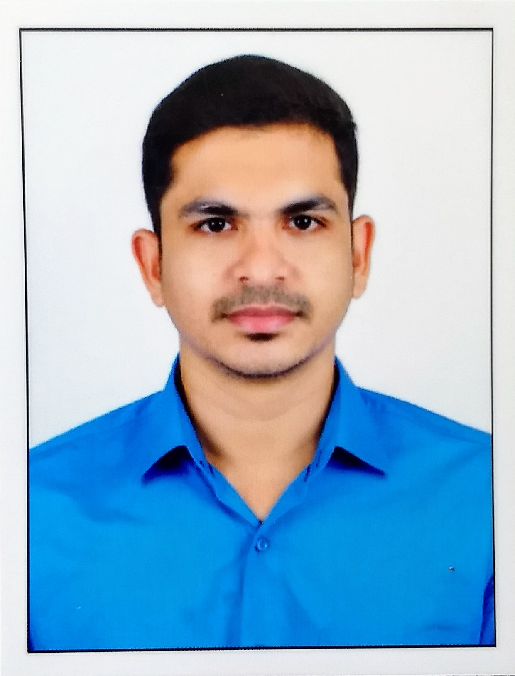

ANUJ
ANUJ.373843@2freemail.com

Professional Objectives
To work in a challenging atmosphere by exhibiting my skills with utmost sincerity, professionalism, discipline and dedicated smart work for the growth of your esteemed organization along with mine.

Career History & Key Responsibilities
- System Administrator , Radhakrishna Finance Pvt. Ltd.,Guruvayur,Kerala,India(June 2015-Aug 2017)www.radhakrishnafinance.com
- Configuring VPNs for more than 30 branch offices in both fortigate and cisco firewalls.
- Creating IP table for devices and assigning IP to devices according to IP tables.
- Supervising/assisting Vendors for the installation of CCTV systems, biometric attendance systems.
- Configuring Cisco business routers and modems.
- Ensuring all network are working fine without any packet loss.
- Prepare documents and auditing assets for information security management system(ISMS)
- Assisted consultancy for attaining ISO Certification.
- Maintaining IT asset Register.
- Excellent knowledge about networking between head office and branches offices.
- Configuring Port forwarding, web filtering.
- Excellent knowledge about windows volume licensing service.
- Expert in windows OS troubleshooting and maintenance.
- Remotely managing/monitoring of computers.
- Server management, backup, cloud backup.
- Conducting meetings for the development or betterment of IT infrastructure for the company.
- Annual Maintenance Services/Contract for CCTV, Access Control, Structured Cabling.
- Finger Print, Time and Attendance & Standalone, Networkable Access Control System installation.
- Fiber Optical Cable Works Splicing, Quality Testing.
- Fiber Optic Cable Single Mode and Multimode cable Laying, Termination, Power Meter Testing.
- Controls project costs by approving expenditures; administering contractor contracts.
- Develops project objectives by reviewing project proposals and plans; conferring with management.
- Confirms product performance by designing and conducting tests.

- Controls project plan by reviewing design, specifications, and plan and schedule changes; recommending actions.
- Maintains safe and clean working environment by enforcing procedures, rules, and regulations.
- Contributes to team effort by accomplishing related results as needed.

- System Assistant, Speedline L.L.C, Ras Al Khor 8,Dubai,UAE (Dec 2013-Feb 2015) www.speedlinedubai.com

- Installing systems, operating systems, application software.
- Tracking vehicles using GPS and corresponding software.
- Printer troubleshooting.
- Managing courier software.
- Document creation like excel, word, pdf etc.
- Managing and configuring CCTV systems.
- Managing daily attendance reports from fingerprint based attendance systems.
- Data entry.
- Configuring Smartphone.

Qualifications
- B-Tech(Computer Science) (course completed)
Thejus engineering college Kerala, India
- Bachelor of commerce, Allahabad University, India
- Cisco Certified Network Associate(CCNA)
Indiaoptions, Kerala, India
- Higher Secondary
Bethany St. Johns English Medium Higher Secondary School, Kerala, India
- High School
Bethany St. Johns English Medium Higher Secondary School, Kerala, India

Projects & Memberships
- “Prevention of black hole attack in Ad-Hoc network” in java Platform.(main project )

- “Smart x web” in java Platform(mini-project)

- Conducted a seminar on "Maximizing the life of wireless sensor networks" at college.

- Event manager of cultural committee programmed at college.

Strengths:
- Self-Thought quick learner and Creative.
- Result driven professional with good experience in leading & networking with teams.
- Committed professional, good at meeting deadlines.
- Team leader capable of interacting effectively with peers, colleagues & superiors through personal involvement.
- Handling team to execute quality work in a cost effective manner.

Technical Skills
- Operating Systems: Windows, Ubuntu, Mac

- Languages : C, C++, Java.

- Applications : Microsoft Office and all types of common applications

- Tools : Photoshop, Net beans, eclipse.

- Other : Firewall, Router, switch, PC, Smartphones,
Internet connectivity troubleshooting.

Personal Details
Date of Birth : 29/8/1991
Nationality : Indian
Sex : Male
Visa status : Visit (4th OCT 2017 to 2nd DEC 2017)
Marital Status : Single
Languages Known : English, Hindi, and Malayalam
Hobbies : Photography, Aquascaping, Football
References
To be furnished up on request.
DECLARATION
I hereby declare that the above mentioned details are correct and true to the best of my knowledge and belief.

Yours sincerely
Anuj

