CURRICULUM VITAE
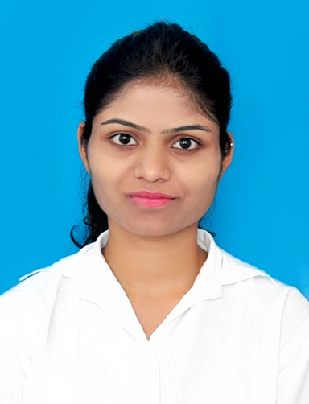

NIKITA
E-mail: nikita.373846@2freemail.com

CAREER OBJECTIVE:

To build successful career in the field of HR Executive, to constantly strive forward for professional excellence by contributing my skills, abilities and experience in the field (2+ Years) towards achievement of both organizational objectives and personal career goal.

SKILLS:

- Reliable team player with active listening & communication skills.
- Good analytical and logical skills with positive attitude.
- Problem Solver, Multitasking, Ethical & Creative Thinking, Quick Learner & Self-Motivated.

EDUCATIONAL QUALIFICATIONS:

- MBA – HR from Deogiri Institute of Engineering and Management Studies, Aurangabad in 2015.
- BCA from Deogiri Institute of Engineering and Management Studies, Aurangabad in 2013.
- HSC from Vivekanand College, Aurangabad in 2010.
- SSC from Shishuvihar High School, Aurangabad in 2008.

EMPLOYEMENT HISTORY:

- Currently Employed as a HR Assistant – Executive with daVITza India Private Limited (MNC) (Maharashtra, India) from January 2017 to Present.
- Employed as Process Executive (Operations) with Infosys BPO Limited (Maharashtra, India) from August 2015 to December 2016.

PROFESSIONAL EXPERIENCE:

- At daVITza India Private Limited (MNC) (India)
daVITza India Private Limited is defining the term Revenue Analytics for the industry. It means a decision support system based on a solid data foundation that helps finance and contracting leaders predict revenue and effectiveness of pricing Incentives. daVIZta has offices both in the US and India.

Human Resource & Other Activities:

- Create and maintain the Employee records – for all existing employees and new joiners.
- Attendance, Leave Records and coordinate with the HR Portal representative to upload the policy documents etc.
- Support the new recruitment process of hiring and interviews – Preparation of JDs, searching suitable candidates by job posting, searching on job portals and doing the initial interview round with each candidate and then scheduling the interview.
- Coordinating and Implementing the Joining and Exit process.
- Provide Training and Induction to all new joiners and explain the policies to them.
- Develop documents required for Policies, Process for India and US employees.
- Manage the appraisal process and documentation for all employees.
- Manage all Training related activities – organizing, feedback, maintaining attendance records and sharing the required information.
- Organize monthly celebrations, festivals and other events to enhance the interaction of all the team members.

Other Exposures:

- Travel desk support for India team travels – Visa, Ticketing and Travel bookings.
- US visitors – Hotel and Cab bookings, follow up for the confirmation and payments.
- Co-ordinate to get the maintenance work for office equipments – Purchases and Repairs.
- Maintain the inventory of all IT and other assets of the company.
- Get vendors for any new purchases, maintain accounts with existing vendors

- At Infosys BPO Limited (India)
Infosys BPO Limited is an end-to-end outsourcing services provider which addresses the business challenges and unlocks business value by applying proven process methodologies with integrated IT and business process outsourcing solutions.

Responsibilities:
- Maintaining HR records
- Scheduling Training new or existing employees
- Communicating and explaining the organization's HR policies to the employees
- Conducting various welfare activities
- Community initiatives programs - organizing and participation
- Regular updating of communication channels
- Conducting employee orientation and facilitating newcomers joining formalities
- Escalating to the right level depending on the nature of the grievance or issues
- Preparing letters such as offer and confirmation
- Implementing and administering performance management processes as per the PMS policy and timelines
- Engaging with employees on a regular basis to understand the motivation levels of people in the organization.

SYSTEM PROFICIENCY:

- M.S. Office Package and Intranet
- HR Software: JIRA, PANORAMA, Time Attendance, Office Timer and Pay Square.

PERSONAL INFORMATION:

Date of Birth | : 12th November 1992
Marital Status | : Single
Nationality | : Indian
Place | : Pune, Maharashtra
Languages Known | : English, Hindi, Marathi

