Curriculum vitae
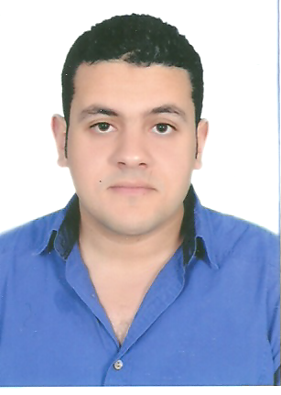

Name: Mohammed

Marital Status: single

Birth Date: 16/6/1991

Adress: SHARJAH ,UAE

Nationality: egyptian .

Military Status: Exempt.

E-mail: Mohamed.373859@2freemail.com

------------------------------------------------------------------------------------------------------------------

Educational Qualifications:

BSc of veterinary medicine

Faculty: veterinary medicine

Graduation year: 2013

University: EL-SADAT CITY

Grade : good \\ (73.74%)

DIAGNOSTIC ULTRASOUND IN PET ANIMAL ZAGAZIK UNIVERSITY JULY 2015.
small animal abdominal ultrasound course phase1 august 2017.

------------------------------------------------------------------------------------------------------------------

Experience :

Worked as a junior veterinarian at american vet center zayrd branch .
working as a veterinariay surgeon at animal nature veterinary clinic for pet animals and exotic birds AT DAMMAM KSA.

------------------------------------------------------------------------------------------------------------------:

job description :

performing routin examinations,vaccinations,diagnosing and treatment both pets and exotic birds with medical conditions.

performing basic soft tissue operations and reconstructive and wound management surgeries.

basic clinical skills(handling,iv and uretheral catheterization)

