Mohammed
Structural Civil Engineer – 2004
Mohammed.373868@2freemail.com
Summary
About 13 years of Experience in 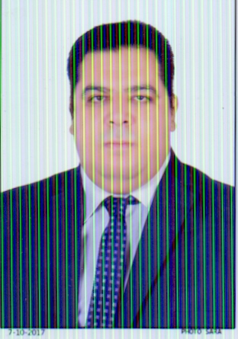
Structural Engineer/Reviewer of
Reinforced Concrete Structures
(Cast in situ ,Precast Concrete and Pre- Stressed Concrete)
Steel Structures
Repair of Buildings
Site Investigations and Site Supervisor
Technical Office Engineer(Detailed Design,Quantity Surveying,Shop Drawing)
Coordination between Drawings
Technically sound with good communication skills
Good experience in Preparing and monitoring project schedule
Responsible for execution of complete projects and follow up with all departments for deliverables
Familiar with :- Residential Buildings, Industrial Buildings , Malls, Mosques,Tanks,Hospitals and Towers
Experience in residential and commercial projects. Mastering different drawing tools. Strong project management and people management skills. Strong presentation and negotiation skills. Ability to work under pressure. Able to Relocate and travel

Previous Experience:

- El Masria International Group for engineering and construction company (Egypt ( 1/8/2016 – 10/6/2017) )
Project manager and reviewer for 67 Residential Buildings Project for low income in 6th of october city , (ministry of housing)
Reviewer for site structural & civil and arch Works.
Preparation of technical monthly progress reports
Coordination between the sub-contractors works
Review shop drawings submitted by sub-contractor
Prepare work plan and coop work problems by doing some mitigation plans
- Almuhaid Consulting Engineers Company (K.S.A (20/8/2011 –10/5/2016))

Senior Consultant Engineer for Construction&Roads projects (El hellwa, Rafia , Ellhaba,Meligah&Naeiria) Ministry of Municipal and Rural Affairs. (Riyadh-Dammam)
Description
Reviewer for all site or technical office works and material or samples submitted by sub-contractors
Preparation of Technical Monthly Progress Reports
Coordination Between Arc and Structural Drawings
- Consolid Brothers Company (K.S.A, (27/07/08 – 30/6/2011))
Senior Site Engineer for El Megazal Residential Commercial Compound , Riyadh
Site Engineer for Alkhazan compound Project – king Fahd road , Riyadh
Site Engineer for ElderaMosque + Elgayza theater, Tumair
- Eltawfekia Construction Company .(( Egypt) (1/10/2006 – 1/7/2008))
Site Engineer for construction700 villa at el mazraa project- (wadi el nattroon)
- Elgendy Construction Company .(( Egypt) (1/10/2004 – 15/9/2006))
Site Engineer for 10 Residential Buildings for low income (mubark project) (el gendy company)
Site Engineer for maintenance &finishing of suez canal hospital project
Personal Data :-
Date of birth : 29/10/1981
Nationality : Egyptian
Religion : Muslim
Marital Status: Married
Educational Background
- B.Sc. of Civil Engineering Suez Canal University -2004
- Graduation project ( Foundations design & Soil Mechanics)
- Project grade (Excellent)
Training Courses
- Design of Reinforced Concrete Structures Diploma (Maroof Acadmy) - egypt
- Safety Management Diploma (OSHA) (Arab Association For Health&Safety)- egypt
- Engineering Training at the Arab Contractors Company - egypt
Language skills
Arabic: Mother Tongue English : good
Computer skills
Microsoft Office 2013 Autocad (2000:2012)
Structural revit MS-project
Sap 2000(v8:v16) Safe(v8:v12) Etabs

