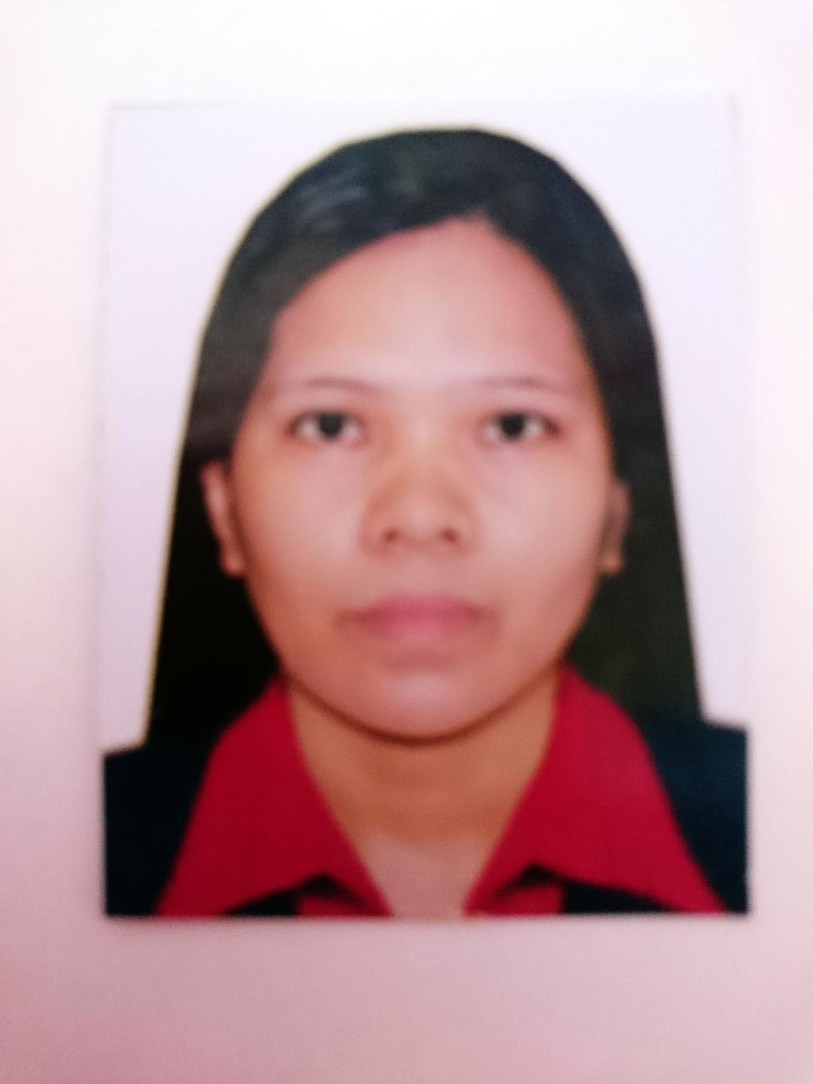

MARY
E-Mail: MARY.373870@2freemail.com

OBJECTIVES:
To maintain a job at your company that offers challenges and opportunity where I can explore more of my skills and knowledge, encourage the company goals, help my beloved family for their needs.

PERSONAL BACKGROUND:
Age: 35 Civil Status: Single
Sex: Female Citizenship: Filipino
Date of Birth: May 05,1982 Religion: Christian
Height: 5'2"
Weight: 50kls.
Education Background:

Bachelor of Science Industrial Education (June 1999- March 2003)
Leyte Eastern Visayas, Philippines

Mercedes National High School (June 1994-March 1998)
Mercedes Eastern Samar,

Taytay Elementary School(June 1989-March 1994)
Taytay Guiuan Eastern Samar

Professional Summary:
- Customer-oriented in quality focused on increasing production, minimizing equipment downtime and costs and maximizing overall plant efficiency.
- Meticulous solar panel with background in conveyor systems, timers, heat controls, hydraulics and maintenance.
- Enthusiastic as quality control who successfully applies vast knowledge of mechanics, shop mathematics, metal properties, layout and machining procedures.
- As Quality Control with six years experience. Areas of expertise included the process of the product. Creative professional with extensive project experience from concept to development.

Skills:
Computer Literate
Excel data

Work History:

March 2017 to Current
Motech Industries Incorporated Guanyain Taoyuan City Taiwan (R.O.C.)
Quality Inspector
- Discarded and rejected products, materials and equipment that did not meet specifications.
- Determined adjustment and certification methods, formulas, and measuring instruments required based on blueprints.
- Identified and helped resolve production problems such as the scratch and broken panels.
- Recorded inspection and test data such as weights, temperatures, grades and quantities inspected and graded.

October 2013 to October 2016 (3 years)
Advanced Semi-conductor Engineering Kaohsiung City Taiwan (R.O.C.)
Machine Operator
- Assisted machine operators with finished pieces.
- Liaised between customers and manufacturing to design new product.
- Adjusted alignment of drills, cutters, dies, guides, and holding devices.
- Collated components for assembly.

March 2010 to March 2013 (3years)
GiantPlus Incorporated Heping Road Taoyuan City Taiwan Taiwan (R.O.C.)
Quality Inspector
- Discarded and rejected products, materials and equipment that did not meet specifications.
- Determined adjustment and certification methods, formulas, and measuring instruments required based on blueprints.
- Identified and helped resolve production problems such broken panels
- Recorded inspection and test data such as weights, temperatures, grades and quantities inspected and graded.

January 2006 to June 2006 (6 Months)
MSM Precision Incorporated Laguna City Philippines
Quality Inspection
- Obtained proper dimensions and finish specifications from blueprints, sketches and verbal instructions.
- Determined the good quality product of the company.

January 2004 to December 2005 (2 years)
ACCUDATA Incorporated Tacloban City Philippines
Computer Data Encoder
- Built, tested and deployed scaled, highly available and modular software products.
- Strengthened developmental methodologies by introducing a code quality document.
- Modified existing software to correct errors, adapt to new hardware and improve performance.

