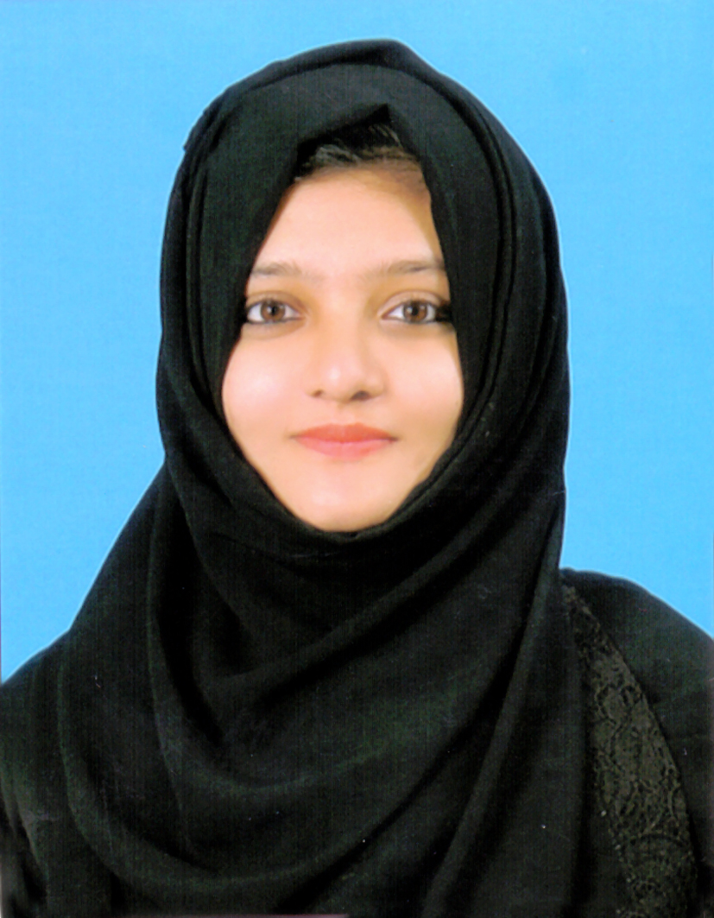CURRICULAM VITAE
Zainaba
Dubai, U.A.E.
Zainaba.373874@2freemail.com

Career Objective:
To work in a growth friendly and professionally managed organization maintaining a mutually beneficial relationship throughout and who are providing a better chance to build up my career in a better way.

KEY QUALIFICATIONS:
- Excellent interpersonal skills
- Good English Communication Skills
- Team building skills
- Analytical and problem solving skills
- Decision making skills
- Attention to detail and high level of accuracy
PERSONAL DETAILS:
- Full Name : ZainabaShamna.
- Nationality : Indian
- Gender : Female
- Religion : Muslim
- Marital status : Married
- Languages : English,Hindi, Malayalam, Kannada.

PASSPORT DETAILS:
- Place of Issue : Bengaluru
- Visa Status : Visit Visa. (Valid up to November 24).
QUALIFICATIONS

ACADEMIC QUALIFICATIONS:

- S.S.L.C – Karnataka Secondary Education Board – 2011 April
- +2 – Department of Pre – University Education – 2013 March.
- Degree – B.COM – 2016 April (Complete).

TECHNICAL QUALIFICATIONS:

- Computer Operating.
- Internet – (Emailing, Browsing, Downloading etc...)

WORK EXPERIENCE:

- 1 Year experience in Accountant in Eye Ball Optical, Mangalore.

DECLARATION:
I here declare that the above mentioned statement is correct & true to the best of my knowledge & belief.
REFEREES:
Available upon request.
Place:
Date:

