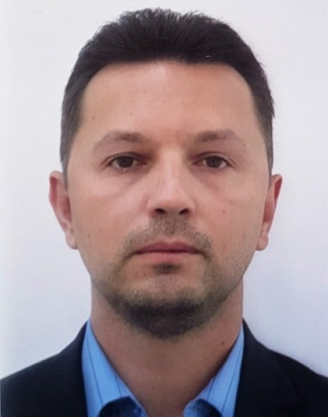  PROFILE  A result-oriented Business Development Manager with 15+ years of experience in marketing/sales/product management/competitive intelligence in heavy machinery, security and defense and automotive industries. Proven expertise in strategic business development, achievement of the annual business target and developing new revenue streams. Specialist  knowledge in seeking new opportunities, building relationships, monitoring markets, developing and executing marketing and business development plans.  SKILLS  - Good communication - written and oral skills  - Excellent conceptual and analytical skills  - Effective interpersonal skills  PERSONALITY  - Communicative  - Punctuality  - Creativity  - Organized  SOFTWARE SKILLS  Microsoft Office  Sales Force  Adobe Photoshop  Solid Works  LANGUAGES  Russian  English  French  Ukrainian | MAKSYM  MAKSYM.373875@2freemail.com
EDUCATION
1995 - 2000
Donetsk National Technical University, Ukraine
Master of electrical and mechanical engineering
1997 - 2000
Donetsk National Technical University, Ukraine
Certificate of technical translator (French)

EXPERIENCE
03.2015 - present
STREIT Group (Dubai, UAE)
Key Account Manager / Business Development Manager

Core Role:
New business development across the region, with key responsibilities towards account management, identifying, developing, negotiating and closing agreements and assigning new distribution network across the region.

Duties:
- managing the product offering life cycle from strategic planning to tactical activities while sustaining business growth and profits
- creation of dealership network in assigned region (CIS, Asia)
- acting as the key interface between the customers/key account and all relevant divisions throughout the sales cycle – procurement, production, logistics, warranty
- identifying and interpreting market intelligence, choosing right channel partners
- dealing with VIP clients and governmental authorities (Police, Army, Civil Defense, Special Forces ) on the top level

Achievements:
- managed a turnkey project with development of a growth plan with product roadmap, budgeting, timeline and products to launch.
- established dealership network in Asian countries – Philippines, Indonesia, Thailand, Bangladesh, Myanmar and Nepal
- sales contract singed with governmental authorities and private companies for total amount more than $ 6 mln.

01.2013 - 03.2015
Corum Group (Ukraine)
Marketing manager / Business Development Manager

Duties:
- managed marketing strategy, developed annual marketing plans, delivered marketing activities within agreed budget
- organization of company participation in specialized exhibitions, conferences, seminars
- supervising technical team (15-20 people) when installing/removing the mining equipment at the exhibitions
- creation of a dealer network in target markets processing requests from clients
- preparation of bids in international tenders, participation in technical and commercial negotiations
- dealing with mining companies and governmental authorities on the top level

Achievements:
- as marketing manager I organized yearly participation in international exhibitions in Ukraine, Russia, Poland, India, South Africa
- as business development manager I coordinated the work of Poland subsidiary with technical support and sales tactics, which brought to the company two years
- contracts for renting of heavy machinery with total amount more than 5 mln. USD.
- initiated and implemented the project of opening of new office in Belarus, and set up the dealership network in Bosnia, Bulgaria and Estonia

02.2011 - 01.2013
Engineering and Technical Center "Mining machines" (Ukraine)
Competitive Intelligence Manager

Duties:
- defining, gathering, analyzing intelligence about products, customers, competitors, and any aspect of the environment needed to support top managers in strategic decision making
- overview trends and tendencies of development of mining equipment
- informational support of engineering and RnD departments

Achievements:
- initiated and implemented the project of ‘Sience and Technical database’ to support engineering, RnD, and procurement departments

07.2002 - 02.2011
National Security Service (Ukraine)
Operations Officer

