CURRICULUM VITAE
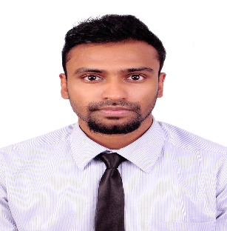

Profile Summary
Name : DANIEL
Email : DANIEL.373899@2freemail.com

Nationality : Indian

Date of Birth: 13th April 1994

Marital Status: Single

Visa Status : Visit

Languages : English, Hindi, French, Tamil

Summary

I am skilled communicator; able to maintain cultural sensitivity, establish rapport with members of diverse groups, and promote team cohesiveness. I am also highly organized and independent; able to effectively coordinate tasks to accomplish projects with timeliness with creativity, high-energy, confident professional with an infectious enthusiasm for technology. I am Creative, resourceful and flexible, able to adapt to changing priorities and maintain a positive attitude and strong work ethic.

Achievements
Attended MUN Conference in Harvard, USA Supervised teams for various conferences.
Attended Pacific air and traffic Association (PATA) conference. Extracurricular activities has organized cultural programs at school and interschool level.
Participated in debates, public speaking and stage shows.
Participated in National Seminar on Incredible India.
Coordinated for Different College events
Education Credentials
High school  Our Own English High School, Abu Dhabi,  United Arab Emirates | [2008-2010]
Secondary Schooling  Oneida Baptist Institute, Kentucky,  United States of America  Bachelors of Arts (Tourism and Journalism)  Garden City College, Bangalore University, India. | [2010-2012]  [2013-2016]
CERTIFICATION:  Diploma certification in “Microsoft Computer Web Designing”, Bangalore, India | March 2013-  June 2013

Key Competencies
. Microsoft Office
. Focus on diverse responsibilities
. Fast learner
. Safety-oriented
. Global traveller
. Team player
. Conflict resolution
. Adaptable
. Organized

Job experience
Worked in the administration section of Healthcare Infoxchange India Pvt. Ltd in Bangalore, as the Senior Service Customer Associate, where I provided healthcare services using a range of IT solutions that enable organisations to integrate diverse system, translate data, enhance workflow, and improve overall administrative efficiency.
Worked temporarily in part time jobs at call canters for 5 months.

I, hereby declare the above details are accurate and authentic, and the above information is true to the best of my knowledge. I will be glad to provide you with my academic certificate copies and references.
Please review my resume and consider my candidature. I am confident of my abilities, hard-work and inter-personal skills. I look forward to attending an interview with you so that my abilities can be assessed to match a position suitable. Thank you for your time and consideration.

Thanking you,
Respectfully yours,

