SHILPA
SHILPA.373909@2freemail.com

Adminisrator/Executive/Lecturer

EXPERIENCE

ExecutiveforTechnicalAidedTeachingand Tutor

Mahesh P.U College

r 2014 - 2015 + INDIA

Educational Institution

Provided all the required databases on time.

Identified and Organised fild trips to enchance curriculum.

MOSTPROUDOF
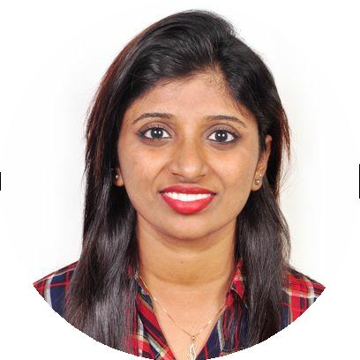

P Whatareyoumostproudof?

I speak upto 6 languages namely English ,

Hindi ,Malayalam, Tamil, Telugu, Kannada

P Whatareyoumostproudof?

I am proud of what I am and my greatest achievement in life is yet to come as iam interested in learning many skills.

LecturerinMathematics

Vikas P.U.College

r 2014 + India

Educational Institution

Developed discipline plans and motivated students.

Provide individualized instructions to all students at expected skill level.

LANGUAGES

Language
Native

Language
Native

EDUCATION

M.Sc in MATHEMATICS with 54% GPA

MangaloreUniversityCollege,Mangalore 4 / 6.00

r 2014
PROJECTS

Teachers Development Counselling

Program

B.Sc in PHYSICS,CHEMISTRY |  |  | r 2017 + India
 |  |  | I
AND MATHEMATICSwith |  | GPA | Employed differentiated teaching methods in
71.16%
 | 5 | / 6.00 | both audio and visual classes to address
CanaraFirstGradeCollege,Mangalore |  |  | differentlearningstyles.
r 2012

P.U.C(PCMB)with53.16% | GPA
Besant National Girls College , Mangalore | 4 / 6.00
r 2009
Counselling andorganised various events

r Date period + India

Provided individual instruction to all students Motivated them by teaching different and

S.S.L.C with83.36% |  | GPA |  | easy way of learning
KeralaSamajamEnglishSchool | 5.65 | / 6.00 |  | Conductedseveralscienceandculturalevents
r 2007

EDUCATION

DIPLOMA IN COMPUTER APPLICATIONS

GPA

Keonics Learning Centre | 6.00 / 6.00
r 2014

TECHNICAL SKILLS

DIPLOMA IN COMPUTER APPLICATIONS

Expert in computer field such as MS Word, Excel, Powerpoint,Oracle,Java,VB,C++ and many more

Excellent in English typing

Teamwork,Educational Seminars,Online Teaching,Public Speaking,Students counseling.

STRENGTHS

Self Motivated Dedication Confident Analytics Team working Flexilbilty

Good communication Hardworking

Dependability

Ability to learn and grasp new techniques and changes.

PERSONAL DETAILS

GENDER : FEMALE

DATE OF BIRTH : 01-06-1991

MARITAL STATUS : UNMARRIED

VISA STATUS : VALID UPTO NOVEMBER 7 , 2017

NATIONALITY : INDIAN

RELIGION : HINDU

LANGUAGES KNOWN : ENGLISH ,HINDI,MALAYALAM ,TAMIL, KANNADA,TELUGU

DECLARATION:

I hereby declare that all the above information is true and correct to the best of my knowledge and belief.

THANK YOU

