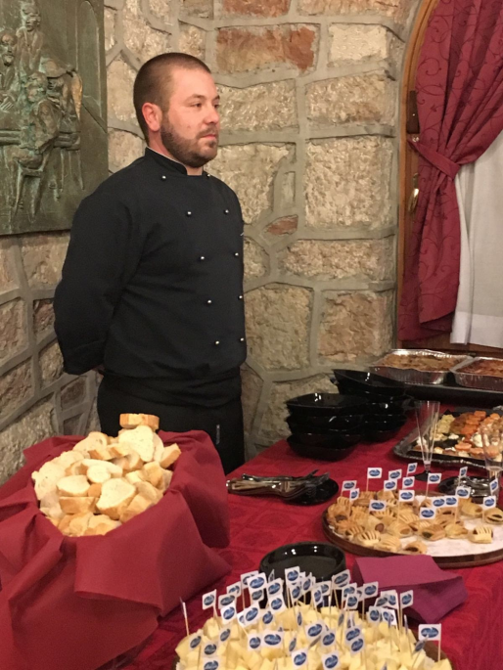  SKILLS  Italian cooking  Cooking methods  Implementing recipes  Food preparation  Ingredients preparation  Time management  PROFESSIONAL KNOWLEDGE  Food and workplace hygiene  First Aider  Languages:  Italian: mother tongue  English: level B2  French: level A1  PERSONAL QUALITIES  Creative flair  Very motivate  Determined to learn  Good communicator and motivator  Excellent storage  Personal cleanliness  Great dexterity  PERSONAL DETAILS  Matteo  Courrent Job at the Rifugio Campolongo in Rotzo (Vicenza, Italy)  Driving license: A (motorcycle) and B (car)  Nationality: Italian | Matteo  Matteo.373934@2freemail.com  Cook  PERSONAL DESCRIPTION  I’m a pleasant, determined, young person (32 years), who likes to work hard. I have a great love for food and cooking makes me happy, but it's seeing the joy of those who eat that I cooked my bigger satisfaction.  Cooking for me is a passion that was born as a child in the kitchen of my grandmother, trying to copy recipes and processes.  For all these reasons, my aspiration of life is fulfill myself and grow in this work.  QUALIFICATION  2001: Diploma in hotel management school in Recoaro Terme (Vicenza)  2001: Regional course for Technician of catering services at hotel school  2003: Course and obtaining the certificate for the use of forklifts and lift trucks  2008: Rescuer certificate issued by AIS (Rescuers Italian Association)  2013: Course for safety in the workplace (8 hours)  2014: Course for safety in the workplace (8 hours)  WORK EXPERIENCES  2000-2002: Cook at the restaurant - pizzeria “Chalet Norda” in Valli Del Pasubio (Vicenza)  2003: Cook at the restaurant “Villa Pasubio” in Valli del Pasubio (Vicenza)  2004: Cook in Hotel “Orthal” in Asiago (Vicenza)  2005: Warehouse at the company that makes cheese “Casearia Tisato” in Schio (Vicenza)  2005: Cook in “Hotel Milano” in Asiago (Vicenza)  2006: Cook at the restaurant- pizzeria “Baita Azzurra” in Treschè Conca di Roana (Vicenza)  2016: Cook at the Gran Cafè Adler in Asiago (Vicenza)  courrent job: Cook at the Rifugio Campomulo in Rotzo (Vicenza)  INTERNSHIPS  Jolly Hotel Ligure (Torino) whit a cook  Jolly Hotel in Palermo (Palermo) whit a cook  Hospital in Schio (Vicenza) whit a cook.  ABILITY 'AND SKILLS  I'm able to perform the preparation of food under the supervision of Chef. I know the methods of conservation of raw materials and basic industry hygiene rules. Physically fit to lift weights and stand up for long periods of work. Mentally I can work even in stressful situations. Able to communicate well with both superiors and subordinates. I'm highly motivated to work in Your Country.

