Curriculum Vitae

It’s an honor for me to introduce this C.V. with my personal information to apply to work in your group as an employee contributing in the development of this corporation.

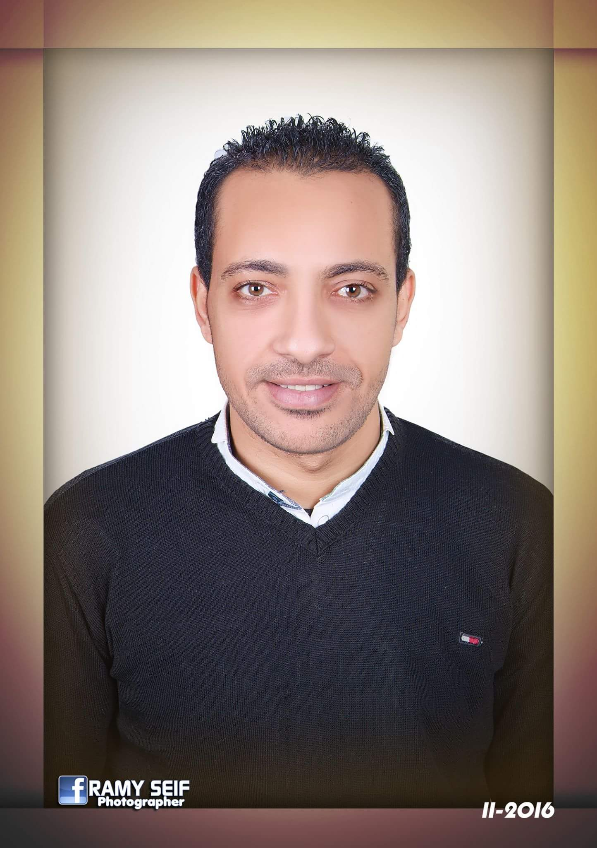

Michael

Presonal information :
Nationality: Egyptian

Marital Statu: Married

Religion: Christian

Visa statu: visit visa for 3 months
Expires date: 28th December 2017

Contact Details

Address: United Arab Emirates

Email address: Michael.373947@2freemail.com
Objective

Work in a challenging environment in a business company or organization in the Computer & network field, maintenance, sales, fundraising or training where I can utilize my capabilities to advance in my career.
I am self-motivated, ambitious and eager to learn. I am a responsible individual with strong communication skills and work ethics besides being creative, focused and highly determined. I am willing to take responsibility and work independently. At the same time, I can work well in teams.
Looking for both personal and professional growth makes me capable of working confidently under pressure. Being bilingual gives me the chance to function efficiently in both English and Arabic.

Education

El Madina Academy
High Institute for Management and Technology,
Bachelor Degree, Information Systems.
Languages

Arabic: mother tongue

English: fluent speaking writing and reading

Computer & software skills
Excellent knowledge of Internet
Excellent knowledge of Microsoft Office
Excellent knowledge of wires and wireless networks
Excellent knowledge of cctv systems
Ability to explain technical issues clearly to non technical colleagues
Extensive knowledge of major networking components & hardware components
- Excellent experience with all operating system (win7 – win8- win10) and server's
Responsible for networking, design installation and maintenan servers and supporting users and network administrators over the telephone and by emails
Maintain the company's network infrastructure
Configuration and testing of any new hardware and software.
Management of the daily data backup and retrieval scheme
Excellent experience with office tell 2017 version
Excellent knowledge of Android phone systems

Communication & Presonal skills
Interactive and fast enough to learn new technologies and sciences
Able to work in group, under pressure, teaching others, helpful, and calm down, high communications skills
Ability to meet deadlines successfully maintaining the quality of work
Work pressure, Co-operative, Work with the team, Ambitious, Self-confidence and Skills to learn quickly
Ability to be clear & concise when explaining technical procedures to customers

Presonal skills

Typing Skills

English: Excellent
Arabic: Excellent

Work Experience.

It director
3 years ( from August 2007 until March 2010)
Company: Te data company for Internet services
Country: Egypt
In 2007 I started my career as It director for Te data company for Internet services I was leading a team contains 7 persons we was responsible for all technical problems hardware and software also I was responsible for the company's network infrastructure and servers

Customer service & call center
Te data company
4 years ( March 2010 untill November 2014)
Country: Egypt
In March 2010 I upgraded to customer service in Te data company in this feild of work responsibly was little bit bigger because we must answer all customers phone calls and handle all kinds of Internet troubleshooting they facing like connection slow or disconnected reception customer if they came to our branch. Sometimes customers came to us and they are very angry so we have to so calm whatever we heard and in November 2014 I leaft the company

Sales manager
Nileherbal Co. for exp & imp
3 years experience ( July 2014 until sep 2017)
Country: Egypt
In July 2014 I changed my career for the first time as a sales manager for export co. My duties was searching for clients and companies throw the Internet and offering our products with prices after that I make the deal and contract
I was managing 3 sales persons untill September 2017

Training & courses
CCNA
MCITP
ICDL
Mctp
Hobbies

Watching decomanteries
Reading

Sports

● Football.

