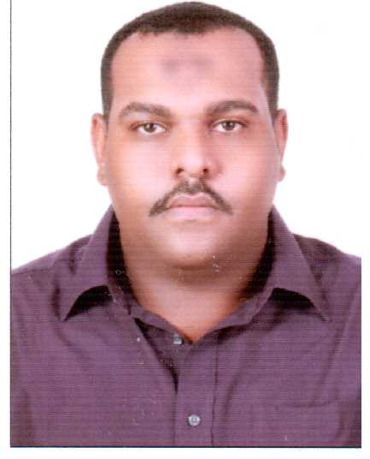
Omer omer.373954@2freemail.com
Summary
- 4 years of professional experience as Sales Supervisor
- Basic computer knowledge/technological skills
- Good verbal and oral communication skills
- Ability to comprehend, capture as well as interpret basic customer information
- Ability to treat people with respect under all circumstances, instill trust in others besides upholding the values of the organization
- Sound judgmental powers; ability to manage difficult customer situations, to respond promptly to the needs of the customer, solicit feedback to improve service, respond to requests for service/assistance
- Ability to adapt to change, meet the changing demands of the work environment, any delays or other unexpected demands.
- Dependability; to follow instructions as well as take responsibility for their actions and also keep commitments
- Analyze the various parts of a problem properly and develop logical solutions
- Quality management- look for means of improving as well as promoting quality
- Ability to make efficient use of resources
- High level of motivation
- Ability to work well as part of a team- to exhibit objectivity and be open-minded towards the ideas and views of others, give as well as welcome feedback, contribute to building team spirit, aid others to succeed
- A sound knowledge of telephone etiquette & good social skills
- Ability to meet tight deadlines

Professional Experience
Feb 2013 - Present Khartoum, Sudan

Alzawawi for Advanced Business Co. LTD
Sales Supervisor
- Coordinating and supervising the day-to-day sales efforts of the team.
- Assisting Account Executives in the preparation of proposals and presentations
- Training and coaching team members on selling techniques.
- Leading, directing and motivating the sales team.
- Presiding over weekly staff meetings.
- Field training new sales representatives.
- Maintaining accurate records of customer contracts
- Attending all company departmental and general meetings
- Completing all sales paperwork.
- Carrying out staff performance reviews.
- Addressing individual and group training needs.
- Gather market and customer information and provide feedback on buying trends
- Represent Alzwawi organization at trade exhibitions, events and demonstrations
- Identify new markets and business opportunities
- Tracking the sales and publish the team report
Education
- B.Sc.(Business Administration) -Emirates College of Technology – Khartoum -Sudan 2012
- High School Certificate, UAE 2003

