EQUIPMENT SKILLS
Radiology/Diagnostic Equipments:
- Computed Radiography
- Digital Radiography
- CT-SCAN
- MRI
- Ultrasound machine
- X-Ray machine
- Mammography
- Pacemaker
- Pressure Injector
- TMT
- EEG
- EMG
Dental Equipments:
- Dental chair
- Dental x-ray
- Dental image processor
- Light cure
General equipments:
- Multi Para monitors
- Defibrillators
- Ventilators,
- Syringe pumps
- infusion Pumps
- ECG Machine
- Nebulizer
- phototherapy unit
- Echo screen

OT Equipments:
- Anesthesia machine
- diathermy
- laparoscopic unit
- OT light
- OT table.
SUDHAKAR

BIOMEDICAL ENGINEER

SULTAN QABOOS HOSPITAL
SALALAH, OMAN.

Email id: Sudhakar.373967@2freemail.com

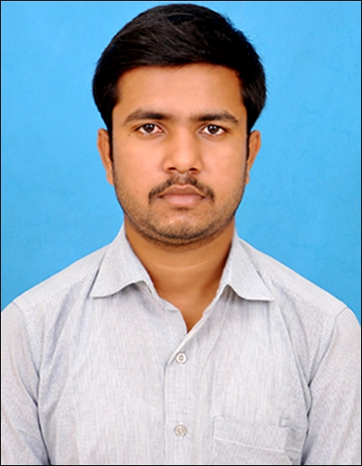

SUMMARY:

- An astute professional with around 6.3 years of good experience in the field of Biomedical Engineering.
- Commissioned new equipment as well as performed corrective maintenance of medical equipment in the hospital.
- Responsible for performing complex tasks pertaining to maintenance of Bio-Medical equipments.
- Investigating safety- related incidents while installing the medical equipment.
- Ready to accept all challenges and assignments which will be assigned to me in the organization, with sincere responsibility.
- Good Knowledge in repair, routine check and calibration of critical care equipment as per ECRI standards.
- Experienced in product demonstration and user trainings.
- Ability for liaising closely with medical professionals such as doctors, therapists etc.

EDUCATIONAL QUALIFICATION:
- Bachelor of Engineering (B.E) in Bio-Medical Engineering (2008 to 2011) With 81.10 % - from Anna University, tamilnadu, India.
- Diploma in Electronics and Communication Engineering (2006 to 2008) with 87.62 % - from Kongu Polytechnic College, tamilnadu, India .
- H.S.C (Higher School Certificate) (2004 to 2006) with 71.6% - from BKN Higher Secondary School, tamilnadu, India.
- S.S.L.C (Secondary School Leaving Certificate - 2004)
With 81.6 % - from BKN Higher Secondary School, tamilnadu, India.

PROFESSIONAL EXPERIENCE:
TEST EQUIPMENTS HANDLED:

1. ECG SIMULATOR
MFG: RIGEL
MODEL: 333
2. VITAL SIGN MULTI CARE STIMULATOR
MFG: FLUKE
MODEL: PROSIM-8
3. DEFIBRILLATOR ANALYZER
MFG: RIGEL
MODEL: UNI-PULSE
4. VENTILATOR TESTER
MFG: IMT MEDICAL AGENCY
MODEL: PF-300
5. ELECTRICAL SAFETY ANALYZER
MFG: RIGEL
MODEL: 288
6. ELECTRO SURGICAL UNIT ANALYZER
MFG: RIGEL
MODEL: UNI-THERM
7. INFUSION DEVICE TESTER
MFG: RIGEL
MODEL: MULTI-PRO
8. NIBP TESTER
MFG: RIGEL
MODEL: BP-SIM
9. PULSE OXIMETER SIMULATOR
MFG: RIGEL
MODEL: SP-SIM
1. HOSPITAL : SULTAN QABOOS HOSPITAL (UNDER ONEIC), SALALAH, OMAN. POSITION : BIOMEDICAL TECHNICIAN DURATION : JUNE 2014 TO OCTOBER 2017
Job description:
- Effectively manage and coordinate activities of the Biomedical Engineering Department to include the evaluation, replacement, service and repair of complex biomedical equipment, administer policies and procedures applicable to efficient operations.
- Direct all aspects of maintenance and repair of the equipment, as well as ongoing training and education of staff related to safe medical device uses and practices.
- Provide first hand support to the medical equipment’s during their breakdown and normal maintenance.
- Handling of different safety analyzers. Direct and manage preventive maintenance on medical equipment, through adjustment or replacement of items on a scheduled basis to prevent equipment failures.
2. HOSPITAL : SRI RAMACHANDRA HOSPITAL AND RESEARCH INSTITUTE, INDIA. POSITION : BIOMEDICAL ENGINEER DURATION : MARCH 2013 TO JUNE 2014
Job description:
- Attending medical equipment breakdown calls from various departments of the hospital. Carried out preventive maintenance for all type of equipment as per JCI&NABH standards. Was involved in In-House maintenance of more than 90 % of the equipment.
- Assisting procurement team on quality and involving in negotiation with vendors on purchase of equipment & accessories .Conducted periodic training to doctors, nurse, technicians on handling equipment.
- Coordinate with the agencies for spares and service support. Advice administration on matters pertaining to equipment’s purchase, performance, financial provisions etc.
3. COMPANY : VIVID HEALTH CARE (FUJI FILM MEDICAL SYSTEM), CHENNAI, INDIA.
POSITION : FIELD SERVICE ENGINEER
DURATION : JUNE 2011 TO JANUARY 2013
Job description:
- Had a role of service engineer for installation and trouble shooting of computed radiography machines.
- Carried out preventive maintenance as per the schedule.
- Collaboratively work with sales and service team to ensure successful work and satisfied customers.
- Configure the CR system with different imaging modalities and DICOM imaging software.
- Got an opportunity to extend my demo skills.

PERSONAL DETAILS:
DOB : 5th June 1989
Gender : Male
Marital Status : Single
Nationality : Indian
Linguistic : English & Tamil, Malayalam & Hindi.

RESUME DECLARATION:

I hereby declare that above furnished details are true to the best of my knowledge. I am an excellent choice because I am fortunately blessed with team work, patience, positive mental attitude and hard working. My passion for saying the word as well as working in the service industry, sleds me to look for an opportunity in a reputable organization.

PLACE:
DATE:

