From,
Nadeem
Civil Engineer
Pakistan Email: Nadeem.374000@2freemail.com
Visa Status: Visit Visa Expiry Date of Visit Visa: Dec 15, 2017

Project: Site Engineer, Estimation Engineer with 4 years of GCC Experience.

Dear Sir/Madam,
I am B.Sc. Civil Engineer from University of Engineering and Technology, Taxila. I am specialized in Estimation, Quantity Take off, Reinforcement quantity for estimation and execution, BOQ Preparation, Data Preparation, Project Planning and Site Management.

Currently, I am in UAE on visit visa.

I look forward to a challenging career opportunity in a progressively growing organization in order to utilize my extensive skills and capabilities. I have enclosed my detailed CV for your kind perusal. If selected I assure you that I will satisfy my supervisors and Project Managers with my hard work and sincere services.

Thanking you and expecting a positive reply.

Curriculum Vitae
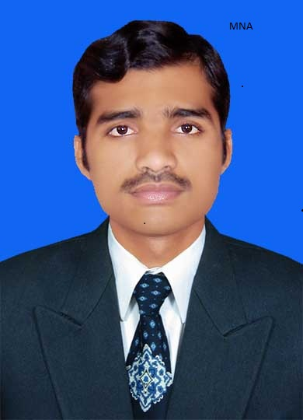
Civil Engineer

Personal Information:
Name: Nadeem
Nationality: Pakistan
Religion: Islam
Date of Birth: 25-12-1992
Professional Summary & Objective:
Having Bachelor degree in Civil Engineering and work experience as site engineer, estimation engineer, quantity surveyor and quality controller. Seeking for a stimulating position in a progressive organization where I can learn and share my abilities and knowledge.
Professional Qualifications:
Degree/Certificate | Passing Year | Percentage | Institution
B.Sc. Civil Engineering | 2013 | 70.75 | University of Engineering & Technology, Taxila.
Pre Engineering | 2009 | 86.18 | Superior Science Higher Secondary School Muzaffar Garh.
Matriculation | 2007 | 91.88 | Superior Science Higher Secondary School Muzaffar Garh.

Professional Experience: 4 years
Having 4 years of working experience on various well reputed construction organizations as responsible management position to manage the site staff, control project activities, supervision of all construction works and execution of work as per drawings and quality control as per satisfaction of consultants and clients.
From 02-07-2014 to 26-07-2017
Country: Saudi Arabia
Company Name: Al-Rajhi Building & Construction Company.
Designation: Site engineer, estimation engineer
Project Name: Technical College for girls, Sabt Alalaya-Bilqern.
Specifications of Project:
Total area of project is 55000 square meter.
No. of buildings= 10
Main building consists of class rooms and laboratories and other surface buildings includes water tank, septic tank, security rooms, guard houses, electric and generator room and boundary wall.
Cost of project: 100 million Rials (approximate)
Duties & Responsibilities:
- Preparation of measurements sheets and assists in quantity take- off for tenders as per the specifications.
- Preparations of cost estimates as required.
- Preparations of Reinforcement schedule for estimating quantity.
- Monitors and records site progress and maintains records of day work.
- Assist in claim preparations in coordination of project manager/ director.
- Monitoring the performance of workers, Sub-Contractors Site activities.
- Develop complete work at site to start the site activities efficiently.
- Controlling and guiding heavy Equipment pipes fabrication& erections.
- Monitoring daily observations and preparing statistic reports for further improvement.
- To coordinate with the Engineer’s representative for the execution of works.
- Resolving any unexpected technical difficulties and other problems that may arise.
- Knowledge of Using Total Station for Building Coordinates.
- Preparation of BOQ bill every month according to site progress.
- Have knowledge of detail calculations of BOQ items according to approved drawings and comparing quantities with consultant engineer.

Technical Skills:
- Excellent Management
- Presentation Skills
- Convincing Power
- Labor allocations
- Coordination over project planning

Computer Proficiency:
- Proficient at working with AutoCAD.
- Proficient in the usage of MS office. (word, excel, power point)
Languages Known:
English, Arabic, Urdu, Punjabi, Seraiki
I hereby declare that all the provided information is true to the best of my knowledge and belief. Reference will be furnished on demand.

