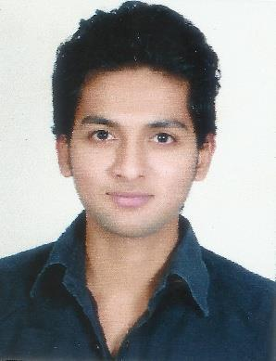SABIR

MECHNICAL ENGINEER

E-mail:- sabir.374004@2freemail.com

SUMMARY
To work in a firm with a professional work driven environment where I can utilize and apply my knowledge, skills which could enable me to grow while fulfilling organizational goals.

EDUCATION
May 2016 | B.E Mechanical | Aug. 2016 to Nov 2016
to | Pune University | P.G Course. (Piping Design & Construction)
May 2013 | GRADE 1ST Class. | Autonomous Board (PUNE)
 |  | Grade 1st class.
May 2013 | Diploma Mechanical
to ` | MSBTE
May 2011 | 73.58%
Sep 2010 | I.T.I (Mech. Draughtsman)
to | D.V.E.T
June 2008 | 69.04%

WORK EXPERIENCE
Dec 2016 Design Engineer

To Global Engineering Services.

Aug 2017 Client: PrajHipurity.

Responsibilities:

- G.A drawing of equipment & Fabrication drawing

- Thickness calculation of pressure vessel as per ASME SEC VIII DIV.1

- G.A preparation and detail engineering of skid mounted pressure vessel.

- Comment incorporation as per client.

- Bill of material as per the approved G.A.

- Familiar with PV Elite & U type heat exchanger.

Oct 2010 INTERNSHIP

To ThyssenKrupp Pvt. Ltd

June 2011 Responsibilities:

- Updating the overall plot plan.

- Modification of the piping layout.

- To read isometric drawing with MTO.

- Preparation of As-built drawing.

- Familiar with the code and standard.

- Wall thickness calculation as per ASME B31.3

- Preparation of material specification as per the process requirement.

INTERPERSONAL SKILLS
- Ability to rapidly build relationship and set up trust

- Confident and determined

- Ability to adjust myself in different situations.

SOFTWARE SKILLS
- AUTO CAD 2D/3D

- PDMS

- PV Elite

- 3DMAX

- MS OFFICE

PERSONAL DETAILS
Date of birth | 21st-june-1992
Language known | English, Hindi & Marathi.
Marital status | Unmarried.
Nationality / religion | Indian/ Islam
DECLARATION
I do hereby declare that the above information is true to best of my knowledge.

PLACE:- ……………

DATE:- / / MOHHMED

