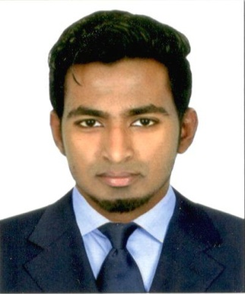

Deric

E-mail Id: deric.374029@2freemail.com

Objective
A Mechanical professional seeking challenging opportunity to work for a renowned organization to enhance my knowledge, skills and techniques which can benefit the organization.

Education

DEGREE/COURSE | BOARD/  UNIVERSITY | YEAR OF PASSING | PERCENTAGE or CGPA
B.Tech  (Mechanical Engineering) | Manipal University,  Dubai. | 2010-2015 | 6.0 *
12th  (C.B.S.E) | Sharjah Indian School,  Sharjah. | 2008 | 59.8 %
10th  (C.B.S.E) | New Indian Model School,  Sharjah. | 2006 | 75 %

*CGPA out of 10

Work Experience

- Worked as an Assistant Manager at Auto Field Car Repair Workshop for a period of 2 years (2014 -2016)

Key Functions
- Supervision and purchase of required vehicle parts.
- Marketing the products and services to the best clients around.
- Coordinate and arrange the workers with their job.
- Establishing relation with the customers.
- Construct and administer all official documents.

Projects and Internship

- B.Tech Project
Individual Project titled as “Optimization of Solar Panel by using Water Cooling System”.
The project aimed at cooling the solar panel with water cooling system thereby increasing the power produced by the solar panel.
- Collaborated with 2015 batch final year project -“Implementation of Anti-lock Braking System in dune buggy”. This project aimed at fixing an Anti-lock Braking System onto a dune buggy as a safety measure.

- Collaborated with 2014 batch final year project- “Fabrication of Go-Kart with Continuously Variable Transmission”. The project aimed for power enhancement of a go-kart by fixing a CVT system onto a single cylinder, 160cc Honda engine and also in fabricating the Go-Kart.
- Worked as an intern at Ashok Leyland UAE LLC for a month in the production department.

Part-Time Work

- Gitex 2012 – 2013 (worked for HP in sales)
- Gitex 2013 - 2014 (worked for E-max in sales)

Achievements

- Best Individual Musician 2015: True Music School – Awarded by Sony Music
- Best Guitarist Title 2015: Nescafe ‘ Ignite
- Best Musician Of Batch 2012-2013 & 2013-2014: Manipal University Dubai

Computer Skills

- MS Office
- AutoCAD
- Creo

Core Strengths

- Expertise in Computer-Aided Design software for preparing drafts, sketches and 2D/3D design concepts of new mechanical products and machinery equipment
- Attention to details and problem-solving skills
- Ability to Multi-task
- Good communication skill and advanced organizational skills
- A team player

Hobbies

- Playing Musical Instrument: Guitar and Keyboard.
- Playing Basketball.
- Photography.

Other Details

Nationality : Indian
Sex : Male
Date of Birth : 12th May 1992
Marital Status : Single
Visa Status : Visit Visa
Language : English, Hindi and Malayalam

Has a valid UAE Driving License till 14-08-2023

Reference

Available upon request

Declaration

I hereby declare that the above furnished information are complete and accurate to the best of my knowledge.

