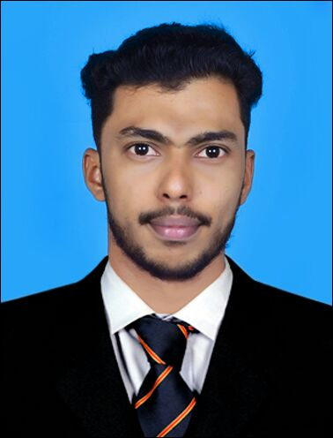
Abdul

Dubai (UAE)
Email: abdul.374033@2freemail.com
Position Desired: - Auto Cad Electrical Draftsman

Objectives

To obtain a challenging position with a growing company that will provide an opportunity to utilize my knowledge of computer aided drafting /design continuing my personal and professional growth, where my positive attitude, integrity and strong desire to succeed will contribute to the company’s success.

Key Strengths:
Able to work on projects from the Concept Design Stage to Tender Stage. Preparation of all type of Electrical Design drawings, Detail Drawing, Production of works mainly on Electrical Design development projects, Elevations Cross-sections as per DEWA rules and regulations. I can work under pressure and meet deadlines without sacrificing quality of output.
Profile Summary

- 2 & Half year Experience in AutoCAD Draughtsman in India including Some UAE projects as outsource.

Have excellent communication & interpersonal skills.
- Young, energetic & enthusiastic individual.
- Can work under pressure & meet deadlines.
- Willingness to learn even from the scratch and able to work with a team.
- Good communication skill, Positive Attitude, Sincerity & self-confidence
Work Experience
- Working as an Draftsman (MEP-Electrical) for period 2016 To 2017 (1-Year)
with ATECO (Al-Dhafra Trading Enterprises Company), Dubai-UAE

- Designing and preparing electrical all layouts independently
- Preparation of detailed design drawings.
- Preparation of plans in AutoCAD, Revit etc...
- Preparation of Electrical layout drawing such as Lighting, Power, Fire Alarm,
Structured Cabling, CCTV, Access control, Central battery systems & all types of risers, schematic diagram.
- Reviewed and corrected electrical designs as required.
- Conduct site visits to understanding/ensuring the accuracy and correctness of drawings.
- Explain drawings to production or construction teams and provide adjustments as necessary.
- Ability to producing details of highest quality and clarity.
- Ability to maintaining high drafting standards and have experience in working with blocks/layers/x-ref systems.
- Knowledge of doing work according to Municipality Rules & Regulations.
- Knowledge of doing work according to DEWA Rules & Regulations.
- Having good experience to make fast & neat drawings manually.
- Thorough knowledge and speed in producing drawings in latest versions AutoCAD and should have good knowledge in tools/commands/options.
- Collaborated effectively with engineering team

Project Designed & Involved From 2016 to Percent
- Al Raha Mall-Abu Dhabi
- Khalidiya Mall-Abu Dhabi
- Lulu Market in AUH
- ADEC( School)Phase 1, 2 & 3
- Habtoor City Residencies-Business Bay- Dubai
- Aloft -Jabel Ali
- Sahara Mall- Al Nahda-Dubai

2. Worked as an AutoCAD Draftsman for period 2012 To 2014 (1 & Half Years) with
Buildex Architect Engineering Planners (Kasaragod, Kerala, India) on following assignment
- Prepared Civil Drawings for Villa, Shops outlet etc. as per Engineer Instruction.
- Design Lighting Layout Diagram
- Design Power Layout Diagram
- Create and modify solid models and detailed drawings from sketches, models, layouts or notes provided by design/engineering.

Academic background:

- KERALA GOVERNMENT CIRTIFICATE EXAMINATION IN ENGINEERING (KGCEE)
Diploma in Electrical Engineering &Technology (Jul 2014 to Apr 2016)
  - Grotek Industrial Technical Institute, Kerala, Kanhangad

- HSE (Higher Secondary Examination in March 2011)
  - Academic Higher Secondary School, Kumbala, Kasaragaod

- SSLC (Central Board Of Secondary Education-CBSE In May-2009)
  - MES Kunil School, Muttam, Shiriya, Kasaragod.

Computer Skills:

- AutoCAD 2D &Revit Diploma in MEP Designing
- Cad Center Training Services (Kasaragod)

- DTP, MS office and MS excel from QIIT Computer Institute
- (Corel Draw, word Excel, PPT)

- Advanced Diploma In Hardware & Networking (ADHN)
- (Cisnets Technologies)
Training Certification:
- WIREMAN (All India Technical Education Society)
- ELECTRICAL ENGINEERING DIPLOMA (All India Technical Education Society)
- ELECTRICAL ENGINEERING (Grotek Industrial Technical Institute)

Language:
- English
- Hindi
- Malayalam
Personal Information:

Date of Birth : 1st August 1993
Status : Single
Nationality : Indian (Kerala)
Visa status : Visit Visa Long Term
Passport Religion : Islam

Declaration:

I hereby declare that all the above furnished information is authentic and true to the best of my Knowledge and belief.

Abdul

