Mechanical Engineer
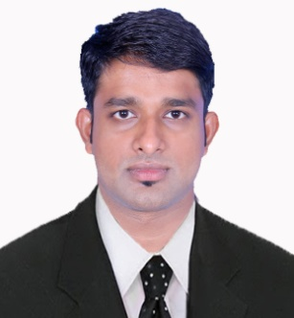

JOJU

Btech & Diploma in Mechanical Engineering
E-mail: Joju.374036@2freemail.com
Dubai
CAREER OBJECTIVE
To work in a firm with a professional work driven environment where I can utilize and apply my knowledge, skills which would enable me as a fresh graduate to grow while fulfilling organizational goals.
EXPERIENCE
ACTUTECH ACTUATOR TECHNOLOGY Pvt.Ltd
Mechanical Engineer (2016-2017)
Via San Lorenzo 70, Italy

Duties & Responsibilities
- Used AutoCAD system to prepare engineering blueprints.
- Execution of jobs according to the drawings.
- Inspection of completed jobs in accordance with the requirements.
- Handling the work safely by obeying plant safety rules.
ACADEMIC CREDENTIALS
Qualification | Board/University | Year | Percentage
B.Tech (Mechanical) | Calicut University, Kozhikode | 2016 | 6.6/10
Diploma (Mechanical) | Anna University, Chennai | 2013 | 83.17%

EXPERIENTIAL LEARNING (SUMMER INTERNSHIP PROGRAM)

    - Company Name : Apollo tires Pvt. Ltd. .
    - Duration : 20.06.2015 to 30.06.2015

PROJECTS UNDERTAKEN
- MAIN PROJECT

- Design of spring loaded hydraulic rail clamp for withstanding wind speed in ship unloader.

- MINI PROJECT

- Power generation from railway station platforms.

IT PROFICIENCY
- Designing Tools : Auto CAD ,Solid works
- Packages :M S Office( Word, Power Point, Excel, Outlook,)Adobe Photoshop
- Internet Browsing

TECHNICAL PROFICIENCY
- Completed Diploma in PROCESS CONTROL INSTRUMENTATION

INTERPERSONAL SKILLS
  - Ability to rapidly build relationship and set up trust.
  - Good knowledge in mechanical design techniques.
  - Ability to design mechanical structures according to the requirement.
  - Good command over English, Italian & other Indian languages
  - Ability to manage my available resources (manpower, time, equipment)
  - Confident and Determined
  - Ability to cope up with different situations.

PERSONAL DETAILS
- Date of Birth : 10-08-1992
- Sex : Male
- Language Known : Malayalam ,English & Hindi
- Marital Status : Single
- Nationality/Religion : Indian / Christian

PASSPORT DETAILS
- Passport number : P0810899
- Place of issue : Cochin
- Date of issue : 04-05-2016

DECLARATION

I do hereby declare that the above information is true to the best of my knowledge.

Yours Sincerely

JOJU

