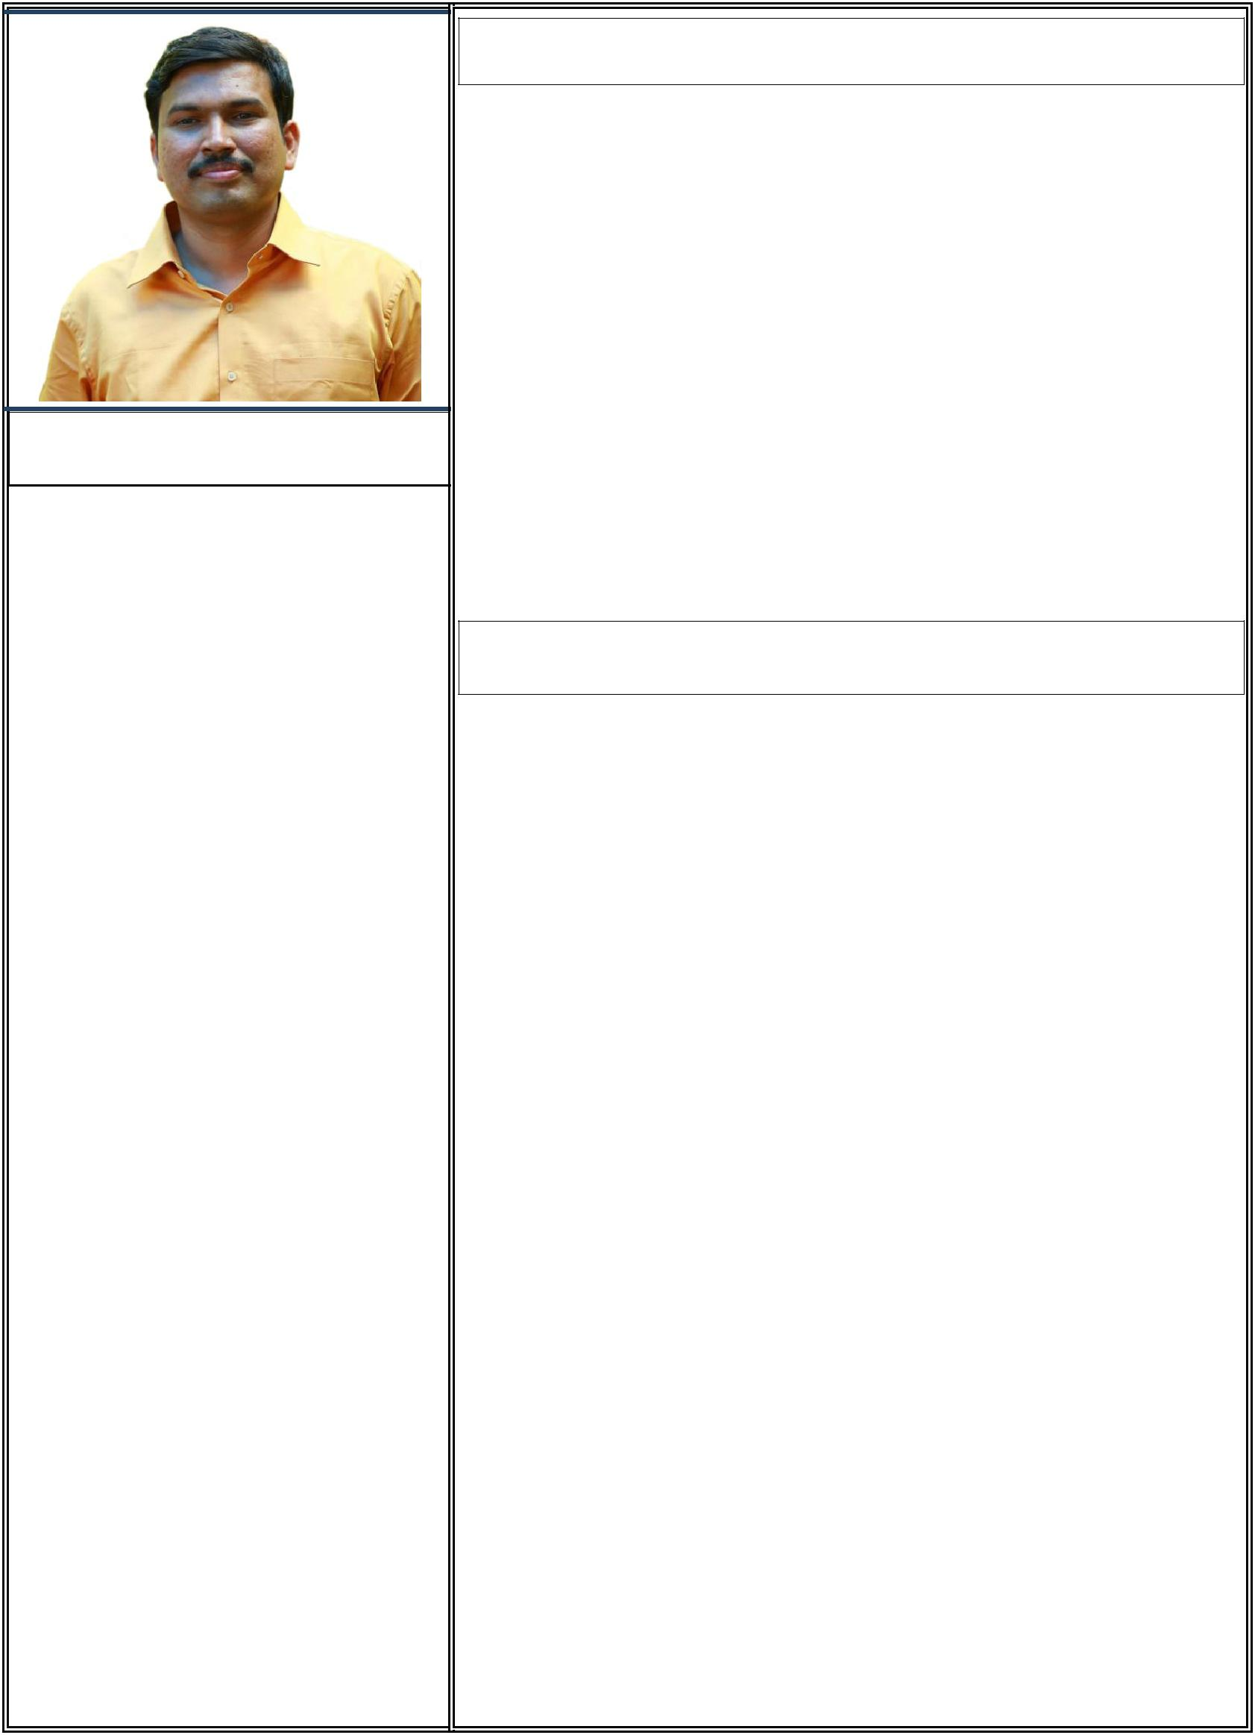

SUBHASH

PERSONAL DATA

Nationality: Indian
Passport No: M3695099
Place of issue: Riyadh
Passport validity: 25-11-2024
Date of birth: 9th February, 1977
Gender: Male
Driving License: India & Saudi
Language Known: English,
Hindi, Malayalam, Telugu

E-mail: subhash.374038@2freemail.com

EDUCATION

Bachelor of Arts in Economics,
Calicut University

Pre Degree (+2), Calicut University
Secondary School Leaving Certificate
Board of Public Examination - Kerala

AWARDS

National Service Scheme Campaign & Tableau – Calicut University Pencil Drawing & Film songs –
School & Village Arts Festivals

PROFILE SUMMARY IN BRIEF

Hands on 15 years in General Administration functional expertise.

A competent and pleasing personality with excellent communication, organizational and interpersonal skills.

Highly efficient, dedicated, hardworking and talented graduate.

Possessing good team spirit, deadline oriented and enhances

corporate development.

Sincere, trustworthy, professional and passion to learn and grow

with the company.

PROFESSIONAL WORK EXPERIENCE

1. KAEFER SAUDI ARABIA – |  | AL KHOBAR
Administrative Coordinator | Mar 2009 – Till Date
2. MITHRA AGRICULTURAL PRODUCER CO. - |  | KOCHI
Administrative Assistant | Aug 2005 – Jan 2009
3. S.N CHARITABLE TRUST & JYOTHIS COMPUTERS
Office Assistant - Thrissur & Kochi. | Nov 2002 – Aug 2005
4. AKSHARA ENGLISH MEDIEM SCHOOL – |  | HYDRABAD
Teacher | Sept 2000 – Oct 2002
5. FOCUZ AUTOMOBILES CO. LTD. |  | MANGALORE
Clerk Cum Data Entry Operator | Aug 1999 – Aug 2000

SKILLS & ABILITIES

IT Skills – MS Office, Photoshop, ERP & E-mails Flexibility – Controlling Multiple Assignments Organisational & Interpersonal Skills Excellent Communication Skills

Customer Relationship building - Serve, Support & Satisfaction Time Management – Reliable and Punctual Record Maintenance and Data Entry Skills

TRAINING UNDERGONE

KEY ROLES & RESPONSIBILITIES

First Aid and CPR Training

Top Performers & Team Building Lean Management Training

ACHIEVEMENTS

Art work of “Mr. MAX” –

A Safety Mascot in connection with Health and Safety day in KAEFER.

Art work of “SUSTAINABILITY” – related to Environmental, Social and Cultural day in KAEFER.

Painting published in KAEFER -

K Flash, Journal

Customer Relationship building Aids Awareness, Health campaign, Employee Welfare & Cultural Programs

INTEREST & ACTIVITIES

- Participating in community welfare

  - Charity programs and

Environmental campaigns.

Pencil Drawing

Photo Editing and designing Listening Music, Movies, Swimming, Singing songs

➢Coordination of supplies include maintenance, Inventory management, logistics, security and related activities.

- Manage safeguard and timely renewal of all important employee related documents.

- Screening and handling telephone communications, greeting and directing visitors, dealing with customer issues and inquiries

as appropriate.

➢Assisting administrative support for hotel reservation and flight booking for senior staff, First Aid and CPR service for all as and when required.

➢Assist in vendor development and ensure efficient office operations and add maximum value to the Organization.

➢Dealing with inside and outside customers to carry out administrative duties effectively.

➢Dealing with incoming and outgoing correspondence, organizing couriers, mail distribution, preparation of documents, photocopying and document binding.

➢Active participate in various health & safety campaign, charity programs, environmental, corporate social responsibility and cultural activities.

References shall be provided at any time

