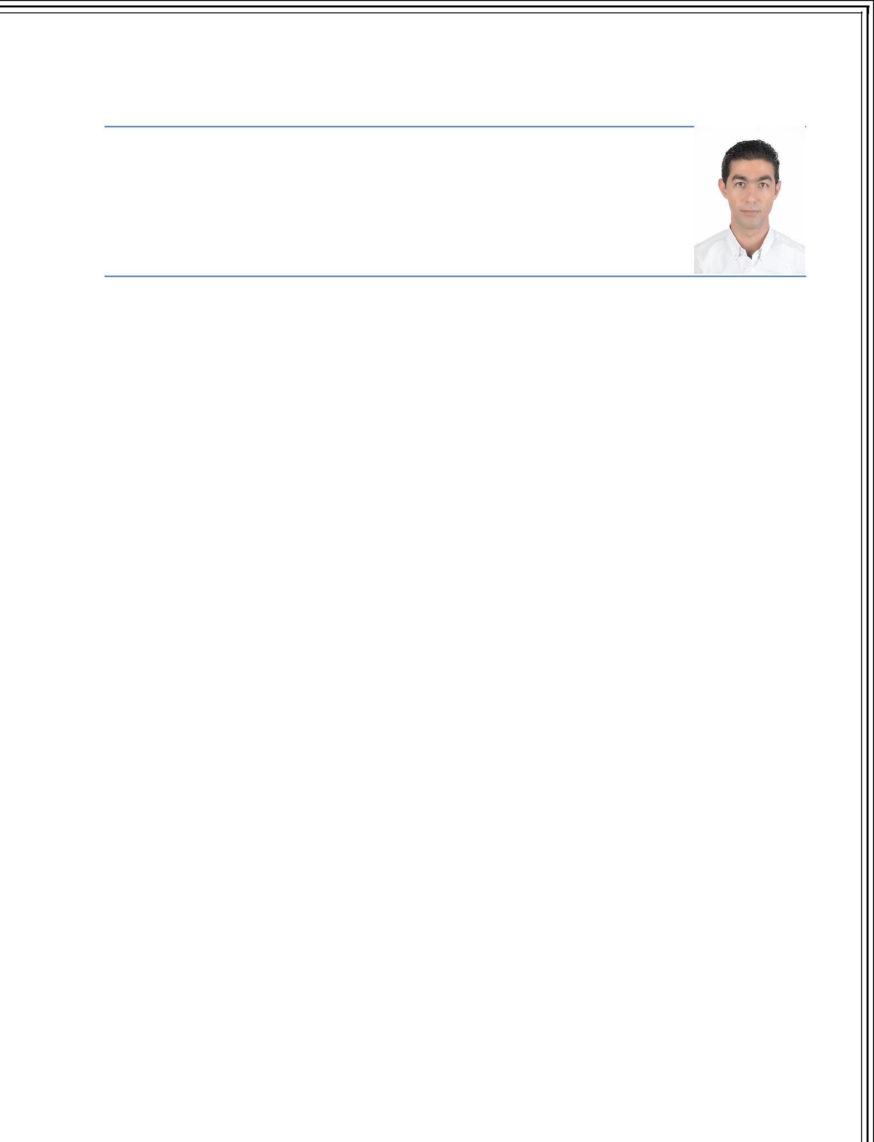
ALAFFAS Email: alaffas.374041@2freemail.com

Address: Dubai, United Arab Emirates
Gender: Male | Marital Status: Married

Date of Birth: 1st Jan 1987 | Nationality: Syrian

Driving License: UAE, Syria

Objective

I have several years of experience in a variety of fields including sales. In addition to my extensive office experience, I have strong communication, customer service, and administrative skills.

Education

Aleppo, Syria

Mamoun Private University for Science and Technology ‘2008

Bachelor in Business Administration

Aleppo, Syria

Commercial High School ‘2004
High School Certificate

Work Experience

Dubai, UAE – Luxury Plus Rent a Car [July 2015 – Present]
- Operations Executive

- Communicating with upper management to develop strategic operations goals.
- Developing strategic long-range plans to achieve strategic objectives.

- Creating and managing the organization’s fiscal operating and capital budget and expenses.

- Monitoring operational performance of both internal and external service providers.

- Monitoring facility condition and environmental performance and recommending or approving funding levels and spending plans.

- Providing a workplace setting that is conducive to productive work.
- Monitoring occupant satisfaction.
- Monitoring construction and renovation projects.
- Monitoring performance metrics.
- Receiving and responding to approvals and notifications.

- Completing bookings and explaining the terms of rental or leasing agreements o Completing paperwork with the customer and taking payments

o Showing customers to their vehicle and pointing out any bumps, scrapes or
special features
o Checking mileage and inspecting for damage when vehicles are returned

Dubai, UAE - Evolia Automobile [October 2011 – July 2015]

- Operations and Office Admin

- Welcomes guests and customers by greeting them, in person or on the telephone; answering or directing inquiries.

- Prepares reports by collecting and information.

- Secures information by completing data base backups. o Sending and replying to emails

o Issue company’s cheques

o Responsible for the overall maintenance of showroom (equipment, offices) o Responsible for printing of office stationeries, including company envelopes,

letterhead, business cards …etc. o Handle courier services

o Deposit (Cash or Cheques) to the company’s bank account o Preparing the daily schedule for the manager

o Finishing cars papers with Dubai Customs and RTA

o Adding new cars, specification sheet, and cars photos to the system o Blocking sold cars to the customers on the system

o Completing all payments with customer
o Delivering the car with the papers to the customer
o Ensure various car types are available in the showroom

Dubai, UAE - Ghassan Aboud Cars [August 2008 – August 2011]

- Office Admin and Manager Assistant
- Welcomes guests and customers by greeting them, in person or on the

telephone; answering or directing inquiries.
- Prepares reports by collecting and information.

- Secures information by completing data base backups. o Sending and replying to emails

o Issue company’s cheques

o Responsible for the overall maintenance of showroom (equipment, offices) o Responsible for printing of office stationeries, including company envelopes,

letterhead, business cards …etc. o Handle courier services

o Deposit (Cash or Cheques) to the company’s bank account o Preparing the daily schedule for the manager

o Finishing cars papers with Dubai Customs and RTA

o Adding new cars, specification sheet, and cars photos to the system o Blocking sold cars to the customers on the system

o Completing all payments with customer
o Delivering the car with the papers to the customer
o Ensure various car types are available in the showroom

Qualifications

Computer Skills

- Internet, E-mails, Microsoft Office
- Proficient in the use of various computer programs and applications

Skills

- Reliable and Responsible

- Management skills, work as a team or group leader

- Strong public relations and marketing skills

- Effective time management skills

- Strong organizational skills and attention to detail.

Languages

- Arabic – Native | English – Very Good

Interests

- Basketball, Swimming

