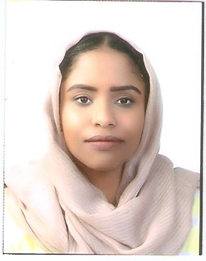
Omnia
Sharjah
Email: omnia.374049@2freemail.com

Summary
Chemical engineering graduate with experience in teaching and inspection field work.
Personal information
Full Name: Omnia
Nationality: Sudanese
Date & place of birth: 11thApril-1994(United Arab Emirates)
Gender: female
Religion: Muslim
Marital status: single
Visa status: On fathers’ sponsorship
Education
2016 B.Sc. (Honours) in Chemical engineering University of Khartoum
First class, Class rank (1st of 68)
CGPA 8.53, GPA: 8.89
2011 High school scientific division Al Shola Private school
Percentage (98.4%)
Work history

January 2017 University of khartoum
– Teaching assistant
July 2017
- Organized grade records to increase reference speed.
- Planned ,implemented ,monitored and assessed tutorial programs which was consistent with the students needs.
- Consistently received positive teacher evaluation from students .
Februaury 2017 Sudanese Standards and Meteorology Organization
– Junior inspector
July 2017
- Ensure quality of export goods durting rotational field trips and issuing export license.
- Kept organized documentation of issued export license for export unit office.
- Oversaw inventory and office supply needs.
Training

2016 New Halfa sugar refinery, Sudan
2015 AL-TAKAMOL Cement plant, Sudan
2015 Atbra Cement plant, Sudan

Skills

Languages Arabic (Native)/English (Fluent)
Technical Computer proficient with advanced level in Microsoft office
Good knowledge of Aspen Hysis and Mathlab
Interpersonal Creative problem solving
Team work skills
Excellent attention to details
Fast learner
Participations

2017 Volunteer in Material science and Nano technology research centre, University of Khartoum.
2015 Attnedee in “Process engineering” workshop, Muse group, Malaysia.
2015 Volunteer in “The Role of techno- pole for engineering graduates” workshop -Techno pole centre, University of Khartoum.
2014 Volunteer in Engineering week, University of Khartoum.
2012 Volunteer in. Tedx Khartoum.
Certifications

- Best Acadmic excellence award in the chemical engineerng department for 2016.
- Best graduation project in the chemical engineering department for 2016.
- “Professinal marketting ” course,Technopole unit of khartoum university.
- Academic IELTS with overall band score 7.5 .
References
Available upon request.

