RIJESH

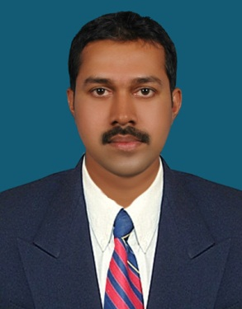

Personal Information:
Age & DOB
34 ; 19-11-1983

Religion
Hindu

Languages known
English
Hindi
Malayalam

Sex & Marital Status:
Male
Married

Passport Details:
Number: P5352615
Date of Issue: 12.01.2017
Place of Issue: Kozhikode
Date of Expiry:
11.01.2027

Driving License Details

M/C with gr
LMV
Valid from-07-05-2010
Valid To -06-05-2030
Place of Issue- Kakanad

Email: rijesh.374052@2freemail.com

CAREER Objective

To seek a challenging position that would enable me to contribute to the organizational goals, to enhance my knowledge and skills which would help me in my professional development and also to contribute to the growth of the organization.

PROFESSIONAL PROFILE
1.K.K. Associates- Accounts Associate: 08-03-2017 to 28-10-2017 (India)
Book Keeping
Bank Reconciliation
Finalization
Prepare Vouchers and Passing entries in Tally ERP-9
General Accounting function
2.Tawoos - Accountant cum Cashier: 17.05.2012 to 27.04.2016. (Muscat)
Cash Management
Preparation of payroll
Account Reconciliation
Interacts with Banks
Getting approval on Vouchers and passing entries to software system
3. Muthoot Finance – Accounts executive: 24.01.2011 to 03.05.2012. (New Delhi)
Preparation of payroll
Cash Management
Gold Appraisal
Getting approval on Vouchers and passing entries to software system.
4.K V R Bajaj-Accountant: 02-12-2007 to 12-12-2008. (Kerala)
Preparation of Payroll
General Accounting function
Getting approval on vouchers and passing entries to software system.
Cash Management.

ACADEMIC PROFILE
Bachelor of Commerce (B. Com) University of Calicut- 2005.

TECHNICAL SKILLS
1.Diploma in Computerized Financial Accounting- Tally ERP-9, Dac Easy, Peachtree (2003-2004)
2.MS OFFICE, MSWord, MS Excel.
Key Skills/COMPETENC

Ability to work under pressure and task oriented environment.
Have passion to learn new things and ability to grasp the subject.
Friendly and easy going with people, keen observer, fast learner, able trainer & good listener

Declaration

I hereby declare that all the information mentioned above is true to the best of my knowledge.

Place : Kannur

Date: Rijesh.

