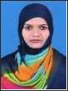
KOUSAR
Email: kousar.374055@2freemail.com

In quest of assignments in senior level positions in Administrative and Management with an organization of repute in Manufacturing & construction Sector.

ORGANIZATIONAL EXPERIENCE

- 17-12-2012 – 17-11-2015 : ICICI BANK PLT (KARNATAKA)-580029

• 15-02-2016 – Till Date : JAMIA MILLIA ISLAMIA (CENTRAL UNIVERCITY DELHI) - 110025

ICICI BANK LTD.

- Handling walking customers, debit cards, loans, receipts, cheque books etc.

- Assist customers in depositing and withdrawing cash & Maintain customer database And update periodically.

- Handle customers professionally & respond to related customer queries & advising Customers on the financial investments.

- Communicate to Front Office and update Department management of branch operations And Monitor staff duties like ledger entries, payment and trade authentication &

- Investigate discrepancies in bank operations.

- Conduct performance appraisal of bank staff. Prepare management reports.

- Deliver quantitative services to customers

- Promote bank products & services.

- Build customer relationship.

- Maintain & manage existing accounts.

- Capture new accounts.

- Respond to customers enquires & resolve.

- Excellent communication & collaboration skills with proficiency at grasping new technical concepts quickly.

JAMIA MILLIA ISLAMIA CENTRAL UNIVERSITY DELHI

- Coordinate in preparing Study Materials for Bachelor of Arts.

- Is involved in updation of Students Information such as marks, grades and preparing Marksheets etc.

- One of the Member of Question Paper of setting committee.

- Resolve and quarries of the students whenever required.

- Conducts term end examination of Bachelor of Arts students.

- Is associated with B.A. Indian Air force and Navy Administrative work at works at University.

- Deputed as an observer in term end examination.

- Deputed as observer in entrance examination of B.Ed.

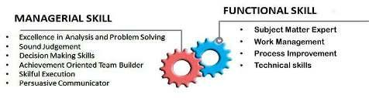

 |  |  | STRENGTH
 | ▪ | Execution Planning | ▪ | Positive Attitude
 | ▪ | Effective Team Leader | ▪ | Self Confidence
 | ▪ | Good Motivator | ▪ | Ability to adapt to new
 | ▪ | Quick Learner |  | environment easily
 | ▪ | Good Trainer | ▪ | Committed to responsibilities
 |  |  | ▪ | Listening Abilities
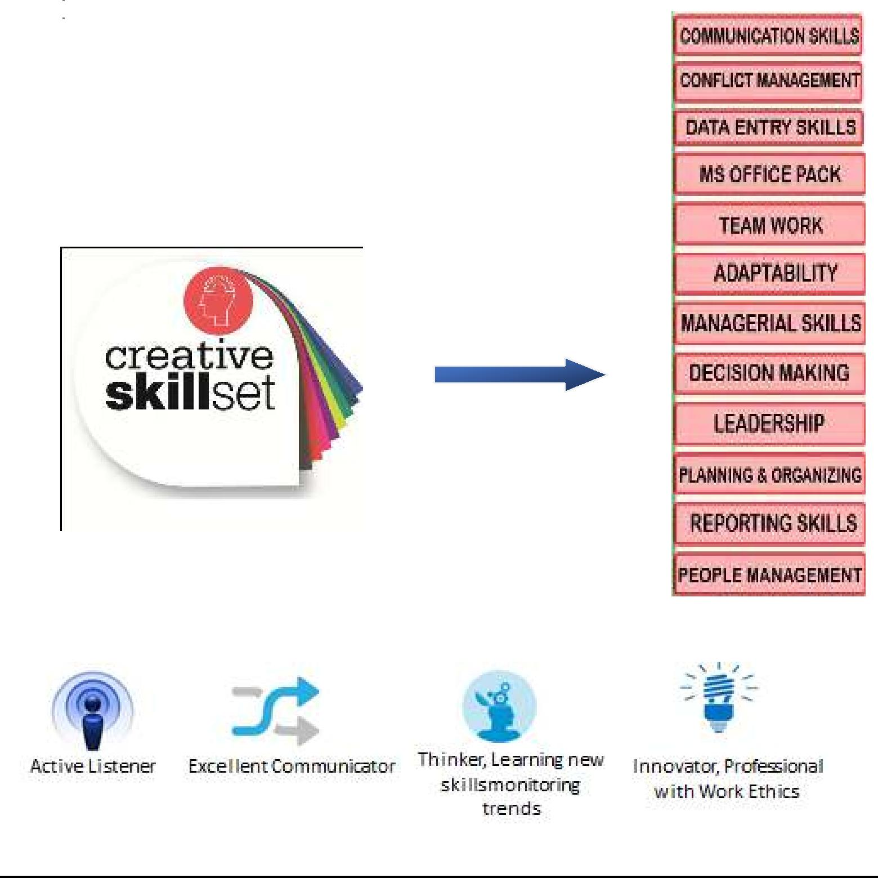
EDUCATION

- 2016 Masters from Rajasthan University. Rajasthan. (MA in English Literature)

- 2012 Graduate from Karnataka University Karnataka. (BBA in Management and finance)

- 2008 12th from pre- university education.

- 2005 10th from Anglo girl’s high school.

CERTIFICATIONS

- Passed personality development course from dharwad institution from Karnataka

- Computer diploma and Management from Gems Technical international Institute.

TRAININGS ATTENDED

- Attained professional enhancement training program from ICICI BANK.

- Attained training from JAMIA MILLIA ISLAMI INDIAN NAVY.

PERSONAL DETAILS

Date of Birth 20, December, 1989.
Nationality Indian

Marital Status Married
Languages Known English, Urdu, Hindi, Kandda, & Arabic

Passport Number R5677687

Passport Valid Up to 15/10/2027

PLACE – NEW DELHI

DATE - TODAY (KOUSAR)

