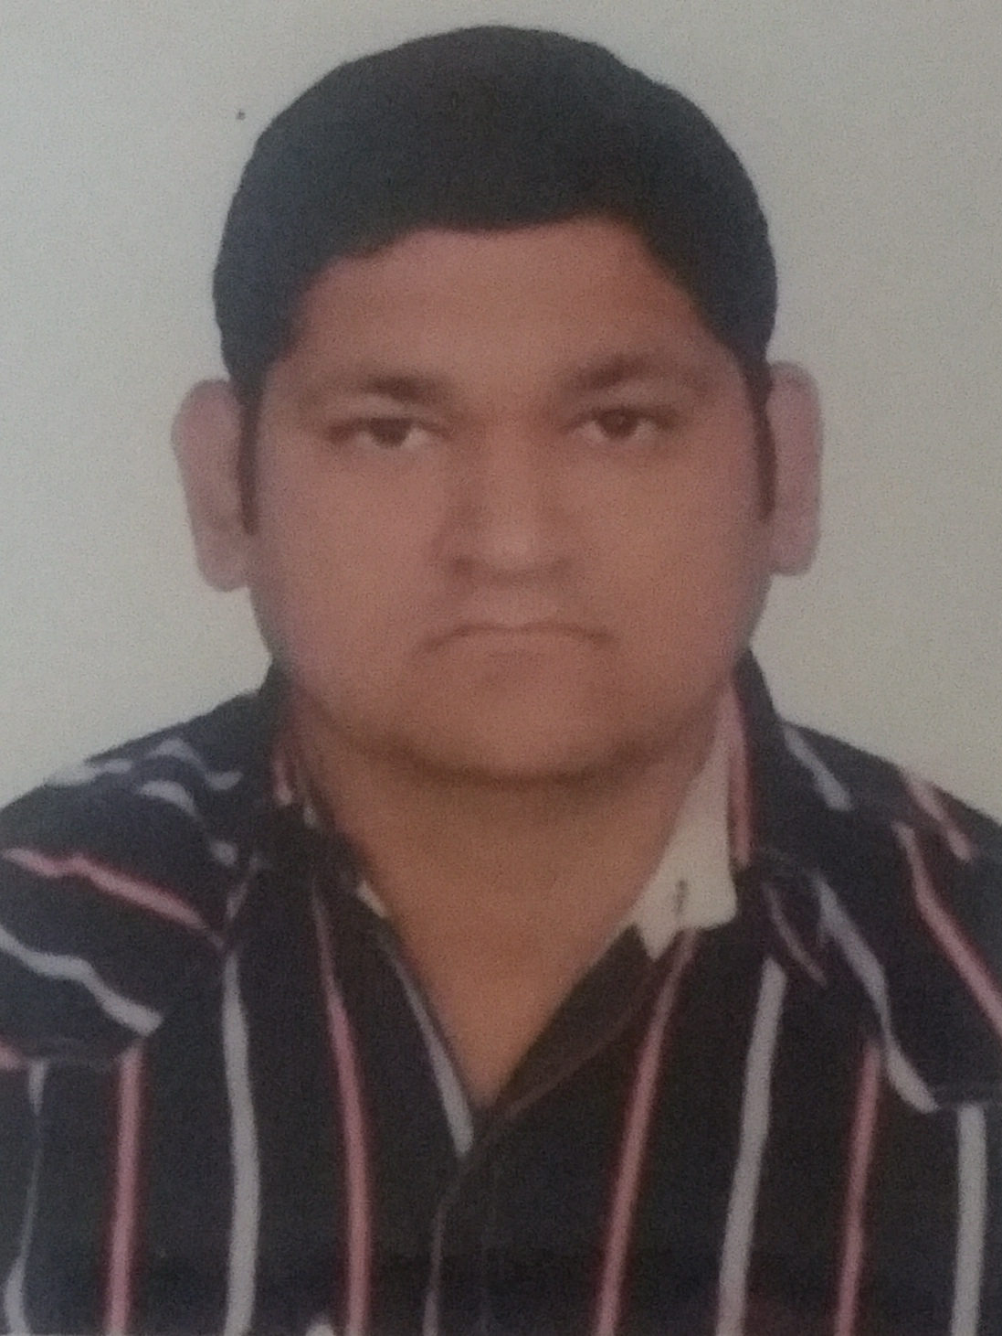
VISHAL
Microsoft Certified Information Technology Professional (MCITP)
Vishal.374058@2freemail.com

PROFILE
To get full time position with responsibility. To develop Professional as well as Personal skills and to contribute in the success of organization.
EXPERIENCE
Casher
February 2016 – Till Date
Vinayaka Overseas Gold L.L.C
Dubai, UAE
- Taking cash and delivering gold
- All bank work
- Making bills for client on software
Self Employed – Head of Engineers
August 2012 – August 2015
R.P.Computec
Rajkot, Gujarat, India
- Hardware and Software Troubleshooting of Laptops and Desktops
- Configurations of Routers and Switches
- Conducted work that includes installation of network points
- Configuration of Microsoft Server 2k8 R2
- Configuring Drivers and Softwares

Hardware Trainee Engineer
April 2011 –June 2014
Network Service Centre
Rajkot, Gujarat, India
- Hardware and Software Troubleshooting of Laptops and Desktops
- Configurations of Routers and Switches
- Conducted work that includes installation of network points
- Configuration of Microsoft Server 2k8 R2
- Configuring Drivers and Softwares
- Implementing, configuring and troubleshooting IP and Analogue CCTV cameras.

IT Technician
September 2010 – November 2010
Satya Sai School
Jamnagar, Gujarat, India
- Configuring and troubleshooting of THINKCLIANT
- Managing of Server 2K3
- Conducted work that includes installation of network points

EDUCATION

June 2010 - Computer Hardware & Networking (A+, N+), MCITP, MCTS, MCSA
January 2011 - Secondary school certificate, Matru Mandir English medium school

SKILLS

Computer
- Microsoft OS: Windows XP, Windows 7, Windows 8, Microsoft Server 2K8 and Microsoft Server 2K3

IT Networking
- Knowledge of Windows operating system architecture and security.
- Configuration and implementation of client network.
- Setup and maintenance of physical environments for desktops.
- Installation and configuration of Windows Server 2K8, Active Directory/Group Policy.
- Knowledge of network security including antivirus software, remote network access, networking and communication devices.
- Competent in network administration responsibilities such as network design,troubleshooting and security.

Technical Support
- Knowledge of remote support of workstations, printers, IT equipment and systems and client software.
- Knowledge of first level of help desk support.
- Test, installation and upgrade of new hardware/software products for PCs.
- First level support to users on hardware, software and LAN.
- Troubleshoot computer systems, hardware and software, e-mail, network and peripheral equipment problems.

LANGUAGES
English : Fluent
Hindi : Fluent
Gujarati : Mother Tongue

PERSONAL DETAILS
Date of Birth : 11 September 1990
Gender : Male
Nationality : Indian
Marital Status : Married
Driving License ; U.A.E. Manual

