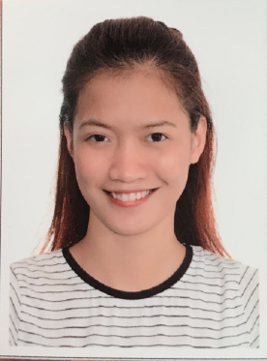
MARICRIS
E-mail Address: maricris.374075@2freemail.com

Objectives:
Seeking a challenging opportunity where I will be able to utilize my strong organizational skills, educational background, and ability to work well with people, which will allow me to grow personally and professionally. I am self-motivated and able to work both independently and as collaborative team member
Skills and Qualification:
- Analytical thinking, planning.
- Strong verbal and personal communication skills.
- Accuracy and Attention to details.
- Organization and prioritization skills.
- Problem analysis, ability to solve problems efficiently.

Work Experience:

  - Emerio Philippines (Part Time)
Ortigas, Manila Philippines
Position: Receptionist (August 2014to February 2015)
- Answers and screens the company’s phone calls and routes the call to appropriate person or department
- Entertain and direct visitors by maintaining employee and department directories; giving instructions.
- Maintains safe and clean reception area by complying with procedures, rules, and regulations.
- Performing other clerical receptionist duties such as filing, photocopying, collating, faxing etc.
- Prepare internal and external business correspondence and documents
- Provide general administrative and clerical support

- Hewlett Packard Enterprise
Quezon City, Manila Philippines
Position: Service Desk Representative (May 2015 to May 2016)
- Primary responsibility is user support and customer service.
- Respond to questions from all emails, callers and tickets entering to the queue.
- Become familiar with each client and their respective applications.
- Learn fundamental operations of commonly used software and other equipment.
- Follow standard Service Desk operating procedures; accurately log all Service Desk tickets using the defined tracking software.
- Other duties as assigned by the Service Manager.

  - Al Naddaf Tourism
Al Jafiliya, Dubai UAE
Position: Ticketing Agent (August 2016 to September 2016)

- Answer inquiries regarding such information as schedules, accommodations, procedures, and policies.
- Assemble and issue required documentation such as tickets, travel insurance policies, and itineraries.
- Handling ticketing & reservations for customers.
- Carry out all follow up procedures pertaining to customer travel, i.e. reconfirmation of airline tickets, tour confirmation, booking / reservation etc..
- Galileo & Amadeus reservation systems and issue and re-issue revalidation.

  - Attibassi Coffee Shop
Al Qasba, Sharjah UAE
Position: Cashier/Sandwich Maker (October 2016 to October 2017)

- Ensure that each customer receives prompt and courteous service.
- Greet customers, use suggestively sells techniques/skills and thank each customer.
- Ensure that grocery, cooler and freezer items are fully stocked, cleaned, faced and fronted.
- Operate cash register system, money order machine and credit card machine within established company guidelines.
Educational Background:

Tertiary Bachelor of Science in Information Technology
June 2012 – April 2015 STI College Baliuag
Gil Carlos St. Baliuag, Bulacan

Personal Details:

Birth Date : February 15, 1995
Age : 22
Civil Status : Single
Nationality : Filipino
Language : English

I hereby certify that the information above are true and correct to the best of my knowledge and belief.

MARICRIS
Applicant

