MENDJEL
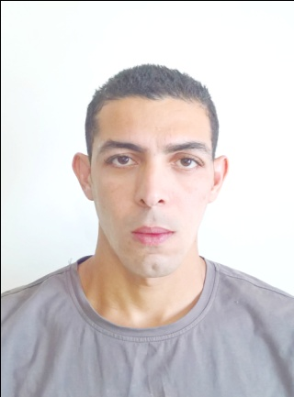
ARCHITECT & 3D VISUALIZER

Name: Mendjel  Nationality: Algerian.  Date of birth: 01 october 1987.  Marital status: Single.  Current location: Dubai – UAE.  Visa status: Visiting. | mendjel.374106@2freemail.com

SUMMARY:
I worked in a consultancy office over 5 years of experience as a multi-tasked architect. I participated in several projects in different stages throughout Algeria, both individually and collectively.
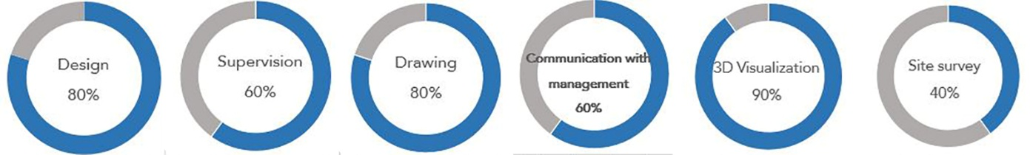

ACADEMIC QUALIFICATIONS:
2004/2005: baccalaureate in Civil Engineering Technology.
BOUAZDIA high school
2005-2010: Master Diploma in Architecture (eco buildings).
BADJI MOKHTAR University –Annaba.
2005-2008: Advanced computer technician (Databases Management).
INFSP –El Hadjar (evening classes).

WORK EXPERIENCE:
11/2010 – 05/2012:
Compulsory practical training includes the mastery of the architect's job as a whole, with the aim of obtaining the approval (CNOA) [Accreditation N °: 12794/23 / 12L].
10/2012 – 20/2017: Atelier d’Architecture & d’Urbanisme AAU [Annaba/ALGERIA].
Designing and site supervising of projects in various categories
Duties:
- Preparing and participate in all phases of the design process.
- Preparing layouts and preliminary sketches, analyzing functional design.
- Preparing and verifying from deficiencies graphical documents, technical reports, specifications loads.
- Ensure all works are conforming to the building standards and regulations.
- 3D modeling and rendering projects till the final production.
- Responsible for interior design process and decoration, colors and finishes.
- Talk with clients to understand their needs building and make design proposals.
- Coordination with partners, Subcontractors and administrative procedure.
- Determine cost estimates and quantity calculation.
- Assist in structural, HVAC design.
- Study of all type of building permits.
- Visiting sites and writing all routine reports, advising and resolving execution problems on site.

Projects designed:
- Redevelopment of the hospital [Ibn Sina, S^{te} Therese - Annaba].
- Interior design for: Hotel PLACE D’ARME, Harbour station SKIKDA.
- Rehabilitation of the Annaba Court.
- Design of new projects from the sketch to Executive Plans:
* Regional Theatre, Municipal Library - EL TARF.
* Harbor Station - SKIKDA.
* Outdoor Theatre - Guelma.
* Administrative headquarters CNAS - Annaba.
* Industrial Structures of private property [Marble Factory / gaz station ...].
* Residential Tours (Les crétes 65lg / Les belles vues 45lg).
* Landscape design of the central square – El Hadjar.
Sites supervision:
Full Service site visits and writing various pieces written about this phase (routine reports, attachments, situations ..) and advising contractor, conducting contracting team, resolve problems.
- Follow-up of the site to redevelop the hospital [Ibn Sina, St. Therese - Annaba].
- Follow-up of the site for the conversion of the new courthouse El Tarf.
- Follow-up of the site for the rehabilitation of the Annaba Court law.

SKILLS:
- Advanced knowledge in various 3D software tools and informatics.
- Strong 3D modeling, visualization and illustrations with good accuracy.
- Familiar in construction details and materials propriety.
- Good knowledge in structural preliminary design.
- Knowledge of types of building and construction methods.
- Knowledge of architectural principles and techniques.
- Good knowledge in interior design, decoration, color choice, finishes.
- Easy to adapt and apply to foreign building standards.
- Ability to communicate with stakeholders in understandable and good language
LANGUAGES:
Arabic: Mother Tongue English: Advanced French: Advanced

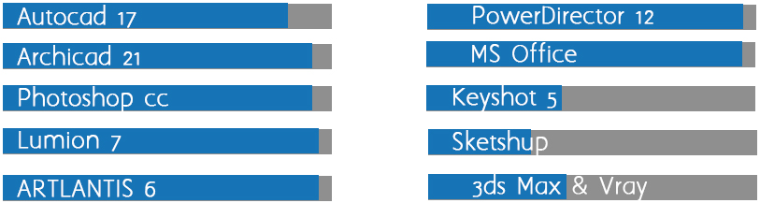
INFORMATICS TOOLS SKILLS:

